Getting Started with LionPATH
LionPATH is the Penn State’s student information system that allows you to accept financial aid, enroll in classes, pay your bill, and much more.

Accessing LionPATH
Access to LionPATH is provided through the LionPATH Support site.
- Navigate to the LionPATH Support site by entering lionpathsupport.psu.edu into the browser address bar.
- Click the STUDENTS, FACULTY, STAFF LOGIN button.
- Log into WebAccess with your Penn State User ID and Password.

Home Base Launcher
If you have more than one role in LionPATH, e.g., student and faculty, when you initially sign in you will see the Home Base Launcher.
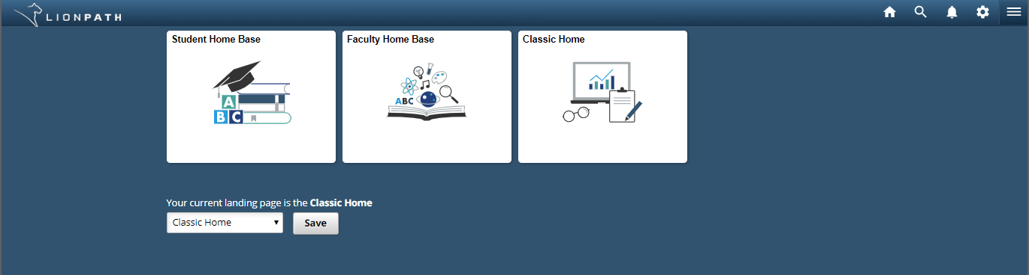
Figure 1: The Home Base Launcher page
The Home Base Launcher is role-based and will contain a tile for each role you are assigned in LionPATH. The Classic Home tile is visible to everyone, and if you select it, you will be able to navigate LionPATH using the original self-service pages. You can set the page you want to see when you enter LionPATH by selecting it from the landing page drop-down menu, and then select the Save button. Clicking on a tile will take you to that view of LionPATH.
Note: If you only have the Student role in LionPATH, you will not see the Home Base Launcher when you log in. Instead, you will be taken directly to the Student Home Base page.

Global Header
The global header contains buttons for taking you to your home page, performing a global search, and for opening the Actions List and NavBar menus.
From the Action List menu, you can select My Preferences to set your accessibility layout mode.
NavBar
Selecting the hamburger icon will open the NavBar.
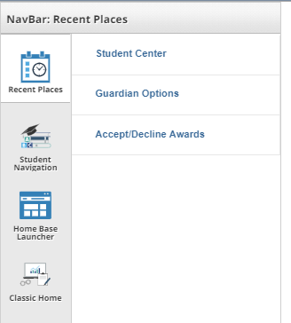
Figure 2: The NavBar
The NavBar contains four options for navigating the system. Recent Places provides access to the last five pages you visited in the system. The Student Navigation button allows you to move through the system by drilling down from a topic to the individual page. It is organized similarly to the buttons located on the Student Home Base page. From the NavBar menu, you can return to the Home Base Launcher or go to the Classic view of the system.

Student Home Base
The Student Home Base page contains your information in an easy to navigate format. Items that are viewed frequently, such as the class schedule, enrollment dates, and grades, are displayed on the front page of the Student Home Base.
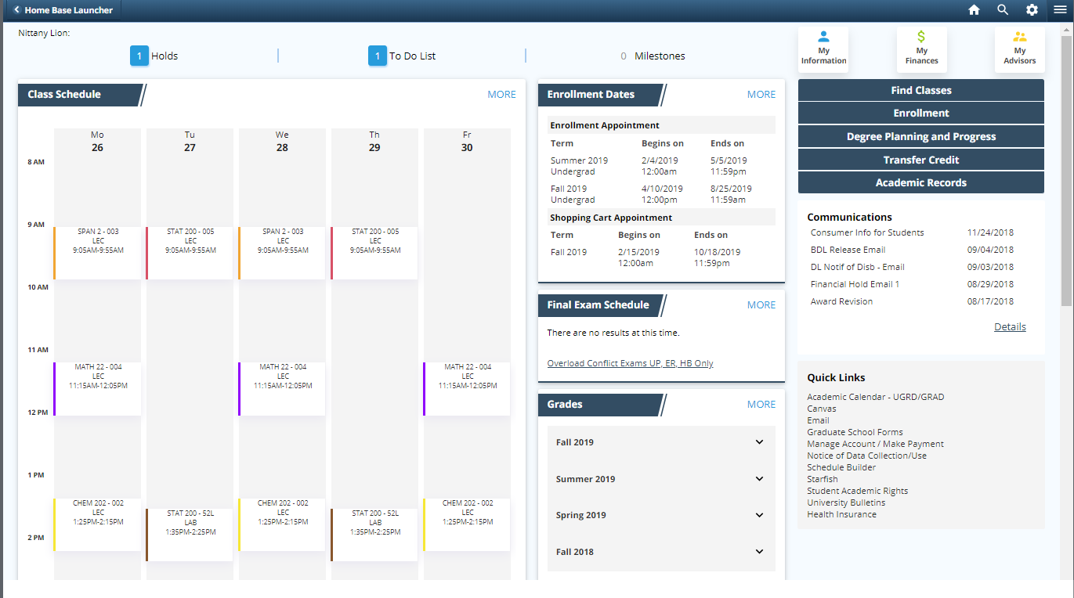
Figure 3: Student Home Base

Class Schedule
The Class Schedule section displays your classes for the current week.
Note: Selecting the MORE link will display additional information about the classes.

Grades
The Grades Section will display the last four terms you attended Penn State. Selecting a term will display your courses and grades for that term.

Navigation collection
You can navigate to other areas of LionPATH by selecting the various buttons located on the Student Home Base page. Selecting any of these buttons will take you to the navigation collection for the selected item or topic.
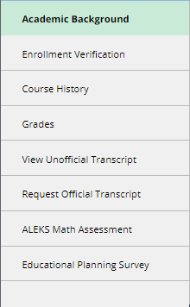
Figure 4: Navigation Collection
Note: After selecting a button in the navigation collection, the center of the page will display the related information.
From a page with a navigation collection, you can return to the Student Home Base by selecting the button in the top left corner.

Holds, To Do List, and Milestones
The Holds, To Do List, and Milestone buttons are located at the top of the page.

Holds
Select the number to the left of Holds to view the Holds page. The Holds page lists the holds (financial, academic, etc.) that have been placed on your record to restrict services. If holds are displayed, click on the name of the hold to get additional information.

To Do List
The To Do List contains items that you need to complete. Be sure to check this area frequently, as items placed here could impact your ability to complete other tasks.
Note: The To Do List will be used to notify you of the receipt of FAFSA information.
Prior to each semester’s enrollment, a Pre-Registration Activity Guide will appear in your Task List. It contains the Financial Responsibility Agreement and an Emergency Contact section, both of which are required to be completed each semester. Completing this activity guide will release the Financial Responsibility hold and allow you to enroll during your enrollment window.
To complete an item, select the link in the Task column.

Milestones
Milestones are non-course requirements such as certifications.

My Information
The My Information button will take you to the navigation collection that displays your personal and demographic information.

My Finances
Selecting the My Finances button will open the navigation collection containing information on your student account and your financial aid. The My Account page contains links for viewing tuition due dates and accessing Penn State's Payment Gateway. The Financial Aid page provides the ability to view, accept, and decline financial aid.

Additional Student Home Page buttons
The Find Classes, Enrollment, Degree Planning and Progress, Transfer Credit, and Academic Records buttons will each take you to a navigation collection where you can find information and perform tasks related to the selected topic.

Quick Links
The Quick Links section contains links to useful sites and information.
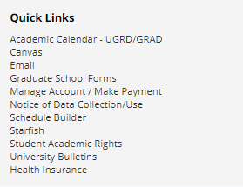
Figure 5: Quick Links

Statement of Non-Discrimination
The University is committed to equal access to programs, facilities, admission, and employment for all persons. It is the policy of the University to maintain an environment free of harassment and free of discrimination against any person because of age, race, color, ancestry, national origin, religion, creed, service in the uniformed services (as defined in state and federal law), veteran status, sex, sexual orientation, marital or family status, pregnancy, pregnancy-related conditions, physical or mental disability, gender, perceived gender, gender identity, genetic information or political ideas. Discriminatory conduct and harassment, as well as sexual misconduct and relationship violence, violates the dignity of individuals, impedes the realization of the University’s educational mission, and will not be tolerated. Direct all inquiries regarding the nondiscrimination policy to the Affirmative Action Office, The Pennsylvania State University, 328 Boucke Building, University Park, PA 16802-5901, Email: aao@psu.edu, Tel 814-863-0471.

