Overview of Schedule Builder
Schedule Builder is a tool used to conduct a class search, examine course offerings, and plan course schedules. This tutorial will cover how to use the filters and add courses and breaks to create possible schedules.
- To begin adding courses select the appropriate Term and click the Save and Continue button.

Applying Filters
Schedule Builder contains filters that allow you to narrow your search based on multiple characteristics.
The top section of Schedule Builder contains filters. Filters are applied by clicking the change button to the right of each item and selecting the appropriate options. 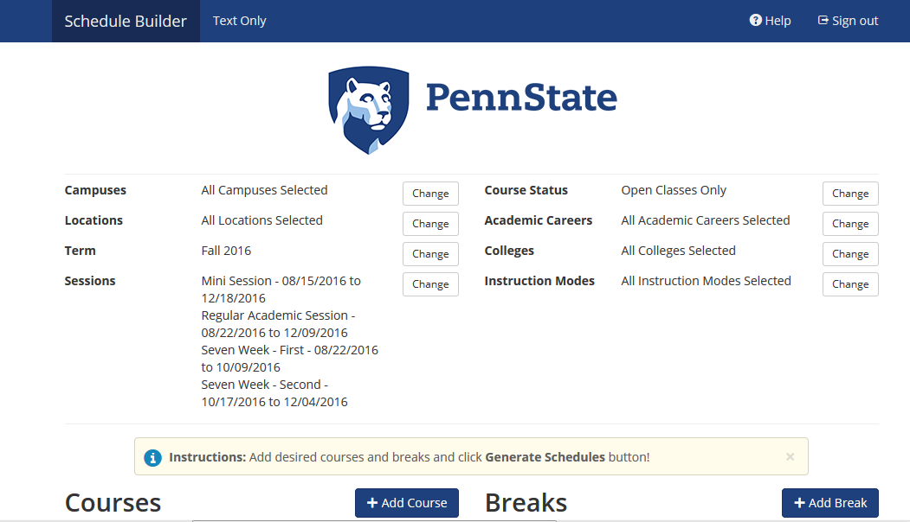
Figure 1: Schedule Builder with filters displayed

Campuses Filters
By default, all campuses are selected. Apply a filter to narrow down the campus where you want to schedule the class.
- Click on the Change button to the right of Campuses.
- Uncheck the Select All Campuses checkbox to clear all of the checks.
- Click the checkbox to the left of the campus you want to filter by.
- Click the Save button to apply the changes and return to the Schedule Builder screen.
A temporary message appears at the top of the window to indicate changes.

Term Filter
The Term filter is set based on the term you selected when entering Schedule Builder. You can change the term filter, if needed, to view other terms.

Sessions Filter
The Sessions filter allows you to select a specific session for the selected term. By default, all session types are selected.

Course Status Filter
The Course Status filter will allow you to display open classes with available seats, classes that are full with a waitlist available, or classes that are both open and full.

Academic Careers Filter
The Academic Careers filter will allow you to view classes that are for a specific career like undergrad, grad, med, or law.

Instruction Modes Filter
The Instruction Modes filter will allow you to choose the delivery mode for the class.

Adding Courses
Once the filters are applied you are ready to add courses.
- Click the Add Course button to the left of the Courses heading.
- Locate the course you would like to add to your schedule, using the Subject and Course drop-down lists. In addition to adding a course By Subject, you can Search by Course Attribute, select a course from My Planner, Search By Instructor, or By Class #. For more details about how to use these options, see Adding Courses and Advanced Options in Schedule Builder in the LionPATH Student Help.
- Click the Add Course button. Your selection will appear in the Courses list on the right.
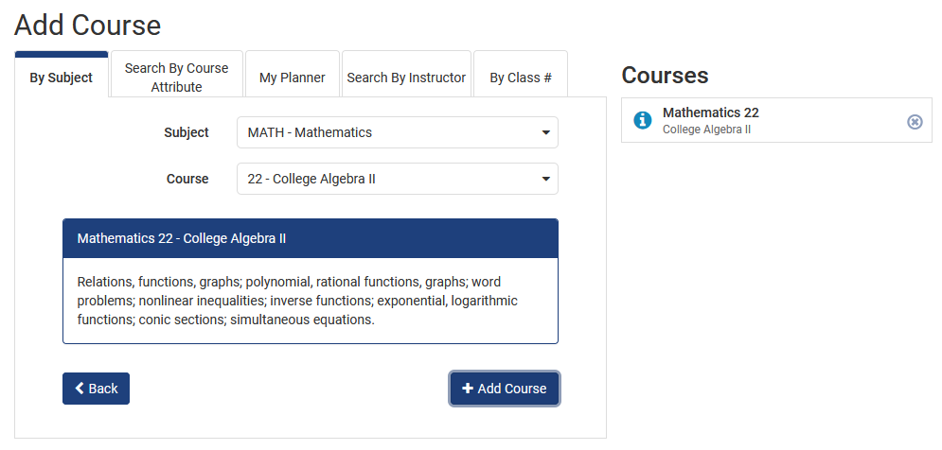
Figure 2: Schedule Builder Add Course page
You can continue to add courses until you have everything you would like in your schedule.
When you are finished adding courses, click the Back button to return to the previous screen.

Viewing the Available Schedules
The courses are now included in the Courses section.
- Click the Generate Schedules button.
- Scroll down to view the list of available schedules.
The total number of schedule options is displayed at the top of the section.
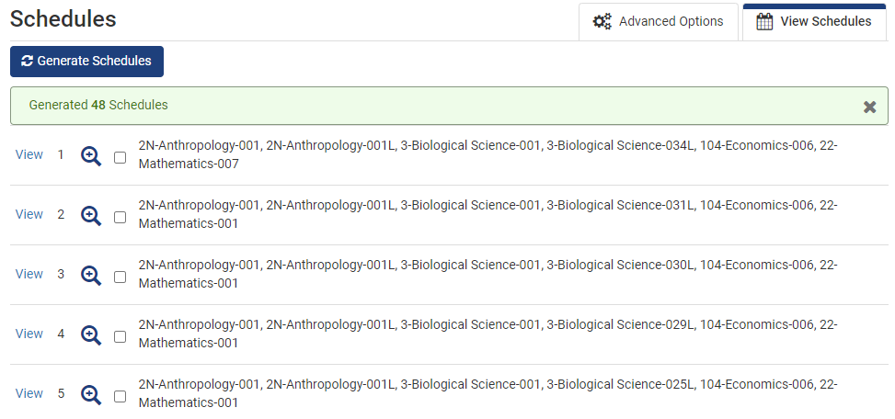
Figure 3: List of potential schedules
- To view a schedule, click the View link to the left of the appropriate schedule. The schedule is displayed in a Summary View at the top of the screen and a Calendar View at the bottom.
- Click on the ‘i” in the summary view or the calendar view to read more information about the course. When available, prerequisite and course enrollment requirements will be included here.
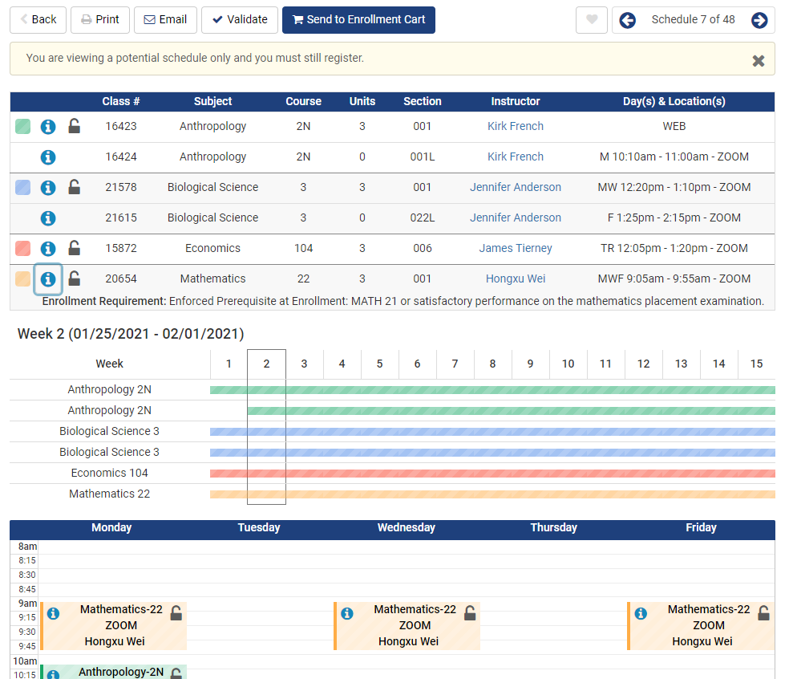
Figure 4: A potential schedule

Quick view
A quick view of each schedule can be viewed.
- Roll over the magnifying glass icon.
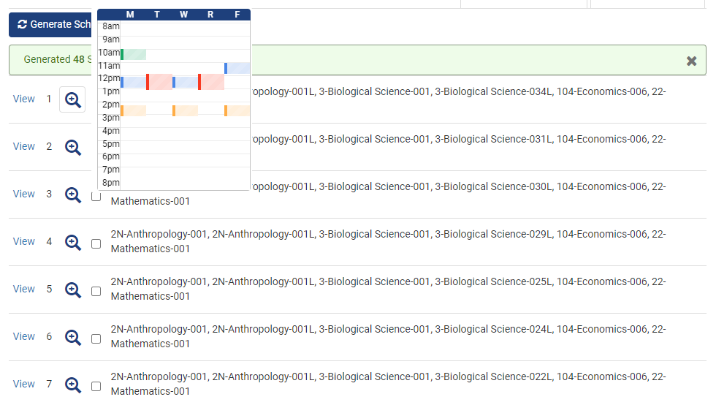
Figure 5: Quick View of potential schedule
You can also compare up to four schedules by selecting them in the list and clicking the Compare button.

Adding Breaks
Adding Breaks can limit the number of schedule options. Schedule Breaks can be added to allow for things like athletic practices or work schedules.
- To add a break, click the Add Break button.
- Enter a break name.
- Select the Start Time and End Time.
- Select the Day(s) you want to add the break.
- Once the selections are complete, click the Add Break button.
- To apply the break, click the Generate Schedules button.
When you view a schedule, you can see the breaks included.
Once you have located a schedule that you like, it can be added to your shopping cart by clicking the Send to Shopping Cart button. You will need to return to your LionPATH Enrollment Shopping Cart and continue with enrollment.

Statement of Non-Discrimination
The University is committed to equal access to programs, facilities, admission, and employment for all persons. It is the policy of the University to maintain an environment free of harassment and free of discrimination against any person because of age, race, color, ancestry, national origin, religion, creed, service in the uniformed services (as defined in state and federal law), veteran status, sex, sexual orientation, marital or family status, pregnancy, pregnancy-related conditions, physical or mental disability, gender, perceived gender, gender identity, genetic information or political ideas. Discriminatory conduct and harassment, as well as sexual misconduct and relationship violence, violates the dignity of individuals, impedes the realization of the University’s educational mission, and will not be tolerated. Direct all inquiries regarding the nondiscrimination policy to the Affirmative Action Office, The Pennsylvania State University, 328 Boucke Building, University Park, PA 16802-5901, Email: aao@psu.edu, Tel 814-863-0471.

