UNDERSTANDING WAIT LISTS - FREQUENTLY ASKED QUESTIONS

How do I add myself to a Wait List?
- When using Class Search, a section that is fully enrolled and has only Wait List availability will display a yellow triangle icon for the Status.
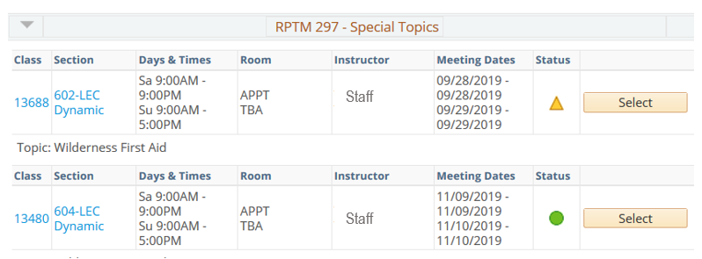

- Click Select.
- On the next page, click the checkbox next to the “Wait list if class is full.” Click Next.

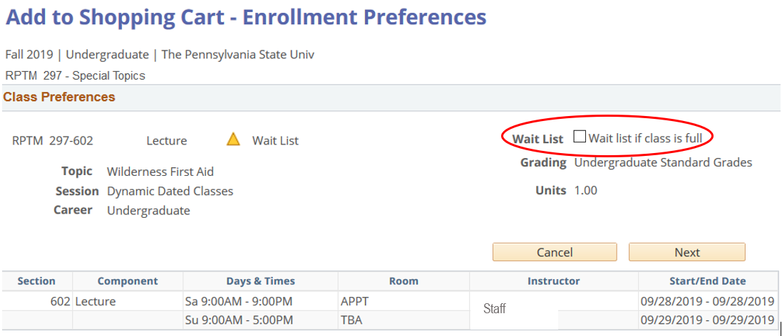

- Proceed to finish enrolling on the Wait List. You should receive a message letting you know that you have successfully added yourself to the Wait List.

I’ve added myself to the Wait List. Do I need to do anything else to get into the class?
- No. You will be automatically added when your turn on the Wait List comes.

How many credits/units can I add to my Wait List?
- You can waitlist up to 15 credits/units per term.

Will I be charged tuition or fees for classes on my Wait List?
- No.

Will I be added in the order I’m listed on the Wait List?
- Yes. Qualified students will be added to the class in the order they were added to the Wait List.
- The only times students are skipped on the Wait List are when:
  - An active registration hold is in effect.
  - Course controls (enrollment requirements) have not been met.
  - There is a time conflict, and the class was not added to the Wait List as a “swap.”
  - An enforced prerequisite is not completed or in progress. (Note: If you took a transfer course to meet a prerequisite, the transfer credit must be posted to your Penn State transcript or you will be skipped on the Wait List.)

Will I be notified when I’ve been added to a class on my Wait List or when I’ve been skipped?
- You will receive an email to your PSU email account when you have been enrolled from the Wait List. You will not be notified when you’ve been skipped.

How long will the Wait List continue to “run” and enroll students into classes?
- The timing for when the Wait List is available and continues to run is based on the session in which the class is held (e.g., Regular Session, 7-Week Session). For example, the Wait List for classes that run the entire semester are available and continue to run through the last day of the Regular Drop period. For other types of sessions, the timing can vary. Questions about specific classes can be directed to the Registrar’s Office at registrar@psu.edu.

Can my position on the Wait List be changed?
- No. Nobody can change your position on the Wait List.

Can I add a class on my Wait List that is the same time as an already scheduled class?
- Yes; you can do this by setting up a swap. Using the Enrollment Swap tool, if a seat becomes available in the class you’ve waitlisted, the swap will automatically enroll you into the waitlisted class and drop the class you requested to swap out of.
- To set up the swap, choose the class you want to swap out of. Then search for the class that has a Wait List.
- On the Swap a Class: Confirm your selection page (see screenshot below), select Finish Swapping.

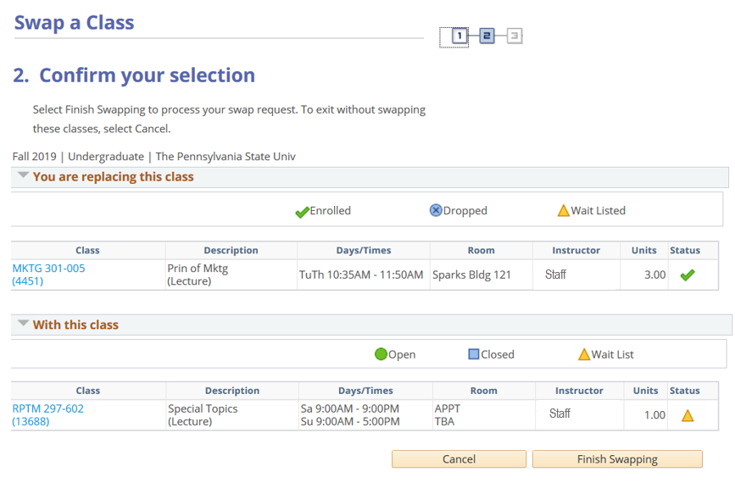

Can I waitlist more than one section of the same class?
- Yes. You can add more than one section of the same class through a Swap. Since a Swap is a direct link or exchange between 2 classes, once a Swap occurs with one section, the other waitlisted sections are no longer linked, causing them to become “orphaned.” While this will not cause a problem, you should remove yourself from the Wait List for the other sections. If you prefer a different section than the one you were enrolled into, you can set up a Swap between the enrolled section and the more desirable section(s).

Do all classes have a Wait List?
- Not all classes have Wait List functionality turned on. The department offering the class determines if a class has a Wait List.

If I have a hold preventing registration, will I be able to add myself to a Wait List?
- If you have a registration hold, you cannot add yourself to a Wait List.
- If a registration hold has been added to your record after you waitlisted a class, you will be skipped (i.e., not enrolled into the waitlisted class) but remain on the Wait List. Once the hold is resolved and removed, you will be enrolled into the class if your turn comes.

Can I add myself to a Wait List for a class for which I have not completed or scheduled a prerequisite?
- Enforced Prerequisites: You can add yourself to a Wait List for a class for which you do not meet an enforced prerequisite, but you will be skipped (i.e., not enrolled into the waitlisted class) if you do not have the prerequisite met or in progress.
- Unenforced Prerequisites: Not all prerequisites are enforced automatically through LionPATH. In these cases, individual departments may choose to enforce the prerequisite themselves.

I’m currently taking the last prerequisite for a class I want to waitlist next semester. Can I still waitlist this class?
- Yes. You will be added to the Wait List conditionally and will be enrolled into the class if your turn comes.
- After the semester’s grades are posted, departments can remove students from the Wait List who have not passed the prerequisite class.

What if I want to take a class but I’m too far down on the Wait List to get it?
- You should remain on the Wait List in order to help departments know that a class is in demand. Schedule an appropriate alternative class as a back-up.

What if I get all the classes I’ve waitlisted and end up with too many credits?
- You should monitor the classes you have waitlisted and remove waitlisted classes you no longer want to get into.
- You can also set up waitlisted classes as “Swaps” so that if a waitlisted class is added to your schedule, the class you want to swap out of is dropped from your schedule.

Statement of Non-Discrimination
The University is committed to equal access to programs, facilities, admission, and employment for all persons. It is the policy of the University to maintain an environment free of harassment and free of discrimination against any person because of age, race, color, ancestry, national origin, religion, creed, service in the uniformed services (as defined in state and federal law), veteran status, sex, sexual orientation, marital or family status, pregnancy, pregnancy-related conditions, physical or mental disability, gender, perceived gender, gender identity, genetic information or political ideas. Discriminatory conduct and harassment, as well as sexual misconduct and relationship violence, violates the dignity of individuals, impedes the realization of the University’s educational mission, and will not be tolerated. Direct all inquiries regarding the nondiscrimination policy to the Affirmative Action Office, The Pennsylvania State University, 328 Boucke Building, University Park, PA 16802-5901, Email: aao@psu.edu, Tel 814-863-0471.

