Viewing Your Grades
LionPATH allows you to view your grades and term statistics for any term.

Navigating to the Grades Page

The Grades Section on the Student Home Base will display the last four terms you attended Penn State. Selecting a term will display your courses and grades for that term.
- To see additional information, select the MORE link located in the right corner of the Grades box.

Viewing Your Grades and Term Statistics
The Grades page will appear with a list of all the terms you have attended at Penn State.
- Select the term you wish to view.
The top part of the page displays the Term and Cumulative GPA. 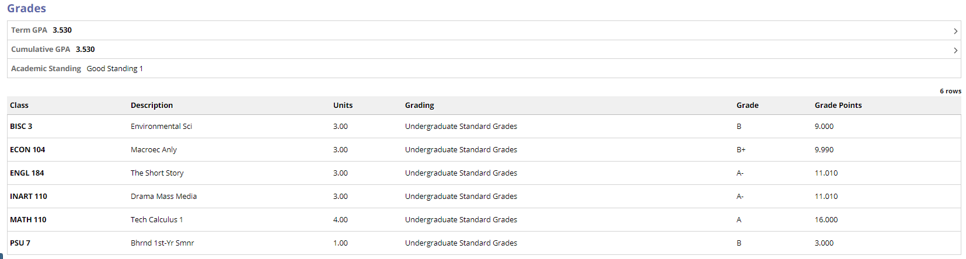
Figure 1: Grades page
Clicking on the Term or the Cumulative GPA row will display additional details for the term.
Note: To see your current GPA, view the Cumulative GPA for the last semester in which you received grades.

Statement of Non-Discrimination
The University is committed to equal access to programs, facilities, admission, and employment for all persons. It is the policy of the University to maintain an environment free of harassment and free of discrimination against any person because of age, race, color, ancestry, national origin, religion, creed, service in the uniformed services (as defined in state and federal law), veteran status, sex, sexual orientation, marital or family status, pregnancy, pregnancy-related conditions, physical or mental disability, gender, perceived gender, gender identity, genetic information or political ideas. Discriminatory conduct and harassment, as well as sexual misconduct and relationship violence, violates the dignity of individuals, impedes the realization of the University’s educational mission, and will not be tolerated. Direct all inquiries regarding the nondiscrimination policy to the Affirmative Action Office, The Pennsylvania State University, 328 Boucke Building, University Park, PA 16802-5901, Email: aao@psu.edu, Tel 814-863-0471.

