Viewing Your Exam Schedule

Your final exam schedule can be viewed in the LionPATH.

Navigating to the Exam Schedule Page

If your exam schedule is available, information regarding the exams will be displayed in the Final Exam Section on the Student Home Base.

Viewing Your Exam Schedule
- To see additional information, select the MORE link located in the right corner of the Final Exam Schedule box.
- Select the term you wish to view and select the Continue button.
The term for the displayed exam schedule is located above the exam schedule table.
Selecting the Change Term button will allow you to go to the previous screen and select a new term.
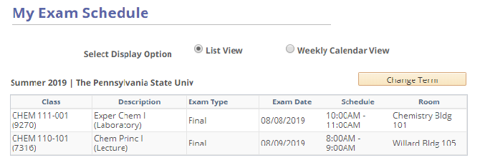
Figure 1: A student's Spring 2017 exam schedule displayed in list view

Viewing Your Exam Schedule: Calendar View
At the top of the My Exam Schedule page, there are radio buttons available for selecting the display option. List View is the default. Clicking the Weekly Calendar View radio button will change the view of your schedule, placing the exam information in a calendar format.
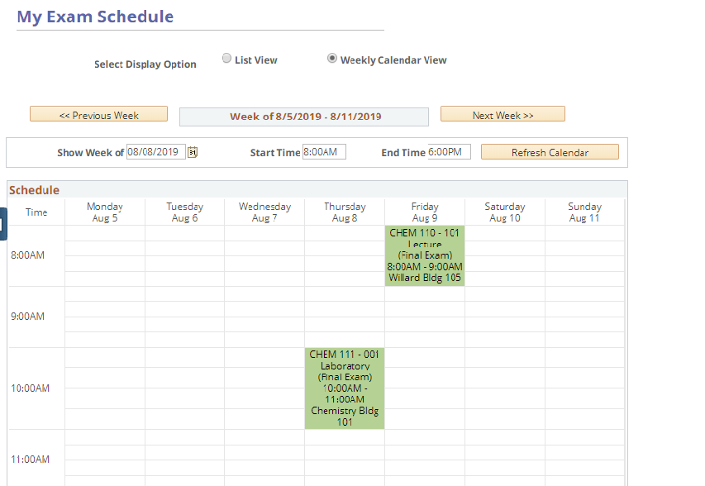
Figure 2: A student’s exam schedule displayed in calendar view
You can change the week that is displayed on the calendar by using the previous/next week buttons. Alternatively, you can view a specific date/time range by entering the date and times into the provided text boxes and clicking the refresh calendar button.
The calendar view can be modified by selecting different Display Options, located below the calendar, and clicking the refresh calendar button.
If you want to print the calendar view of your exam schedule, click the Printer Friendly Page link and use your browser’s print function.

Statement of Non-Discrimination
The University is committed to equal access to programs, facilities, admission, and employment for all persons. It is the policy of the University to maintain an environment free of harassment and free of discrimination against any person because of age, race, color, ancestry, national origin, religion, creed, service in the uniformed services (as defined in state and federal law), veteran status, sex, sexual orientation, marital or family status, pregnancy, pregnancy-related conditions, physical or mental disability, gender, perceived gender, gender identity, genetic information or political ideas. Discriminatory conduct and harassment, as well as sexual misconduct and relationship violence, violates the dignity of individuals, impedes the realization of the University’s educational mission, and will not be tolerated. Direct all inquiries regarding the nondiscrimination policy to the Affirmative Action Office, The Pennsylvania State University, 328 Boucke Building, University Park, PA 16802-5901, Email: aao@psu.edu, Tel 814-863-0471.

