Viewing Your Course History
Your course history is available in LionPATH and displays every course you have previously taken, courses you are currently enrolled in, and any course placed in your planner.

Navigating to the Course History Page
- From the Student Home Base, select the Academic Records button.
- Select the Course History button located in the navigation collection on the left side of the page.

Viewing Your Grades and Term Viewing Your Course History
The Course History page displays the courses you are currently taking, courses you took in past terms, transfer courses posted to your transcript, and courses you plan to take in the future. The filter icon, located above the course history table, allows you to choose which courses you would like to display.
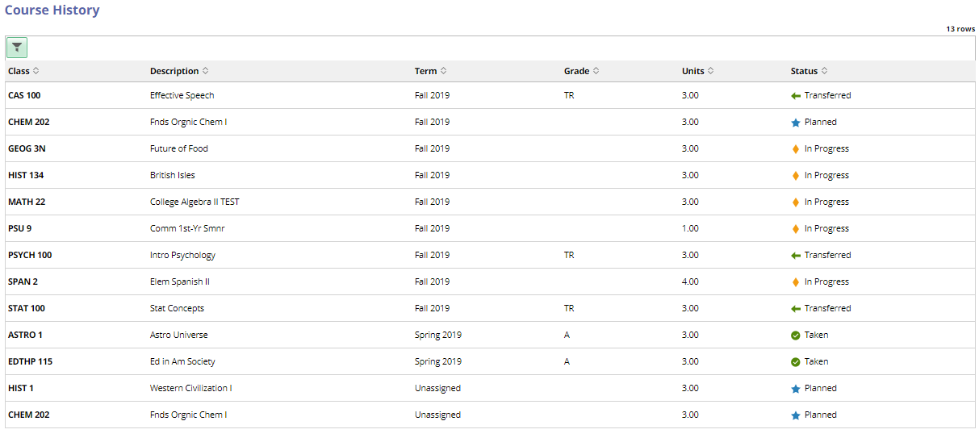
Figure 1: A student’s My Course History page
Note: You can sort the table by clicking on the column headers.
The Status column contains an icon indicating if the course is one you previously took at Penn State, if it is one you are currently enrolled in, or if the course was taken at a different institution and transferred to Penn State.

Statement of Non-Discrimination
The University is committed to equal access to programs, facilities, admission, and employment for all persons. It is the policy of the University to maintain an environment free of harassment and free of discrimination against any person because of age, race, color, ancestry, national origin, religion, creed, service in the uniformed services (as defined in state and federal law), veteran status, sex, sexual orientation, marital or family status, pregnancy, pregnancy-related conditions, physical or mental disability, gender, perceived gender, gender identity, genetic information or political ideas. Discriminatory conduct and harassment, as well as sexual misconduct and relationship violence, violates the dignity of individuals, impedes the realization of the University’s educational mission, and will not be tolerated. Direct all inquiries regarding the nondiscrimination policy to the Affirmative Action Office, The Pennsylvania State University, 328 Boucke Building, University Park, PA 16802-5901, Email: aao@psu.edu, Tel 814-863-0471.

