Viewing Your Bill
You will have access to view your monthly statement as well as real time account information through the Penn State Student Account Dashboard.
The first bill of the semester is due after the regular drop/add period of that term and enrolled course(s). All other monthly statements (September, October, and November) will have a due date on the 22nd of the month.
Note: Refer to the Penn State Office of the Bursar website at https://bursar.psu.edu for tuition due dates.

Navigating to Penn State Student Account Dashboard
- From the Student Home Base, select the My Finances button.
- On the My Account page, select the Manage My Account / Make a Payment button.

Viewing Your Statements
The Your Statements section of the Penn State Student Account Dashboard will display your three most recent statements. You can view additional statement by selecting the View All link.
- Select the View link to the right of the statement to open that statement in a new window. Note: to download the statement select the download link.
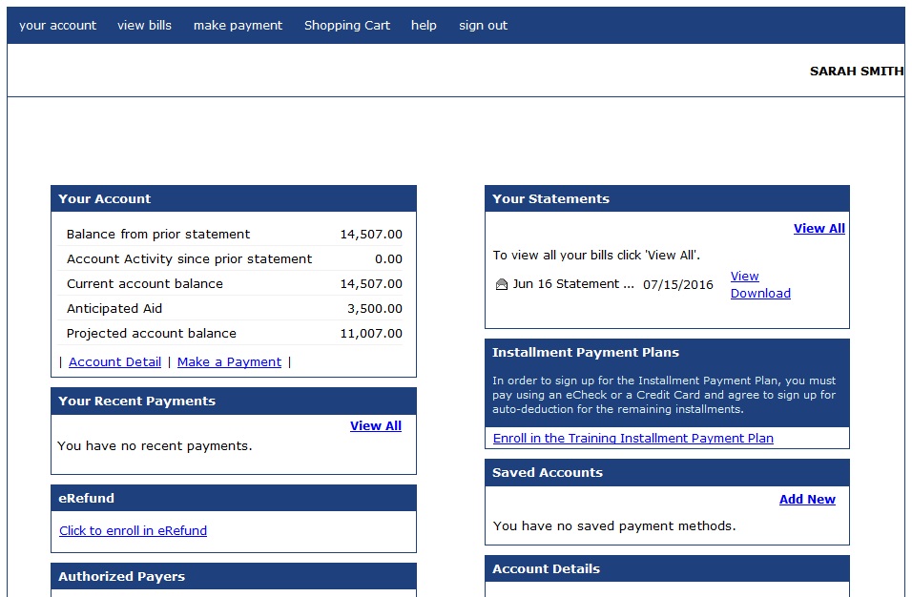
Figure 1:Penn State Student Account Dashboard
The top portion of the statement contains a summary of your account as of the Statement Date listed in the upper right. If a payment is being mailed, print the statement using the pdf reader’s print functionality and return the top portion with your payment.
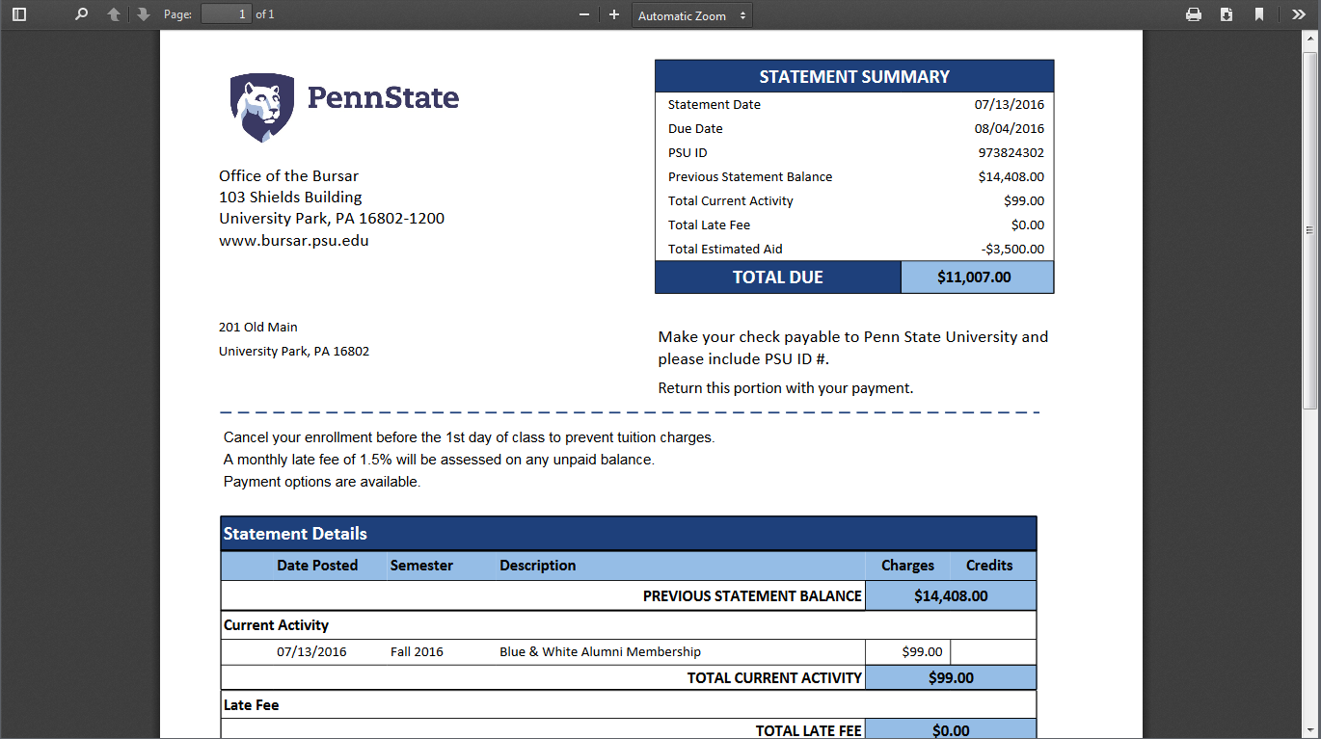
Figure 3: Account statement from the Office of the Bursar

Statement Details Section
The Statement Details section contains details of transactions on your account, including activity since your last statement, late fees, financial aid, and your balance as of the statement date.
Note: Important messages will be displayed just about the Statement Details section.

Enrollment Information Section
The Enrollment Information section displays your schedule as of the statement date.

Holds Section
A Holds section will appear at the bottom of the statement only if you have bursar holds on your account. This section will display the bursar holds active on your account as of the statement date.

Viewing Your Account
The Your Account section of the Student Account Dashboard will display a real time summary of your account including all activity since your last statement. From here you can see additional details by selecting on the Account Details link.

Statement of Non-Discrimination
The University is committed to equal access to programs, facilities, admission, and employment for all persons. It is the policy of the University to maintain an environment free of harassment and free of discrimination against any person because of age, race, color, ancestry, national origin, religion, creed, service in the uniformed services (as defined in state and federal law), veteran status, sex, sexual orientation, marital or family status, pregnancy, pregnancy-related conditions, physical or mental disability, gender, perceived gender, gender identity, genetic information or political ideas. Discriminatory conduct and harassment, as well as sexual misconduct and relationship violence, violates the dignity of individuals, impedes the realization of the University’s educational mission, and will not be tolerated. Direct all inquiries regarding the nondiscrimination policy to the Affirmative Action Office, The Pennsylvania State University, 328 Boucke Building, University Park, PA 16802-5901, Email: aao@psu.edu, Tel 814-863-0471.

