Viewing and Printing Your 1098-T
You will have access to view and print your 1098-T tax document through the Penn State Student Account Dashboard. In addition, you can opt-in to only receive the 1098-T form electronically.
The 1098-T section will display your most recent form. Students, and the Authorized Payers for which the student has granted 1098-T access, will receive an email when the form is available.
Note: Authorized Payers will login via the LionPATH Guest site at https://public.lionpath.psu.edu using their Authorized Payer login information.

Navigating to the Penn State Student Account Dashboard
- From the Student Home Base, select the My Finances button.
- On the My Account page, select the Manage My Account / Make a Payment button.

Viewing and Printing Your 1098-T
- Select the link for the most recent 1098-T in the 1098-T section to display the form in a new window.
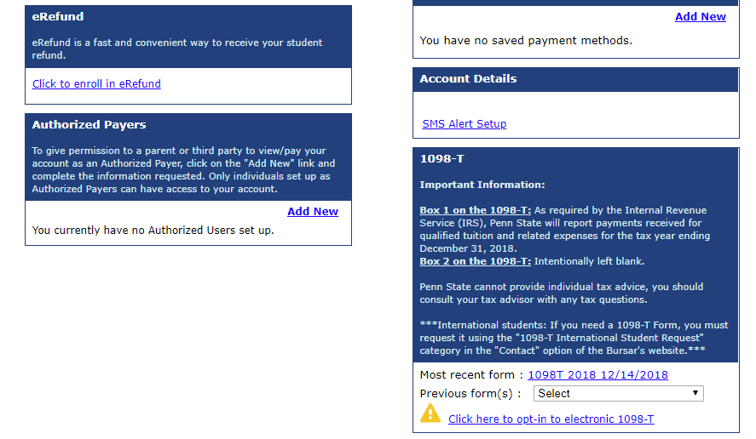
Figure 1: Figure 1: Penn State Student Account Dashboard

Note: If you have multiple 1098-T forms, the Previous form(s) drop-down will allow you to access any prior 1098-T forms.

Viewing and Printing Your 1098-T
The 1098-T will display in your computer’s pdf viewer.
- Use the pdf viewer’s print functionality to print your form.
- Select the X in the upper right to close the pdf viewer window and return to the Student Account Dashboard.

Opting-In to the Electronic 1098-T
You have the option to Opt-In to the electronic 1098-T form. If you opt-in, a paper 1098-T form will not be mailed to you.
- Select the link to opt-in to the electronic 1098-T form.
- Select the Yes radio button.
- Select the Continue button.
- Once you have read and understand the terms and conditions, Select the consent checkbox.
- Select the Continue button.
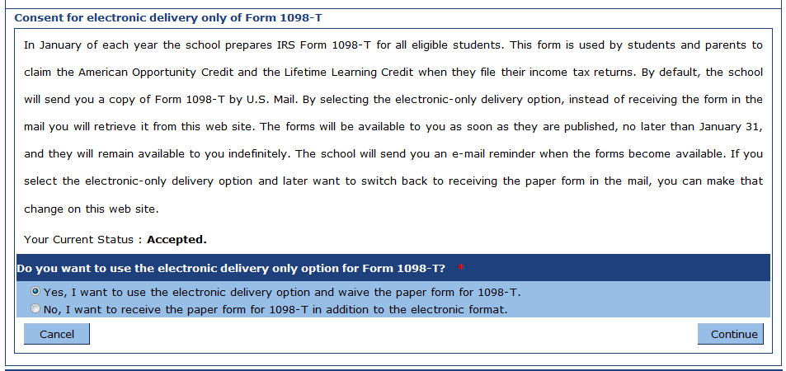
Figure 2: Consent for the electronic delivery of the 1098_T form
The 1098-T section of the Student Account Dashboard has been updated to an Accepted status for the Electronic delivery only option.
Note: If you need to make changes to your 1098-T delivery option, select the Accepted link to open the window and make changes.

Statement of Non-Discrimination
The University is committed to equal access to programs, facilities, admission, and employment for all persons. It is the policy of the University to maintain an environment free of harassment and free of discrimination against any person because of age, race, color, ancestry, national origin, religion, creed, service in the uniformed services (as defined in state and federal law), veteran status, sex, sexual orientation, marital or family status, pregnancy, pregnancy-related conditions, physical or mental disability, gender, perceived gender, gender identity, genetic information or political ideas. Discriminatory conduct and harassment, as well as sexual misconduct and relationship violence, violates the dignity of individuals, impedes the realization of the University’s educational mission, and will not be tolerated. Direct all inquiries regarding the nondiscrimination policy to the Affirmative Action Office, The Pennsylvania State University, 328 Boucke Building, University Park, PA 16802-5901, Email: aao@psu.edu, Tel 814-863-0471.

