Viewing Your Transfer Credit Report

Your transfer credit report shows credit granted for college courses taken at other institutions as well as credit received from other sources, such as Advanced Placement Exams and military experience.
The Transfer Credit Report is divided into three sections: Course Credits, Test Credits, and Other Credits.

Navigating to the Transfer Credit Report
- From the Student Home Base, select the Transfer Credit button.
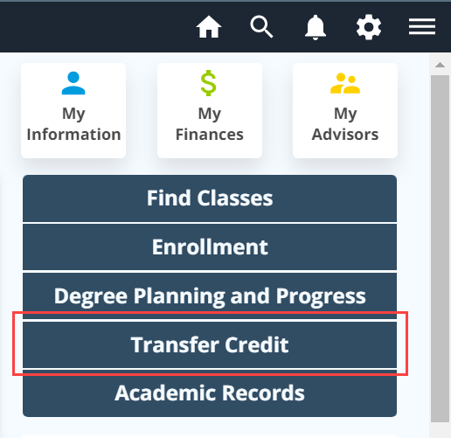
Figure 1: Transfer Credit button within Student Home Base

Course Credits
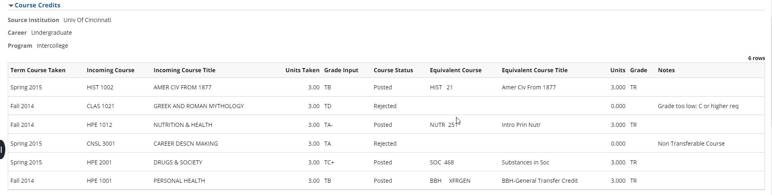
Figure 2: Transfer Credit Report with the Course Credits section displayed.
Transfer credits are listed in groups according to the institution you are transferring credit from, the term they were entered onto your record, and the program/academic college you were enrolled in at that time.
The header for each group of courses will contain your Penn State career and program as well as the abbreviated name of the institution where the coursework was completed.
Below the header information is a table listing the academic term that the credit is being applied, the coursework taken at the source institution, and the Penn State equivalent course information.
Each transfer course will have a status of either Posted or Rejected. Posted status indicates that the transfer course is accepted as Penn State credit. Rejected status indicates transfer course is not accepted as Penn State credit. This usually occurs because the grade earned was below a C or because the course is non-transferable.
Credits from another institution can transfer into Penn State in a variety of ways. Work with your academic department to determine the usability of these credits within your degree program.
Explanations of transfer credit designations are found at Penn State Credit Equivalencies.

Examples of Transfer Course Credits
In some cases, a single course from an external institution may be evaluated as two or more courses at Penn State. When this happens, you will see the credits divided between the equivalent courses. In the image below, 4-credit CHE 220 taken at Northampton County Area Community College transfers to Penn State as CHEM 112 (3 credits - direct equivalent) and CHEM 113 (1 credit – direct equivalent).
Figure 3: Image showing one incoming course that is posted to two equivalent courses at Penn State.
Another example of a transfer course is ACCTG XFR100. This code indicates a transferrable Accounting course at the 100-course level.
Figure 4: Image highlighting the equivalent course ACCTG XFR100.
In this last example, TRN XFRGEN is a transferable course not assigned a level or general education designation. Work with your academic department to determine the usability of these credits within your degree program.
Figure 5: Image highlighting the equivalent course TRN XFRGEN.

Test Credits
The Test Credits section displays credits earned through examinations and includes the Test ID, Test Component, Description, and Score as well as the Penn State equivalent course information.
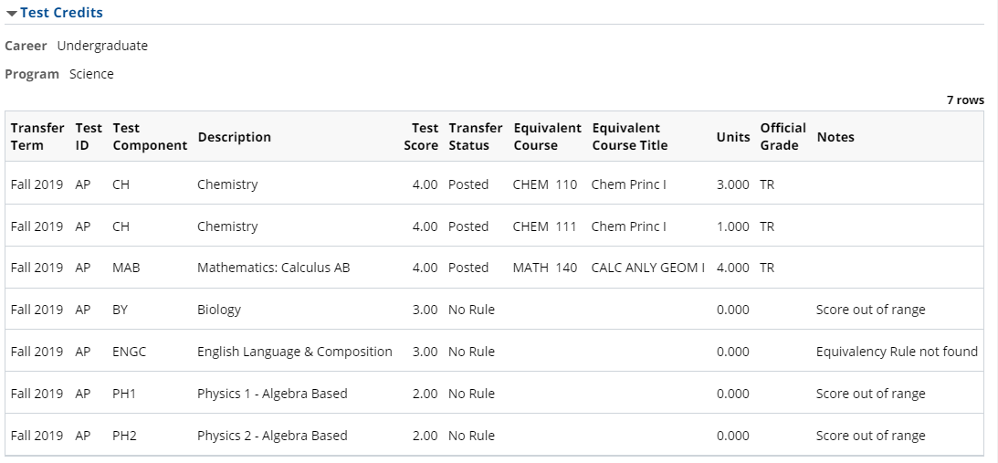
Figure 6: Transfer Credit Report with the Test Credits section displayed.

Other Credits
The Other Credits section displays credits earned through other avenues. For example, you may receive credit based on a portfolio assessment or for educational experiences in the armed services. Work with your academic department to determine the usability of these credits within your degree program.
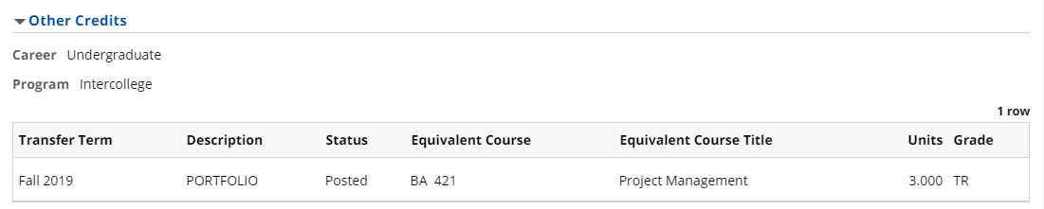
Figure 7: Transfer Credit Report with the Other Credits section displayed

View as PDF
You may also print your Transfer Credit Report to a pdf by clicking the View Report as PDF button located at the top of your Transfer Credit Report.
Figure 8: Transfer Credit Report – View Report as PDF button

Miscellaneous Information

Crediteval@psu.edu is the electronic mailbox monitored by UAO to process course syllabi sent by admitted students with TRN XFRPEN courses on their PSU record.

Transferring Credits to Penn State provides a comprehensive review of transferring credit to Penn State.

Explanations of transfer credit designations are found at Penn State Credit Equivalencies.

Statement of Non-Discrimination
The University is committed to equal access to programs, facilities, admission, and employment for all persons. It is the policy of the University to maintain an environment free of harassment and free of discrimination against any person because of age, race, color, ancestry, national origin, religion, creed, service in the uniformed services (as defined in state and federal law), veteran status, sex, sexual orientation, marital or family status, pregnancy, pregnancy-related conditions, physical or mental disability, gender, perceived gender, gender identity, genetic information or political ideas. Discriminatory conduct and harassment, as well as sexual misconduct and relationship violence, violates the dignity of individuals, impedes the realization of the University’s educational mission, and will not be tolerated. Direct all inquiries regarding the nondiscrimination policy to the Affirmative Action Office, The Pennsylvania State University, 328 Boucke Building, University Park, PA 16802-5901, Email: aao@psu.edu, Tel 814-863-0471.

