Viewing Your Unofficial Transcript
LionPATH allows you to view your unofficial transcript.

Navigating to the View Unofficial Transcript Page
- From the Student Home Base, select the Academic Records button.
- Select the View Unofficial Transcript button located in the navigation collection on the left side of the page.
The View Unofficial Transcript page appears with the View Report tab selected.

Viewing Your Unofficial Transcript
- The Academic Institution should be set to The Pennsylvania state University.
- Select the appropriate report from the Report Type drop-down menu.
- Select the Submit button.
Figure 1: The View Unofficial Transcript page with Advising Undergrad Transcript selected.
A new window will open with a pdf of your unofficial transcript. This is an unofficial copy of your student record listed by term. To request an official transcript, refer to the Requesting Your Transcript tutorial.
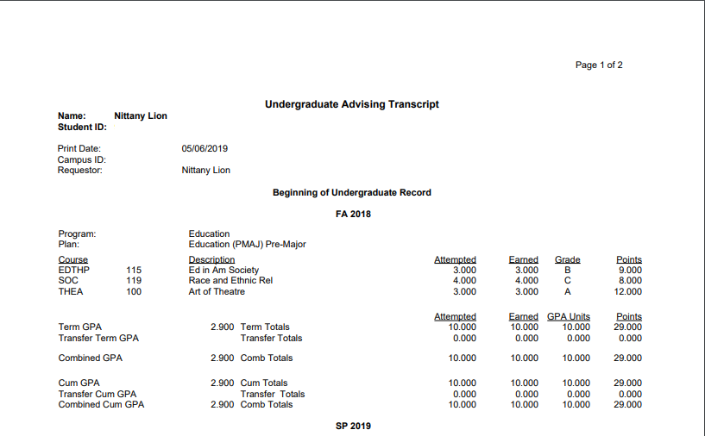
Figure 2: A pdf of the student’s unofficial transcript.
Use your pdf viewer’s print functionality for a paper copy of your unofficial transcript. When you are done, close the window to return to the LionPATH.

Note: Selecting the View All Requested Reports tab will provide a list of the prior reports that have been run. Selecting the checkbox for a previous request will provide you with the options to view the report or delete it.

Statement of Non-Discrimination
The University is committed to equal access to programs, facilities, admission, and employment for all persons. It is the policy of the University to maintain an environment free of harassment and free of discrimination against any person because of age, race, color, ancestry, national origin, religion, creed, service in the uniformed services (as defined in state and federal law), veteran status, sex, sexual orientation, marital or family status, pregnancy, pregnancy-related conditions, physical or mental disability, gender, perceived gender, gender identity, genetic information or political ideas. Discriminatory conduct and harassment, as well as sexual misconduct and relationship violence, violates the dignity of individuals, impedes the realization of the University’s educational mission, and will not be tolerated. Direct all inquiries regarding the nondiscrimination policy to the Affirmative Action Office, The Pennsylvania State University, 328 Boucke Building, University Park, PA 16802-5901, Email: aao@psu.edu, Tel 814-863-0471.

