VA Enrollment Certification Request
Student Desktop Guide

Information about the Office of Veterans Programs
Information can be found at http://equity.psu.edu/veterans

Before You Get Started
If you are a new student and have not yet completed the Military-Connected Student Questionnaire you must do so before continuing. Instructions are found at https://lionpathsupport.psu.edu/student-help/ in the Getting Started with LionPATH section.

Navigating to the VA Enrollment Certification Request
Sign into LionPATH
In your Student Home Base, click the icon for My Information
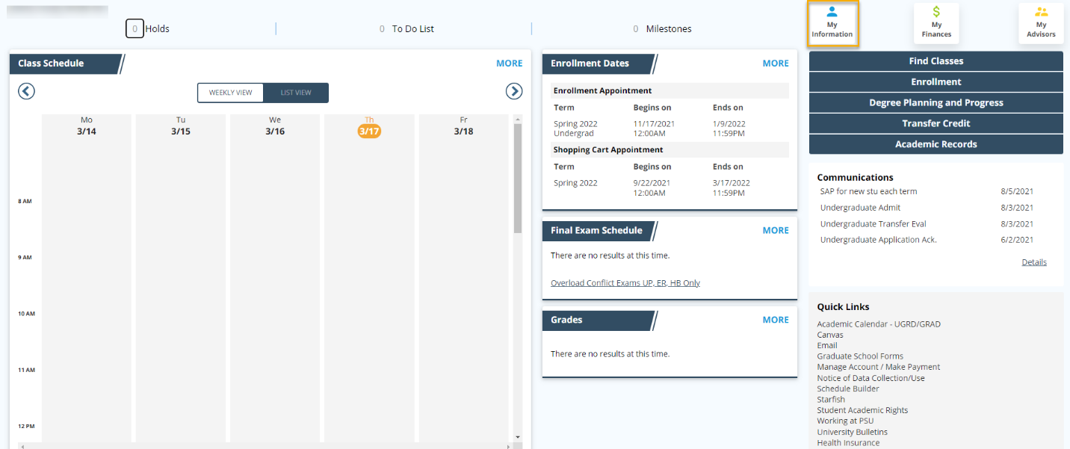

Click on VA Enrollment Cert Request in the menu.
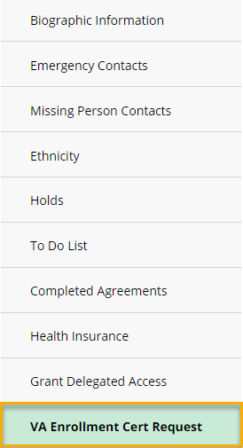

Completing the VA Enrollment Certification Request
Read all Support, Important Information, and Additional Information provided.
Click Next to go to the next page.
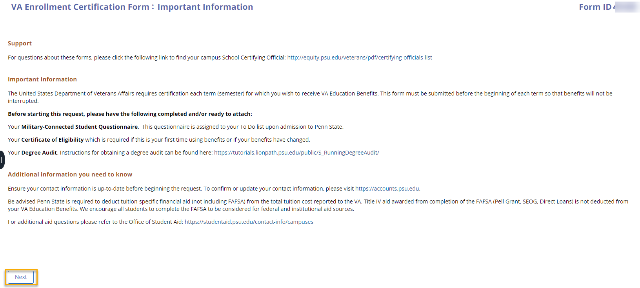
If you have not completed the Questionnaire (see Before You Get Started, above) or do not have a Veterans Benefit Summary record on file with the Office of Veterans Programs, you will receive a message you cannot continue.
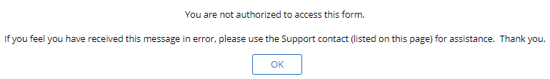

Verify your information in the My Information section. If you need to update any personal information, visit https://accounts.psu.edu.
Complete the Request Information, Military-Connection, VA Benefit, and Tuition Specific Financial Aid sections.
If you have completed the Military-Connected Student Questionnaire for the term, the Service Disability and Veterans Affairs Education Benefit will populate for you, based on your answers to the questionnaire.

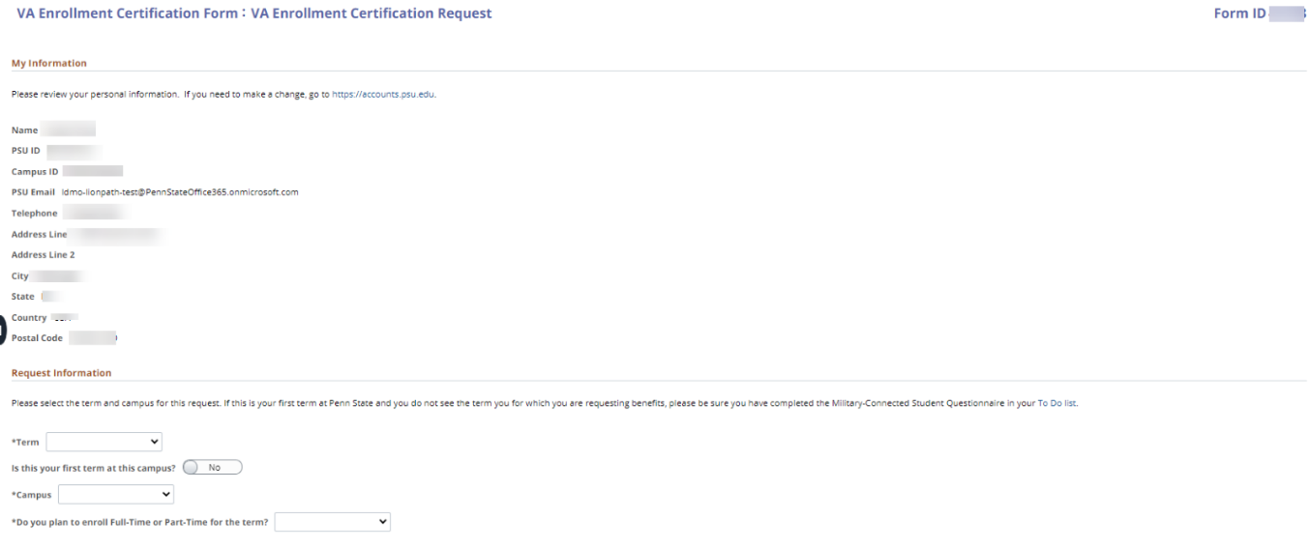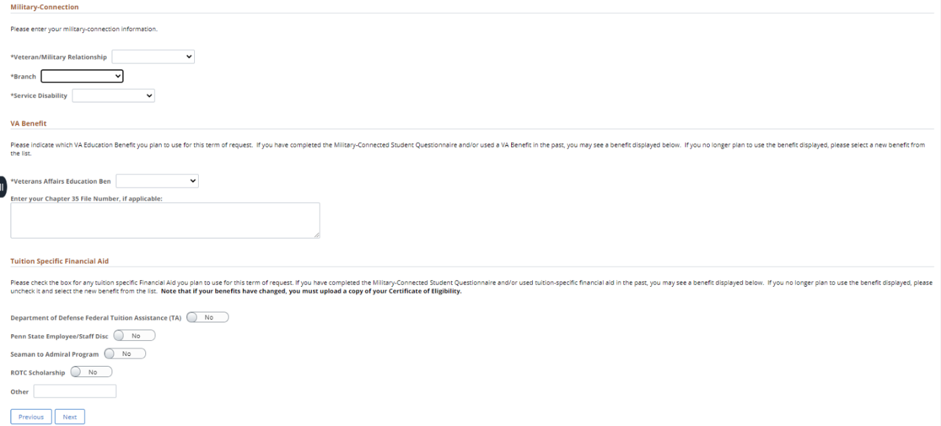
Click Next to go to the next page.
Read all information in the Acknowledgement and enter your initials in the box.
Attach all required documents.
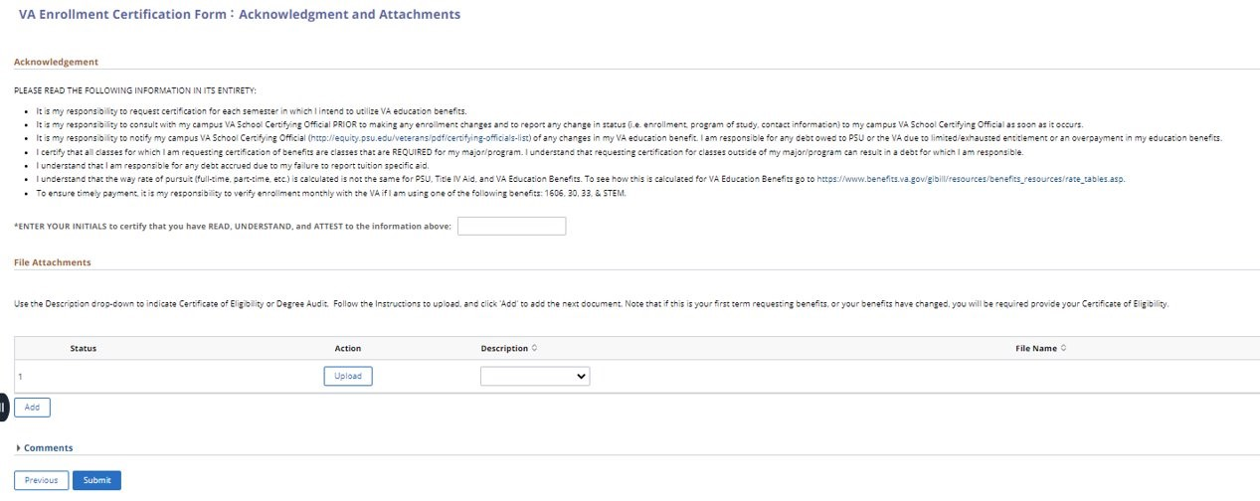
Click Submit to submit your request form. The form will be routed to the School Certifying Officials (SCO) at the campus on your request.
You will receive an email with your Form ID confirming the submission.

Questions about the VA Enrollment Certification Request Form
Please direct any questions about the VA Enrollment Certification Process to your campus School Certifying Official: http://equity.psu.edu/veterans/pdf/certifying-officials-list

Statement of Non-Discrimination
The University is committed to equal access to programs, facilities, admission, and employment for all persons. It is the policy of the University to maintain an environment free of harassment and free of discrimination against any person because of age, race, color, ancestry, national origin, religion, creed, service in the uniformed services (as defined in state and federal law), veteran status, sex, sexual orientation, marital or family status, pregnancy, pregnancy-related conditions, physical or mental disability, gender, perceived gender, gender identity, genetic information, or political ideas. Discriminatory conduct and harassment, as well as sexual misconduct and relationship violence, violates the dignity of individuals, impedes the realization of the University’s educational mission, and will not be tolerated. Direct all inquiries regarding the nondiscrimination policy to the Affirmative Action Office, The Pennsylvania State University, 328 Boucke Building, University Park, PA 16802-5901, Email: aao@psu.edu, Tel 814-863-0471.
END

