Using Update Campus
Students can request a change of campus through LionPATH using the Update Campus application. This application is available to undergraduate degree-seeking students only.

Navigating to the Update Campus Page
- From the Student Home Base, select the Degree Planning and Progress button.
- Select the Update Campus button located in the navigation collection on the left side of the page.

Using Update Campus
The first page of the Update Campus tool displays your current academic information, as well as instructions for completing a Change of Campus (COC) request.
Note: Read these instructions carefully, discuss your academic plans with your academic advisor, and determine when/if a COC is necessary.
If you still wish to request a change of campus after completing the preparatory activities listed on this page, click the Next button. If you decide not to continue with the request, click the Exit button.

Completing the Change of Campus Request
The Change of Campus (COC) Request page displays your current academic information at the top of the screen, followed by a message indicating the semester that the change of campus will take effect. Below this information, there are 4 sections for you to complete.
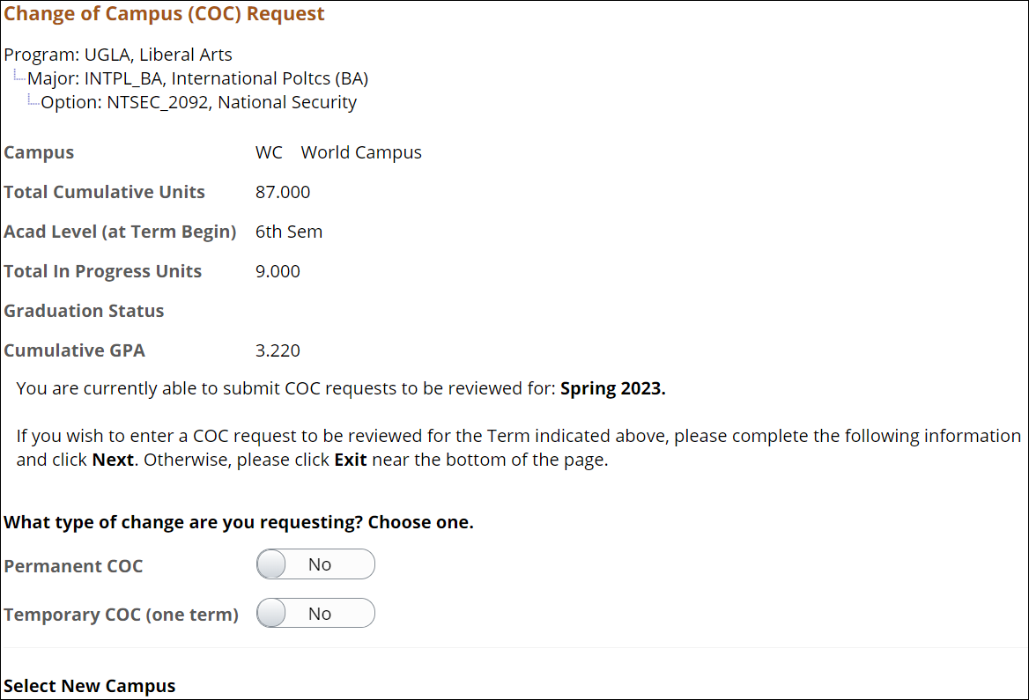
Figure 1: Change of Campus Request page for a student.

Type of Change
You can request either a permanent or a temporary change of campus. A temporary change of campus should be requested when circumstances are such that you need a change to a campus other than your home campus for one semester only. At the end of an approved temporary change of campus, you must return to your home campus.
If you select the Temporary COC option, you will be taken to a page that lists the temporary change of campus policies. In order to continue with the request, you must confirm that you acknowledge and understand the policies by changing the toggle button to Yes and click the Next button. You will be expected to adhere to all policies outlined on this page.

Requested Campus
After selecting the type of change you are requesting, use the drop-down list in the Select New Campus section to select the Campus you are requesting to attend.
Note: If you are requesting a permanent change of campus, you must be able to graduate with your major at the selected campus. If you select a campus that does not accept your major, your request will be denied during the review process. If you have questions about your major, or which campuses can support your major, please contact your academic advisor before completing the change of campus request.

Reason for Change of Campus
The Enter a COC Reason section contains 4 reasons for requesting a change of campus.
Select the radio button to the left of the reason for your request.

Comments
In the Comments section, provide the details of your request. If you are requesting a temporary change of campus for academic reasons, enter the course(s) you plan to take at the requested campus that are not available at your current campus.
Note: These comments will be considered by the person reviewing the request. Please be thoughtful and informative when you provide the reason for requesting a temporary change of campus.
Once you complete the form, click the Next button to review the information you entered into the form.
After verifying the information is correct, click the Submit button.
Note: To make changes to your request, click the Previous button. If you’ve decided not to process the request, click the Exit button.

Request Status
Once the request has been submitted, you will receive immediate notification if you have been approved for an automatic change of campus or if your request has been submitted for review.
Automatic Change of Campus: If you are approved for an automatic change of campus, your student record will be updated immediately, and you will be eligible for enrollment at your new campus as soon as your enrollment appointment opens. You will also receive an email confirming your automatic change of campus approval.
Change of Campus Submitted for Review: If you receive notification that your change of campus request has been submitted for review, please note that this review is a two-part process. First your current college or campus representative approves your request, then the request is forwarded to the requested college or campus for their approval.
- If that approval is granted, you will receive email notification confirming the decision. Your student record will be updated immediately once a decision is made, and you will be able to enroll in classes at your new campus as soon as your enrollment appointment opens.
- If your current college or campus representative, or the requested college or campus representative denies your change of campus request, you will receive email notification of the reason for denial. You should then contact your academic advisor for additional guidance on how best to proceed in your specific situation. If an additional change of campus request is then needed, you can submit it based upon their advice.
Note: At any time, you may log into LionPATH, navigate to the Update Campus tool, and view the status of your request.

Statement of Non-Discrimination
The University is committed to equal access to programs, facilities, admission, and employment for all persons. It is the policy of the University to maintain an environment free of harassment and free of discrimination against any person because of age, race, color, ancestry, national origin, religion, creed, service in the uniformed services (as defined in state and federal law), veteran status, sex, sexual orientation, marital or family status, pregnancy, pregnancy-related conditions, physical or mental disability, gender, perceived gender, gender identity, genetic information or political ideas. Discriminatory conduct and harassment, as well as sexual misconduct and relationship violence, violates the dignity of individuals, impedes the realization of the University’s educational mission, and will not be tolerated. Direct all inquiries regarding the nondiscrimination policy to the Affirmative Action Office, The Pennsylvania State University, 328 Boucke Building, University Park, PA 16802-5901, Email: aao@psu.edu, Tel 814-863-0471.

