Using Update Academics
(Changes to Major(s), Minor(s), Certificates)
Students can use Update Academics to change, add, or remove majors, options, minors, and certificates. Currently this application is available to undergraduate and nondegree students.

Navigating to the Update Academics Page
- From the Student Home Base, select the Degree Planning and Progress button.
- Select the Update Academics button located in the navigation collection on the left side of the page.

Using Update Academics
The first page of the Update Academics tool displays the Instructions. Read these instructions carefully to ensure understanding of any ramifications related to changing your academic record.
If you still wish to make changes to your academic record after completing the preparatory activities listed on this page, click the Continue button. If you decide not to continue with the request, click the Exit button.
The Update Academics tool consists of three steps.

Update Academics: Step One
The first step of the Update Academics tool is to select the type of action you are requesting.
Your current academic information is listed on the left side of the screen. This may include your program, majors, minors and/or certificates. To the right of each section will be the actions. The actions you can request will vary based on your current academic information.
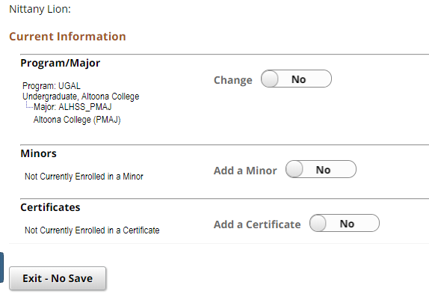
Figure 1: Step 1 of Update Academics

- To request a change of major, set the Change toggle to yes in the Program/Major section. Note: If you are beyond 5th semester standing, or you are requesting a change out of majors that are administratively controlled, are direct-admit, or have a portfolio review requirement, a warning message will be displayed. Read the warning message carefully and cancel the change if you have any concerns.
- Once the Change toggle is set to yes, a link for selecting a program/major will appear. Click the Select Program/Major link to make your selections.
Note: If you wish to exit the application without submitting a request, select the Exit - No Save button.

Update Academics: Identify proposed change
The next step is to identify the proposed change. During this step you will enter the campus offering the major, the academic program, if necessary, and academic plan.
Based on the campus selected additional drop-down menus will be available. For example, if University Park is selected as the ending campus a Select Academic Program drop-down list will display. This list is populated with University Park’s programs (colleges). Once the program is selected, the plans available within that program will be populated and if the selected plan requires an option, they will display in the Select Option(s) menu.
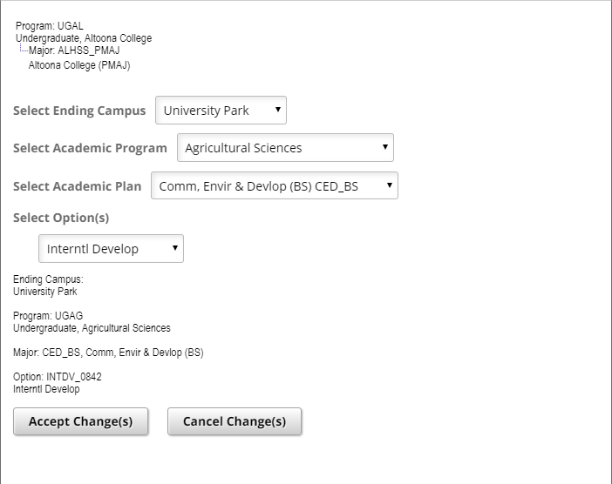
Figure 2: Update Academics proposed changes

- Select an Ending Campus from the drop-down menu. Note: Selecting an Ending Campus populates the majors that are available at that campus. This does not change your campus. For example, if Altoona is selected as the campus, only plans available at Altoona will display.
- Continue to make the selections from the available drop-down boxes.
- Once you have made your selections, click the Accept Change(s) button to continue submitting your request. Your proposed change(s) are displayed for your review.
- Click the Confirm Proposed Change(s) button in order to continue.

Update Academics: Step Three
The final step is to confirm that you have read the statement regarding tuition recalculation. Clicking the tuition recalculation link will help you determine if your proposed major has a different tuition rate than your current one.
- Click the Confirm and Submit button in order to continue.
- You will receive a message telling you that your request has been submitted. Click the OK button to see the progress of your request.
The status of your request is displayed on the last screen. Possible statuses include Approved, Conditional Approval, Dean’s Review, or Denial.
Approved indicates the change will go into effect for the current term, or if there is already something on your record in the future, for that future term. The change will be visible in LionPATH based on that date.
Conditional Approval indicates enrollment in remaining entrance courses in the current term. The entrance requirements that must be successfully completed will be listed in the message. Upon successful completion of entrance requirements, a conditional approval will change to a permanent approval. If requirements were not successfully completed, the student would be changed back to their prior academic status.
Dean’s Review indicates that the college needs to evaluate the request manually. Some reasons for a Dean’s Review include adding a major, different entrance criteria for transfer or nondegree-to-degree students, or specialized entrance requirements. Once the college affiliated with a Dean’s Review request has acted upon the request, students will be notified through their Penn State email.
Denial indicates that the requirements were not met. The message will include the reason why the request was not granted.
If you were approved for a major inconsistent with your current campus, you will receive a message indicating whether or not you have enough credits for a change of campus. If you have completed enough credits to be considered for a change of campus, the message will display with the necessary next steps.
Note: The Update Academics tool does not change a student’s campus.

Statement of Non-Discrimination
The University is committed to equal access to programs, facilities, admission, and employment for all persons. It is the policy of the University to maintain an environment free of harassment and free of discrimination against any person because of age, race, color, ancestry, national origin, religion, creed, service in the uniformed services (as defined in state and federal law), veteran status, sex, sexual orientation, marital or family status, pregnancy, pregnancy-related conditions, physical or mental disability, gender, perceived gender, gender identity, genetic information or political ideas. Discriminatory conduct and harassment, as well as sexual misconduct and relationship violence, violates the dignity of individuals, impedes the realization of the University’s educational mission, and will not be tolerated. Direct all inquiries regarding the nondiscrimination policy to the Affirmative Action Office, The Pennsylvania State University, 328 Boucke Building, University Park, PA 16802-5901, Email: aao@psu.edu, Tel 814-863-0471.

