LionPATH: Swapping a Class

Swapping a class provides a way for you to drop a class you are currently enrolled in and replace it with a new class. Since this process is done simultaneously, it is a way to keep your space in the enrolled class while trying to enroll in a new class.

Navigating to the Swap Classes Page
- From Student Home Base, select the Enrollment button.
- Select the Swap Classes button located in the navigation collection on the left side of the page.
- If prompted, select the term in which you would like to swap a class and select the Continue button.

Swapping a Class
- In the Swap This Class section, select the class you wish to drop from the drop-down menu.
- Enter the class number, of the class you want to add, in the Enter Class Nbr field and select the Enter button. (You can also locate the new class by using the class search or selecting a class from your shopping cart.)

NOTE: Students are advised not to set up a Swap for classes that have a related Class Component (e.g., required lecture and recitation) they are already enrolled in. This scenario may cause the Swap to fail, and students may be unintentionally dropped from their original class without getting swapped into the desired class.

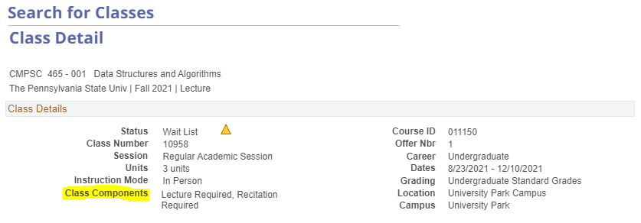

- Once you select the desired class, the Enrollment Preferences page appears. This page contains the details of the class section. Select the Next button.
- To complete the process and swap the selected classes, select the Finish Swapping button.
Review the results to verify you have successfully dropped the class and are enrolled in the desired class. You can select the My Class Schedule button to view your schedule.

Statement of Non-Discrimination
The University is committed to equal access to programs, facilities, admission, and employment for all persons. It is the policy of the University to maintain an environment free of harassment and free of discrimination against any person because of age, race, color, ancestry, national origin, religion, creed, service in the uniformed services (as defined in state and federal law), veteran status, sex, sexual orientation, marital or family status, pregnancy, pregnancy-related conditions, physical or mental disability, gender, perceived gender, gender identity, genetic information or political ideas. Discriminatory conduct and harassment, as well as sexual misconduct and relationship violence, violates the dignity of individuals, impedes the realization of the University’s educational mission, and will not be tolerated. Direct all inquiries regarding the nondiscrimination policy to the Affirmative Action Office, The Pennsylvania State University, 328 Boucke Building, University Park, PA 16802-5901, Email: aao@psu.edu, Tel 814-863-0471.

