Student Health Insurance Plan (SHIP)
Penn State requires all full-time U.S. students to submit their current health insurance coverage information to the University. All international students are required to provide proof of health insurance coverage that meets University requirements or purchase the Penn State Student Health Insurance plan (SHIP).
Note: After registering for classes, students will have the ability to enter health insurance coverage information through LionPATH.
To learn more about health insurance coverage at Penn State, visit the Penn State Student Affairs Health & Wellness website at https://studentaffairs.psu.edu/health-wellness/health-insurance.

Navigating to the Health Insurance Page
- From the Student Home Base, select the My Information button.
- Select the Health Insurance button located in the navigation collection on the left side of the page.
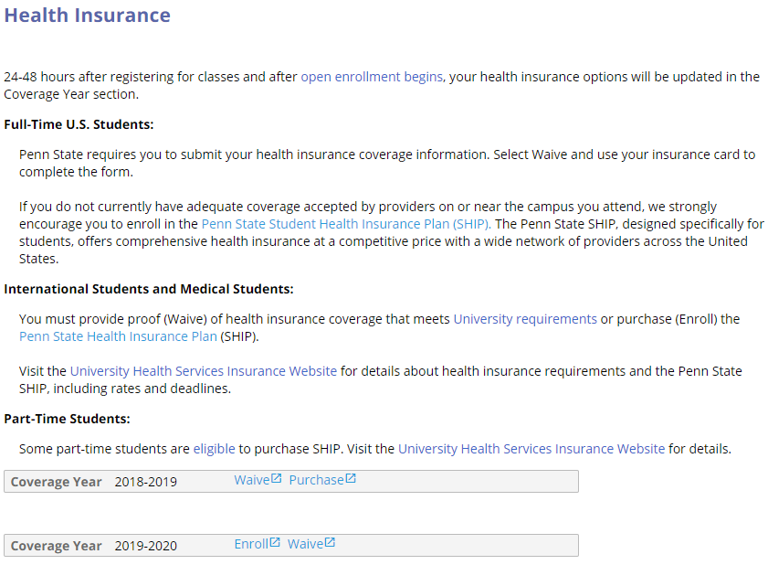
Figure 1: Health Insurance page with the 2018/2019 and 2019/2020 Coverage Year displayed.

Coverage Year Status
If you are eligible for the Penn State Student Health Insurance Plan (SHIP), you will see the Enroll and Waive links or Waive and Purchase links.
Note: Required Students (International and Medical) will see the Enroll link. Other students who can voluntarily enroll will see the Purchase link instead of the Enroll link.
If you have a current health insurance plan that covers you at your campus health center/clinic or with local providers in the campus community, select the Waive link to enter the details about your current plan.
Clicking on the Waive link will open a new browser window and display the United Healthcare Student Resources site. Enter your information as prompted to complete the process of waiving the insurance for the Coverage Year.
If you do not have health insurance coverage at the campus you attend, you may purchase the Penn State Student Health Insurance Plan (SHIP) by selecting the Purchase or Enroll link.
Note: The Purchase link will take you to the First Student College Student Health Insurance website, where you will be able to complete the purchase. The Enroll link will take you to the United Healthcare Student Resources site for the campus you are attending.

Statement of Non-Discrimination
The University is committed to equal access to programs, facilities, admission, and employment for all persons. It is the policy of the University to maintain an environment free of harassment and free of discrimination against any person because of age, race, color, ancestry, national origin, religion, creed, service in the uniformed services (as defined in state and federal law), veteran status, sex, sexual orientation, marital or family status, pregnancy, pregnancy-related conditions, physical or mental disability, gender, perceived gender, gender identity, genetic information or political ideas. Discriminatory conduct and harassment, as well as sexual misconduct and relationship violence, violates the dignity of individuals, impedes the realization of the University’s educational mission, and will not be tolerated. Direct all inquiries regarding the nondiscrimination policy to the Affirmative Action Office, The Pennsylvania State University, 328 Boucke Building, University Park, PA 16802-5901, Email: aao@psu.edu, Tel 814-863-0471.

