Using the Enrollment Shopping Cart

The LionPATH Enrollment Shopping Cart is where you can create and maintain your class sections for the upcoming term. It is used to temporarily save classes until it is time to enroll for the term.
Note: Placing a class in your shopping cart does not mean a space will be held for you in the class.

Navigating to the Shopping Cart
- From the Student Home Base, select the Enrollment button.
- Select the Enrollment Shopping Cart button located in the navigation collection on the left side of the page.
- Select the term.

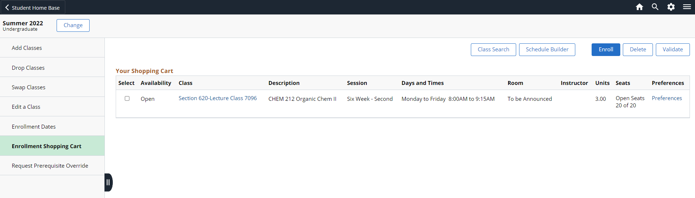
Figure 1: A student’s Enrollment Shopping Cart page displaying a table of classes in the shopping cart, search options, and shopping cart functions.

You can add classes to your shopping cart by accessing Class Search or Schedule Builder directly from your Enrollment Shopping Cart.

Alternatively, you can add classes to your Enrollment Shopping Cart using a class number, searching for a class, or by selecting classes from your planner on the Add Classes page. See the Adding a Class Using the Add Classes Page for additional details.

Adding a Class to your Shopping Cart: Using Class Search
You can add a class to your shopping cart by searching for classes using Class Search.
- Select the Class Search button.
- Enter your search criteria into the Class Search and Additional Search Criteria sections.
- After all the criteria are selected, select the Search button to view the filtered class list.
- Locate the class section that you want to schedule and click the Select button. If there are preferences available for the class (for example, Wait List), those preferences can be indicated at this time. Preferences can also be viewed and set from the Enrollment Shopping Cart.
- To finish adding the class to your schedule, select the Next button.

Your Enrollment Shopping Cart page will open. A confirmation message appears, and the class is displayed in your shopping cart. Additional class information details can be viewed by selecting the Class section label.
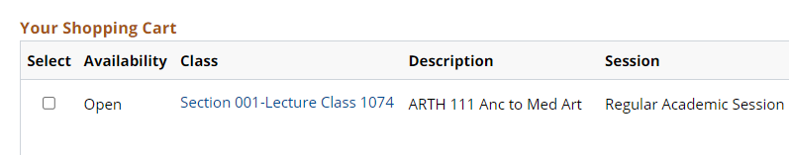
Figure 2: The section label in the Class column displays as a link. When opened, a pop-up will display additional class information.
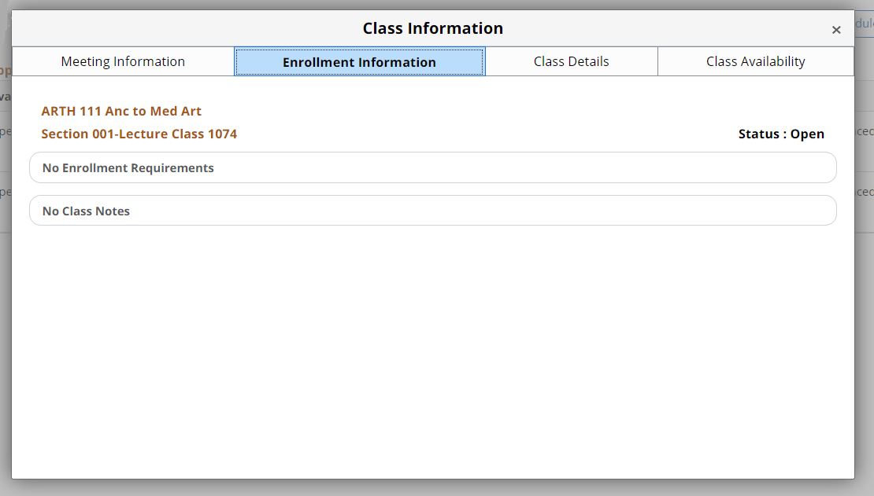
Figure 3: The Class Information pop-up with tabs for Meeting Information, Enrollment Information, Class Details, and Class Availability.
Note: Remember that placing a class in your shopping cart does not mean a space will be held for you in the class. The Enrollment Shopping Cart is used to temporarily save your desired classes until it is time to enroll for the term.

Adding a Class to your Shopping Cart: Using Schedule Builder
You can add a class to your shopping cart by searching for classes using Schedule Builder.
- Select the Schedule Builder button. More details on how to use Schedule Builder can be found in the Accessing Schedule Builder and Overview of Schedule Builder help documents.
- After you have selected classes and generated your desired schedule, you can validate the classes in Schedule Builder by selecting the Validate button. A pop-up window will display with the results of the validation. The displayed messages provide additional information that you should be aware of, be sure to read the message(s) carefully. Review the validation results and make any necessary changes.
- Once you have completed your class selection(s) in Schedule Builder, select the Send to Enrollment Cart button. If there are preferences available for the class (for example, Wait List), those preferences can be indicated at this time. Preferences can also be viewed and set from the Enrollment Shopping Cart. A pop-up message will display the Enrollment Cart results. Select Close to remain in Schedule Builder or select Continue to exit Schedule Builder.

Close the Schedule Builder tab and return to the LionPATH tab. Select the Enrollment Shopping Cart from the Enrollment navigation collection to view the classes in your shopping cart. Additional class information details can be viewed by selecting the Class section label (see Figure 2 and 3).

Note: Remember that placing a class in your shopping cart does not mean a space will be held for you in the class. The Enrollment Shopping Cart is used to temporarily save your desired classes until it is time to enroll for the term.

Setting your Enrollment Preferences
Preferences, when available for a class, can be set from the Enrollment Shopping Cart.
- Select the Preferences link that corresponds to the class where you would like view or update your preferences.
- A Preferences pop-up window will appear. If preferences (like a Wait List) are available for the class, you can set your preferences. Select Cancel to close the pop-up window without making changes or select Save to save your changes and close the pop-up window.

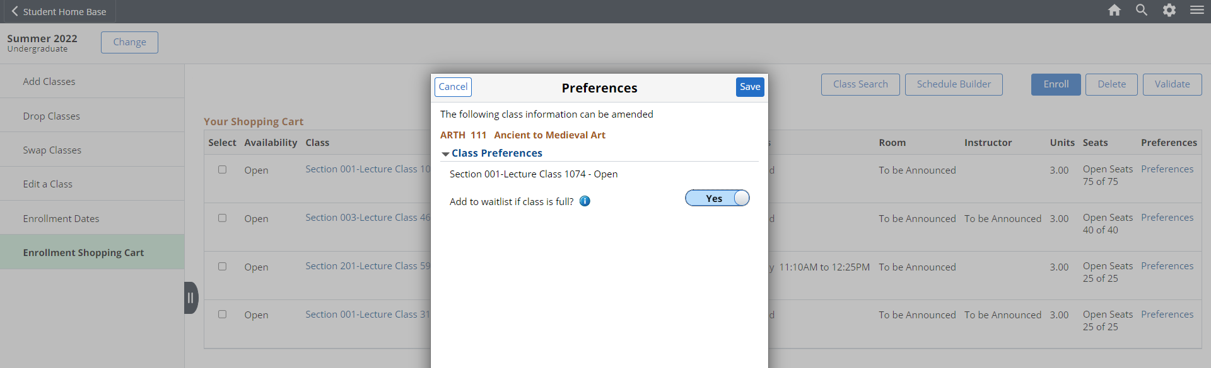
Figure 4: A Preferences pop-up window displaying in the student’s Enrollment Shopping Cart. Class preferences such as ‘Add to waitlist if class is full?’ can be set in the Preferences window.

Completing the Enrollment Process: Validate Classes
Items placed in the Enrollment Shopping Cart should be validated before enrolling to check for common problems such as time conflicts and prerequisites.
- Select the classes you want to check by checking the box for each class and then select the Validate button.
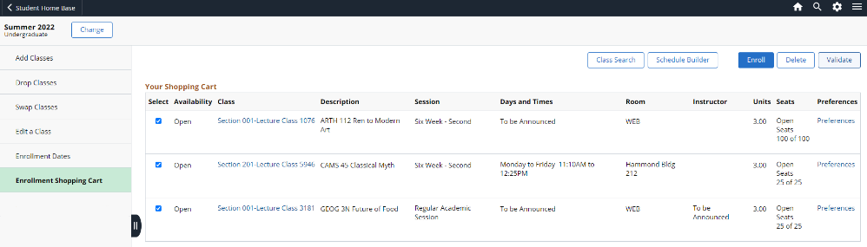
Figure 5: A student’s Enrollment Shopping Cart page displaying a table of classes in the shopping cart. Several classes have been selected for validation.
A page will display with the results of the validation. A green checkmark will let you know if the class is ok to add or you will see a red X if there is a potential problem. A message provides additional information that you should be aware of, be sure to read the message(s) carefully. Review the validation results and make any necessary changes.

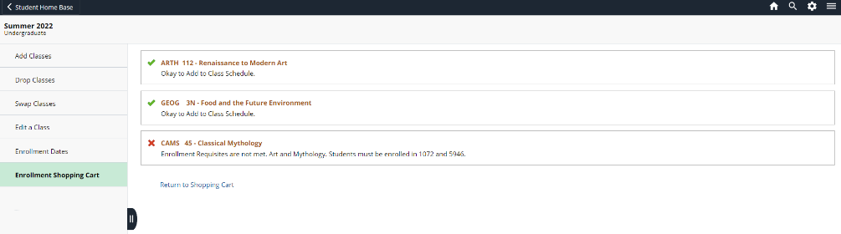
Figure 6: Validation results and messages displaying in the Enrollment Shopping Cart. A ‘Return to Shopping Cart’ link appears below the results.
- Select the Return to Shopping Cart link to return to the shopping cart where you can complete the enrollment process.

Completing the Enrollment Process: Enrolling in Classes
- Once your enrollment appointment is active, select the class(es) you wish to schedule and select the Enroll button.
- To complete the process and add the courses to your schedule, select Yes in the enrollment confirmation popup.

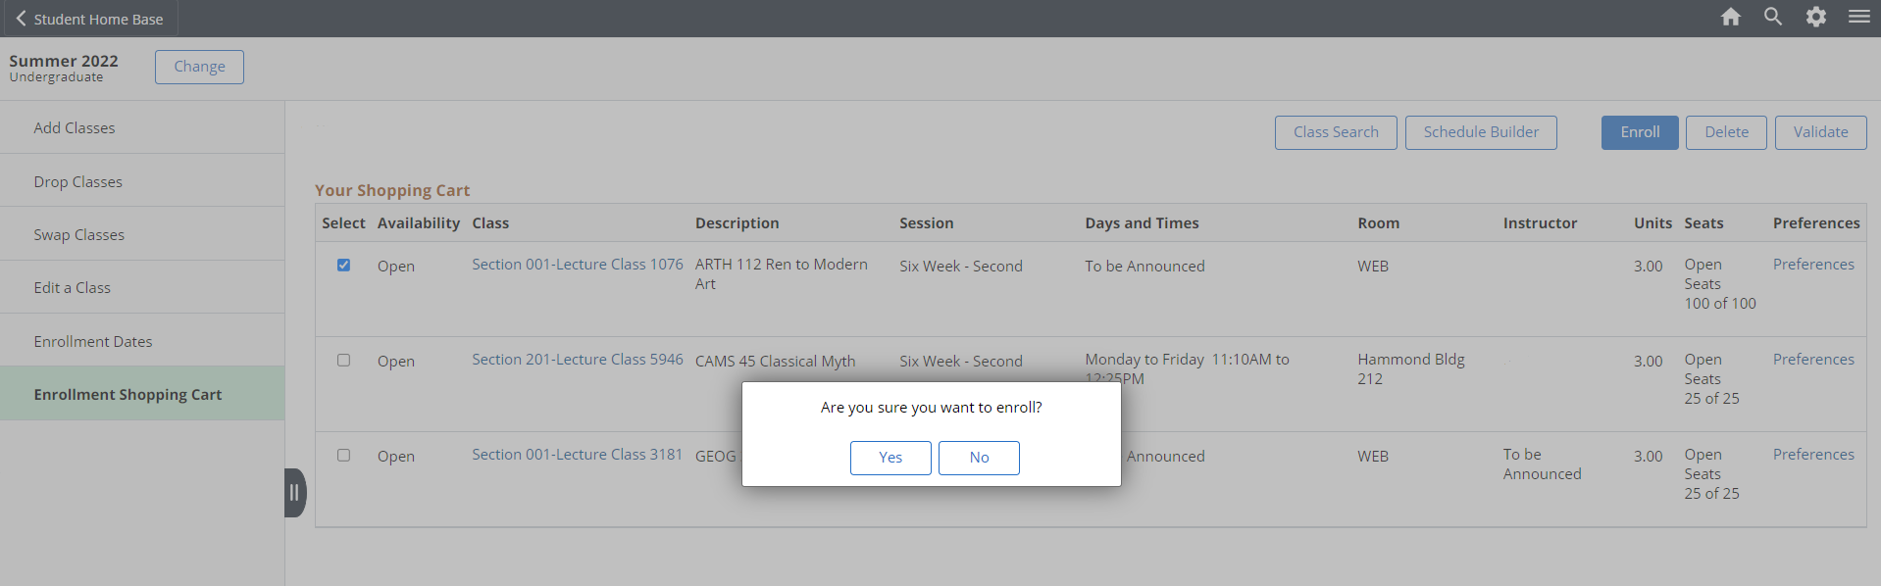
Figure 7: A confirmation popup displaying in the Enrollment Shopping Cart.
- Review the results to verify you have successfully enrolled in the selected classes.

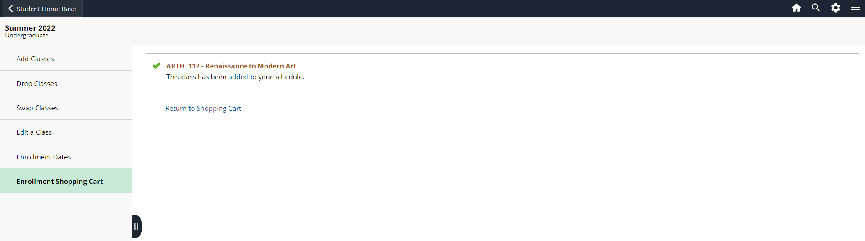
Figure 8: Enrollment results displaying in the Enrollment Shopping Cart.
Once you are finished verifying the results, you can select Return to Shopping Cart and add additional classes or return to your Student Home Base to view your schedule.

Statement of Non-Discrimination
The University is committed to equal access to programs, facilities, admission, and employment for all persons. It is the policy of the University to maintain an environment free of harassment and free of discrimination against any person because of age, race, color, ancestry, national origin, religion, creed, service in the uniformed services (as defined in state and federal law), veteran status, sex, sexual orientation, marital or family status, pregnancy, pregnancy-related conditions, physical or mental disability, gender, perceived gender, gender identity, genetic information or political ideas. Discriminatory conduct and harassment, as well as sexual misconduct and relationship violence, violates the dignity of individuals, impedes the realization of the University’s educational mission, and will not be tolerated. Direct all inquiries regarding the nondiscrimination policy to the Affirmative Action Office, The Pennsylvania State University, 328 Boucke Building, University Park, PA 16802-5901, Email: aao@psu.edu, Tel 814-863-0471.

