Set Delegate Access
Delegated Access is the process by which a student can delegate the ability to view a selection of their student data to other individuals. The student can determine who they wish to delegate to, what areas they wish to provide access to, and ultimately, activate and deactivate those delegates, as needed.
The student may provide delegated access in LionPATH to the following areas:
- Enrollment Verification Requests
- Financial Aid
- My Grades
- Holds
- My Class Schedule
- To Do List

Navigating to Guardian Access Page
- From the Student Home Base, select the My Information button.
- Select the Grant Delegated Access button located in the navigation collection on the left side of the page.

Entering the Delegate’s Contact Information
In order to delegate access to an individual, you must be able to enter their first and last name, and a valid email address. This should be the email address they wish to use for managing their delegated access.
- From the Delegate Access page, select the Create New Delegate link located.
- You must first accept the privacy statement by selecting the Privacy Statement Accepted checkbox and then clicking the OK button.
- Enter the appropriate information into the Contact Information fields. Note: It is critical that the email address is correct. Essential login details and the link to access LionPATH will be sent to the entered email address.
- Select the appropriate Relationship from the drop-down menu. This is the relationship of the delegate to the student. For example, you would select Parent from the drop-down menu if you are entering your mother’s information.
- Once complete, click the Next button.

Granting Access to Specific Items
The delegate’s name is now displayed above the table.
- Select the checkboxes in the Access column next to each area that you want to give the delegate the ability to view. Note: You may give any combination of access to each delegate you identify, though the areas in this table are the only areas which can be delegated. This access can be altered or deactivated at any time.
- Select the Next button to activate the delegate’s access and generate the email to notify them.
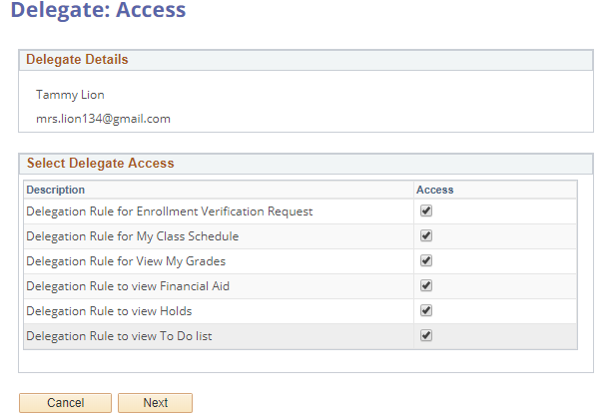
Figure 1: Guardian Delegation Access page

Sending a Notification Email
The delegate’s email address is populated, and the body of the email is automatically generated. The email contains a login ID, password, and a link for the delegate to access LionPATH.
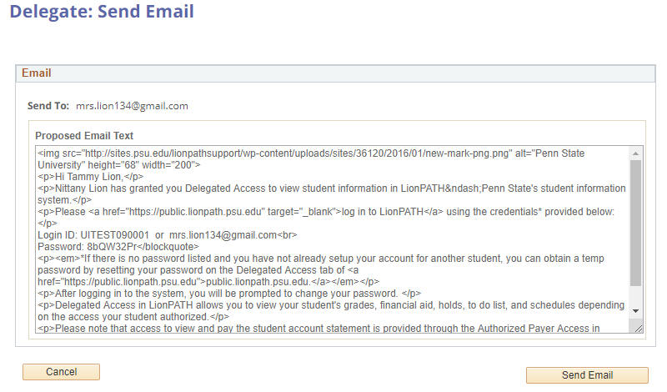
Figure 2: Email template
Note: The email text is not editable.
- Click the Send Email button to send the email.
- A confirmation message appears, select the OK button to return to the delegation screen.
Selecting the Create New Delegate link will open a blank delegate screen where you can add additional delegates to your record.
Note: There is no limit to the number of delegates you can have.

Modifying Delegate Access
You can adjust the access of your delegates at any time.
- Clicking on a delegate’s name will allow you to make changes to their access.

To alter a delegate’s access, add or remove checkmarks in the Access column and select the Save button.
Note: You do not need to click the Activate/Notify button when you change access levels. The delegate will simply see a different set of data the next time they login.
Deactivating a delegate’s access will prevent the delegate from logging in using their credentials. You can deactivate a delegate by clicking the Deactivate button, then the Save button.
Note: Deactivation isn’t permanent. A delegate can easily be activated again using the Activate button that will appear once the delegate is deactivated.

Statement of Non-Discrimination
The University is committed to equal access to programs, facilities, admission, and employment for all persons. It is the policy of the University to maintain an environment free of harassment and free of discrimination against any person because of age, race, color, ancestry, national origin, religion, creed, service in the uniformed services (as defined in state and federal law), veteran status, sex, sexual orientation, marital or family status, pregnancy, pregnancy-related conditions, physical or mental disability, gender, perceived gender, gender identity, genetic information or political ideas. Discriminatory conduct and harassment, as well as sexual misconduct and relationship violence, violates the dignity of individuals, impedes the realization of the University’s educational mission, and will not be tolerated. Direct all inquiries regarding the nondiscrimination policy to the Affirmative Action Office, The Pennsylvania State University, 328 Boucke Building, University Park, PA 16802-5901, Email: aao@psu.edu, Tel 814-863-0471.

