Searching for Classes
The class search is used to locate classes within a specific term.

Navigating to the Class Search Page
- From the Student Home Base, select the Find Classes button.

Entering Class Search Criteria
The search parameters are used to narrow down your results. You must select at least 2 criteria.
- If you are looking for a class outside of the current term, make sure the appropriate term is selected. Note: A term must always be selected in order to perform a search.

- Enter your search criteria into the Class Search sections. When entering your search criteria, it is best to work from top to bottom.
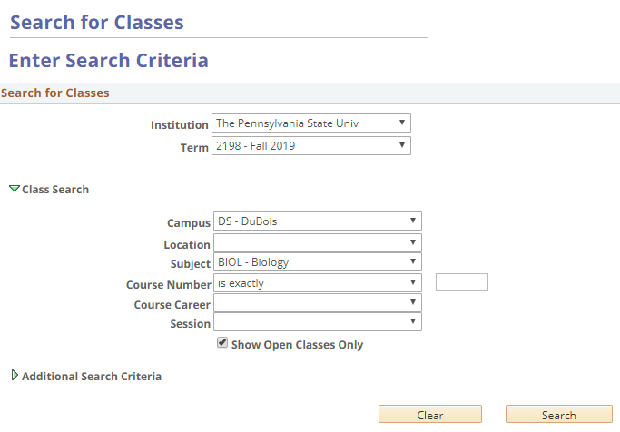
Figure 1: The Search for Classes page
The Show Open Classes Only checkbox is checked by default. If you want to also display classes that are closed or have a wait list, uncheck this box.

Entering Additional Search Criteria
The additional search criteria fields allow you to narrow down the search based on multiple variables. You can search for classes that meet specific criteria such as meeting times and days of the week, number of units (credits), classes that fulfill specific requirements (i.e., General Education, US/IL Cultures, Bachelor of Arts, etc.), and more.
- To display additional search options, expand the additional search criteria section by selecting the green arrow to the left of Additional Search Criteria.
- Once all the criteria are selected, select the Search button.
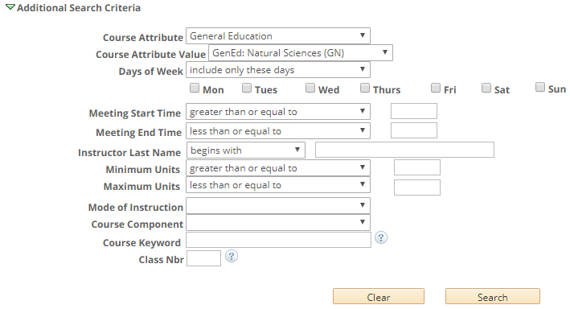
Figure 2: Additional Search Criteria
The class section(s) that match the search criteria will display. Information for each class section is displayed showing the meeting dates and times, room assignment, instructor, and section status. Each class section will display a status icon indicating the availability of the class. A status legend is displayed at the top of the search results, describing each status icon.
The select button, to the right of each class, allows you to place the class into your shopping cart if you have an open Shopping Cart (Validation) Appointment and/or Enrollment Appointment.
From the Search Results page, you can select the Modify Search button to return to your currently selected search criteria. Use the New Search button to clear your current search criteria and begin a new search.
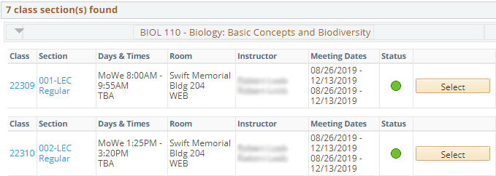
Figure 3: The Search Results page with the class sections displayed

Viewing Class Details
The Class Details page contains the meeting and enrollment information, class availability, course description, textbook information when it’s made available, and additional details.
- Select the Class or Section link to open the Class Details page for that specific section.
The View Search Results and Select Class buttons are available at the bottom of the page. The Select Class button will allow you to add the class to your shopping cart if you have an open Shopping Cart (Validation) Appointment and/or Enrollment Appointment. Select the View Search Results button to return to the listing of classes that met your search criteria.
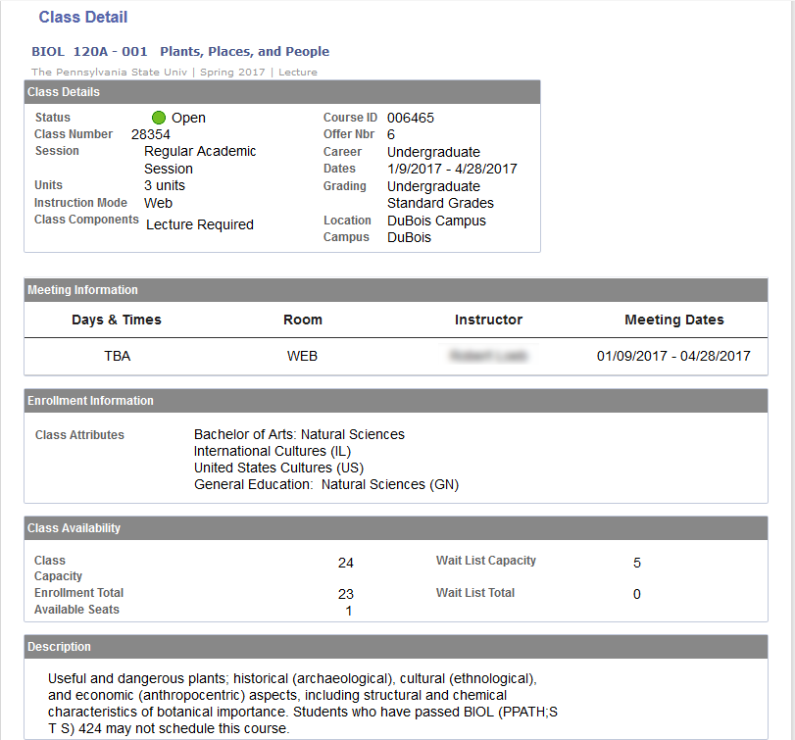
Figure 5: Class Detail page
To return to the listing of classes that met your search criteria, select the View Search Results button.

Statement of Non-Discrimination
The University is committed to equal access to programs, facilities, admission, and employment for all persons. It is the policy of the University to maintain an environment free of harassment and free of discrimination against any person because of age, race, color, ancestry, national origin, religion, creed, service in the uniformed services (as defined in state and federal law), veteran status, sex, sexual orientation, marital or family status, pregnancy, pregnancy-related conditions, physical or mental disability, gender, perceived gender, gender identity, genetic information or political ideas. Discriminatory conduct and harassment, as well as sexual misconduct and relationship violence, violates the dignity of individuals, impedes the realization of the University’s educational mission, and will not be tolerated. Direct all inquiries regarding the nondiscrimination policy to the Affirmative Action Office, The Pennsylvania State University, 328 Boucke Building, University Park, PA 16802-5901, Email: aao@psu.edu, Tel 814-863-0471.

