Schedule Builder: Accessing Schedule Builder
Schedule Builder can be used to conduct a class search, examine course offerings and plan course schedules. There are several locations within LionPATH where you can access Schedule Builder.

Navigating to Schedule Builder Using Find Classes
- From the Student Home Base, select the Find Classes button.
- Select the Schedule Builder button located in the navigation collection on the left side of the page.
- Once the Schedule Builder tab opens you can select a term and start planning your schedule.

Navigating to Schedule Builder Using Quick Links
1. From the Quick Links on the Student Home Base, select Schedule Builder.
2. Once the Schedule Builder tab opens you can select a term and start planning.

Navigating to Schedule Builder Using Enrollment
- From the Student Home Base, select the Enrollment button.
- Select the Add Classes button located in the navigation collection on the left side of the page. Alternatively, you could select the Enrollment Shopping Cart button from the navigation collection.

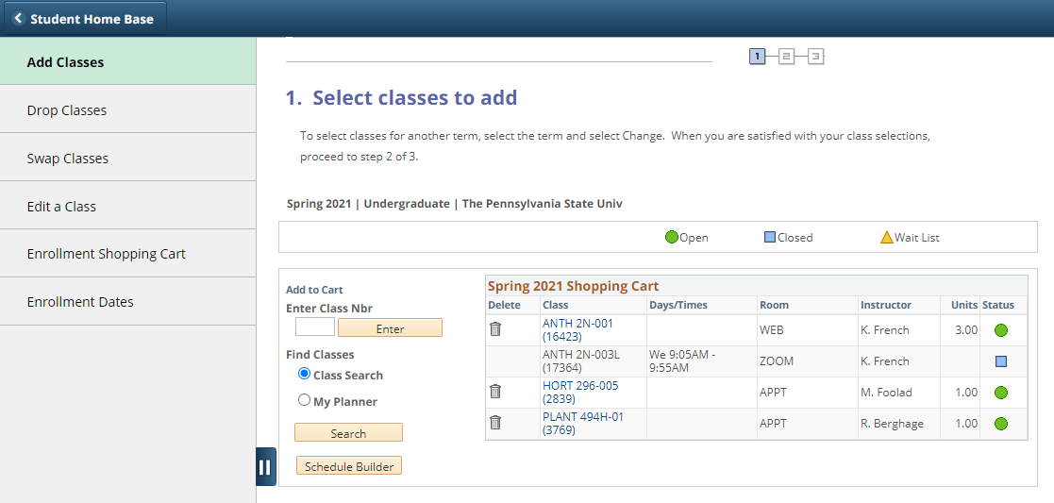
Figure 1: Navigating to Schedule Builder via Enrollment

- On the Add Classes page, you can choose to search for classes using Schedule Builder. The Schedule Builder button appears in the lower left corner of your Shopping Cart.
- Once the Schedule Builder tab opens you can select a term and start planning your schedule.

Statement of Non-Discrimination
The University is committed to equal access to programs, facilities, admission, and employment for all persons. It is the policy of the University to maintain an environment free of harassment and free of discrimination against any person because of age, race, color, ancestry, national origin, religion, creed, service in the uniformed services (as defined in state and federal law), veteran status, sex, sexual orientation, marital or family status, pregnancy, pregnancy-related conditions, physical or mental disability, gender, perceived gender, gender identity, genetic information or political ideas. Discriminatory conduct and harassment, as well as sexual misconduct and relationship violence, violates the dignity of individuals, impedes the realization of the University’s educational mission, and will not be tolerated. Direct all inquiries regarding the nondiscrimination policy to the Affirmative Action Office, The Pennsylvania State University, 328 Boucke Building, University Park, PA 16802-5901, Email: aao@psu.edu, Tel 814-863-0471.

