Running a What-if Report

A What-if report is used to request an Academic Requirements report for a plan other than the one(s) in which you are currently enrolled. This report also allows you to select courses in which you are not enrolled and see how they count toward degree progress.

Navigating to the What-if Report Page
- From the Student Home Base, select the Degree Planning and Progress button.
- Select the What-If-Report button located in the navigation collection on the left side of the page.

Running a What-if Report
The What-if Report Selection page will appear. If you have previously run a What-if Report, a link with the date of the most recent copy will display. Selecting a date link will allow you to view that previously created report.
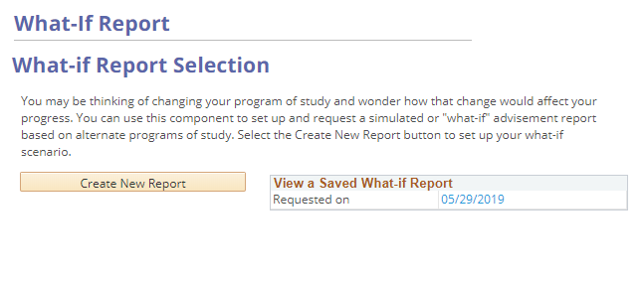
Figure 1: The What-if Report page

What-if Scenario
When running a What-if Report you will need to define the what-if scenario, including the academic plan you want to explore.
Note: For additional information, refer to definitions of the terms displayed on the Create What-if Scenario page
- Select the Create New Report button to create a new What-if Report.
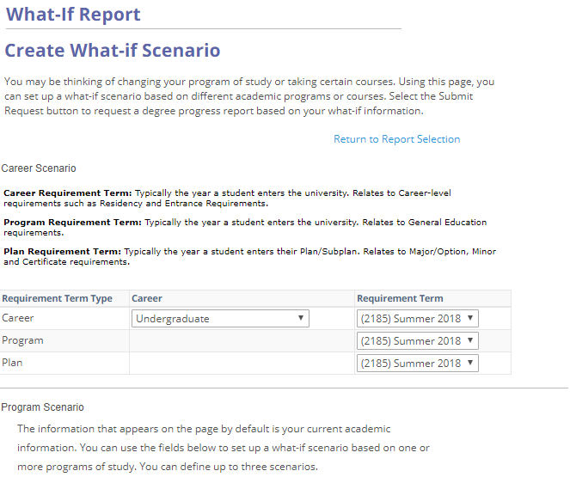
Figure 2: The Create What-if Scenario page displaying the Career Scenario
- Review the Career, Program, and Plan Requirement Terms in the Career Scenario section and make any necessary changes.
- In the Program Scenario section choose the Academic Program, Plan and, if appropriate, Subplan for up to 3 plans of interest. By default, this area will populate with your current Program and Plan information.
- The Course Scenario section will allow you to choose specific course(s), if desired. Select the browse course catalog button to locate courses you would like to include in your what-if scenario. Courses entered here will appear in the In Progress Courses section of the degree audit with a Status of “?”. Note: Refer to the Browse Course Catalog tutorial for additional information on navigating the course catalog.
- Select the Submit Request button to retrieve your What-if Report.
A degree audit for your scenario will displayed. This new What-if Report is available in your saved What-if Report section and can be viewed in the future if needed.
Note: Refer to the Interpreting a Degree Audit tutorial for help in understanding the degree audit.

Statement of Non-Discrimination
The University is committed to equal access to programs, facilities, admission, and employment for all persons. It is the policy of the University to maintain an environment free of harassment and free of discrimination against any person because of age, race, color, ancestry, national origin, religion, creed, service in the uniformed services (as defined in state and federal law), veteran status, sex, sexual orientation, marital or family status, pregnancy, pregnancy-related conditions, physical or mental disability, gender, perceived gender, gender identity, genetic information or political ideas. Discriminatory conduct and harassment, as well as sexual misconduct and relationship violence, violates the dignity of individuals, impedes the realization of the University’s educational mission, and will not be tolerated. Direct all inquiries regarding the nondiscrimination policy to the Affirmative Action Office, The Pennsylvania State University, 328 Boucke Building, University Park, PA 16802-5901, Email: aao@psu.edu, Tel 814-863-0471.

