Paying Your Bill
You will have access to make an online payment using a credit card or electronic check through the Penn State Student Account Dashboard.
The first bill of the semester is due after the regular drop/add period of that term and enrolled course(s). All other monthly statements (September, October, and November) will have a due date on the 22nd of the month. Refer to the Penn State Office of the Bursar website at https://bursar.psu.edu for tuition due dates.
Note: If you have set up an Authorized Payer, they may make a payment on your behalf. Refer to the Adding an Authorized Payer tutorial for more information.

Navigating to The Penn State Student Account Dashboard
- From the Student Home Base, select the My Finances button.
- On the My Account page, select the Manage My Account / Make a Payment button.

Penn State Student Account Dashboard
The Your Account section will display a real time summary of your account including all activity since your last statement.
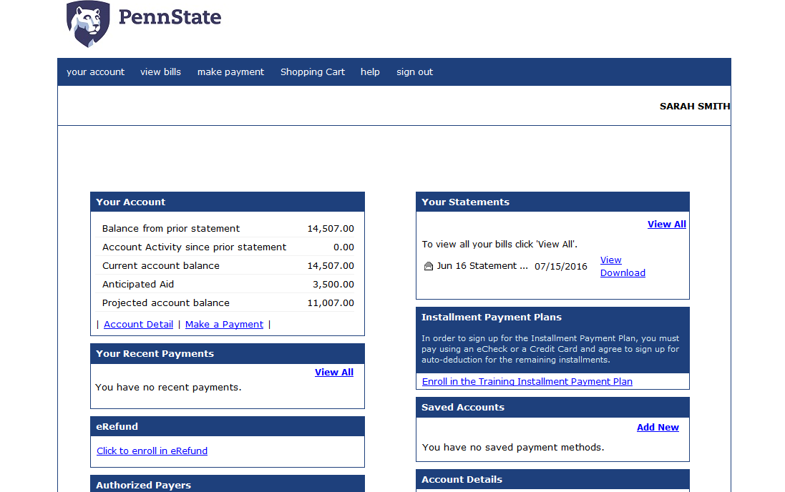
Figure 1: The Penn State Student Account Dashboard

Selecting the Charges to pay
The charges on your account will be listed in the Payment Window.
- Select the Make a Payment link to open the payment window.
- Select on the Term link.
- The Amount field will populate with your current account balance. Select the Add to Shopping Cart button to put this payment in your shopping cart.
- Select the Checkout button to make the payment. Note: You can Edit or Delete a payment using the links provided.

Entering Payment Information
You can make an online payment using a credit card or electronic check through Penn State Student Account Dashboard.
- Select the radio button to the left of the payment method you would like to use for this payment. Note: If you have setup a saved payment method previously, it will appear in the list as an option.
- Select the Continue Checkout button.

Credit Card Payments
A service fee applies to all credit card transactions. This service fee will be assessed at the time the payment is applied to your credit card.
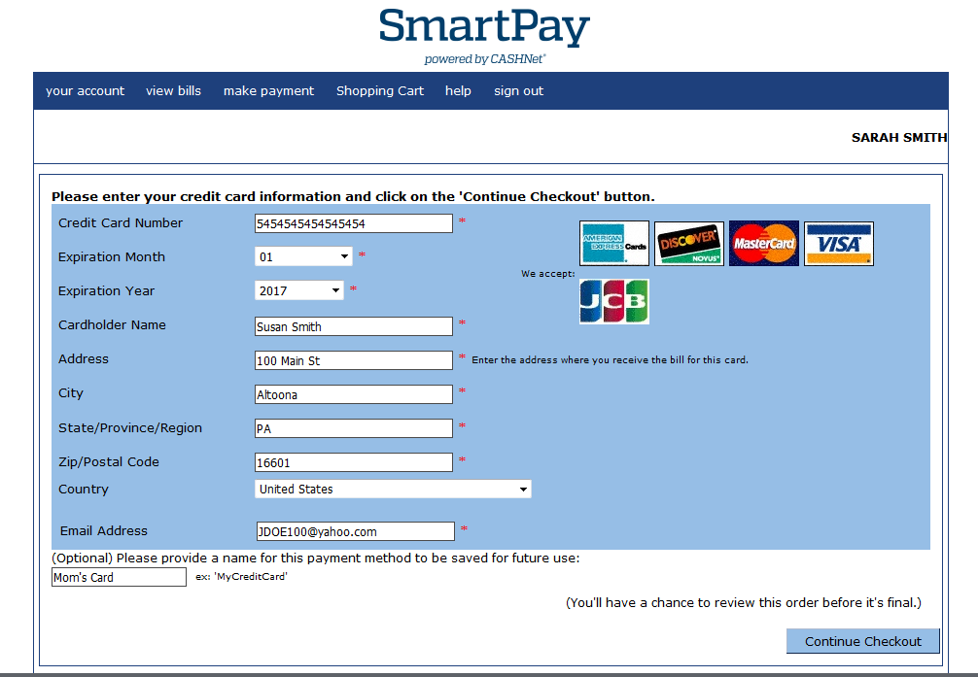
Figure 2: Payment information form

- Complete the form by entering the appropriate information into the fields provided. Note: The fields with an asterisk to the right are required.
- If you would like to make this a saved payment option that you can use again, enter a familiar name into the field provided.
- Select the Continue Checkout button.
- Select the checkbox to accept the terms and conditions.
- Select the Continue Checkout button.
- A summary of the transaction is displayed including any Service Charge for credit card transactions. Select the Submit Payment button to process the payment.
Your receipt will be displayed including a message indicating that a copy was emailed to the address listed.

Electronic Check Payments
There are no additional fees assessed on electronic check transactions.
- Complete the form by entering the appropriate information into the fields provided. Note: The fields with an asterisk to the right are required.
- If you would like to make this a saved payment option that you can use again, enter a familiar name into the field provided.
- Select the Continue Checkout button.
- Select the checkbox to accept the terms and conditions.
- Select the Continue Checkout button.
- A summary of the transaction is displayed. Select Submit Payment to process the payment.
Your receipt will be displayed including a message indicating that a copy was emailed to the address listed.

Returning to the Student Account Dashboard
- Select the your account link, located in the blue header bar, to return to the dashboard.
Your payment will be displayed in the Your Recent Payments section and the Your Account section is updated to reflect the payment.

Statement of Non-Discrimination
The University is committed to equal access to programs, facilities, admission, and employment for all persons. It is the policy of the University to maintain an environment free of harassment and free of discrimination against any person because of age, race, color, ancestry, national origin, religion, creed, service in the uniformed services (as defined in state and federal law), veteran status, sex, sexual orientation, marital or family status, pregnancy, pregnancy-related conditions, physical or mental disability, gender, perceived gender, gender identity, genetic information or political ideas. Discriminatory conduct and harassment, as well as sexual misconduct and relationship violence, violates the dignity of individuals, impedes the realization of the University’s educational mission, and will not be tolerated. Direct all inquiries regarding the nondiscrimination policy to the Affirmative Action Office, The Pennsylvania State University, 328 Boucke Building, University Park, PA 16802-5901, Email: aao@psu.edu, Tel 814-863-0471.

