Military-Connected Student Questionnaire Student Desktop Guide

Information about the Office of Veterans Programs
Information can be found at http://equity.psu.edu/veterans

Navigating to the Military-Connected Student Questionnaire
Log into LionPATH using your Access ID and password

From your Student Home Base, click on To Do List
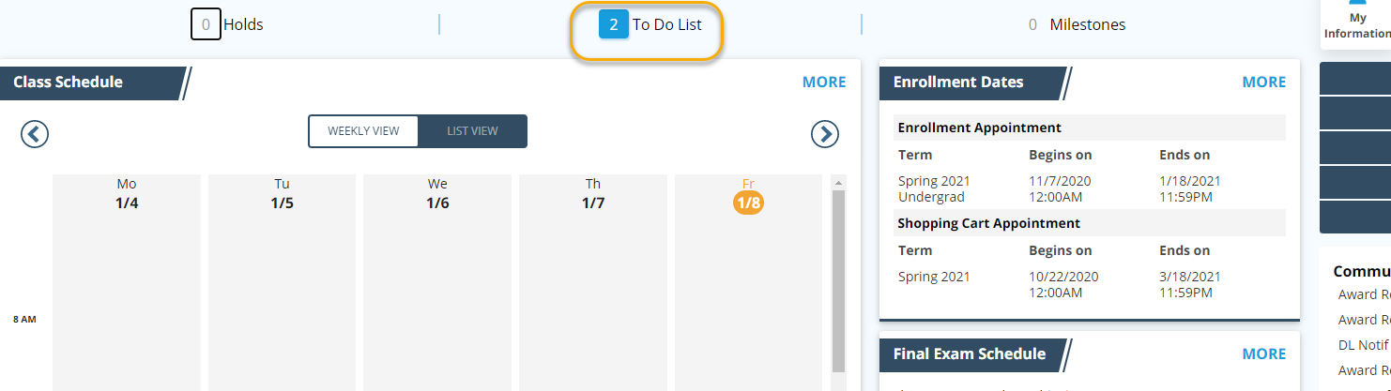

On the next screen, you will see your To Do List with the Military-Connected Student Questionnaire task assigned.
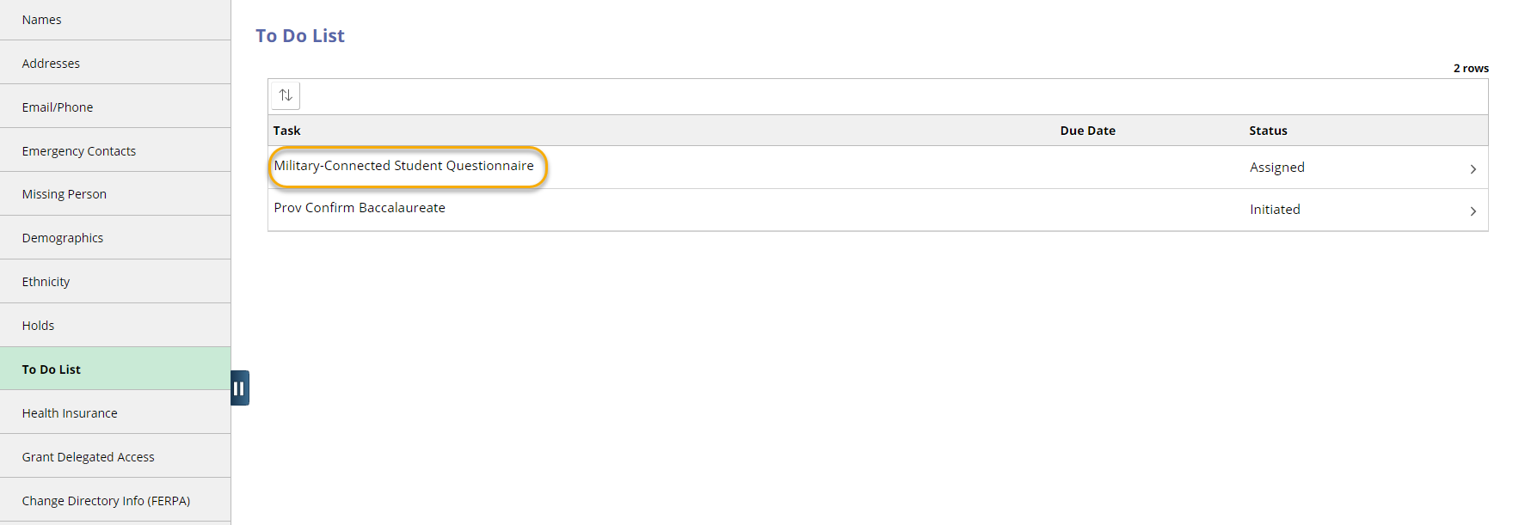

Completing the Military-Student Questionnaire
Clicking on the Military-Student Questionnaire task will take you to the activity guide in which the questionnaire is assigned. Follow the directions within the guide to complete the Military-Connected Student Questionnaire. Your answers will be shared with your campus certifying official(s).
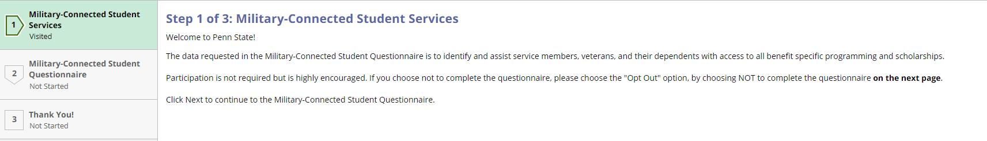

Questions about the Military-Student Questionnaire
Questions should be directed to your campus certifying official. A list of certifying officials is found at http://equity.psu.edu/veterans/pdf/certifying-officials-list

Statement of Non-Discrimination
The University is committed to equal access to programs, facilities, admission, and employment for all persons. It is the policy of the University to maintain an environment free of harassment and free of discrimination against any person because of age, race, color, ancestry, national origin, religion, creed, service in the uniformed services (as defined in state and federal law), veteran status, sex, sexual orientation, marital or family status, pregnancy, pregnancy-related conditions, physical or mental disability, gender, perceived gender, gender identity, genetic information or political ideas. Discriminatory conduct and harassment, as well as sexual misconduct and relationship violence, violates the dignity of individuals, impedes the realization of the University’s educational mission, and will not be tolerated. Direct all inquiries regarding the nondiscrimination policy to the Affirmative Action Office, The Pennsylvania State University, 328 Boucke Building, University Park, PA 16802-5901, Email: aao@psu.edu, Tel 814-863-0471.

