Completing the Major Preferences Activity Guide
Prior to each semester’s enrollment as an undergraduate student in a pre-major, you will receive an email notification that a new task, Major Preferences Activity Guide, has been assigned to your To Do List. The guide contains the View My Major Preferences tool which collects information about your current major(s) of interest. Complete the activity guide to remove the task from your To Do List.

Navigating to the Major Preferences Activity Guide
The Major Preferences Activity Guide can be accessed using the direct link in the body of the email or through LionPATH.
- To access the activity guide, click on the number to the left of the To Do List.
- To complete an item, select the desired row on the To Do List table.

Major Preferences Activity Guide: Interface
The left side of the activity guide screen contains the tasks in the activity guide as well as your progress in completing them.
The center of the screen contains information or tasks that must be completed. In this case, directions on how to complete the guide are included.
The upper right contains navigation buttons to move through the activity guide. Click the Next button when you have completed the screen.
Note: You can use the Exit button to leave at any point and return to the activity guide later, if necessary.
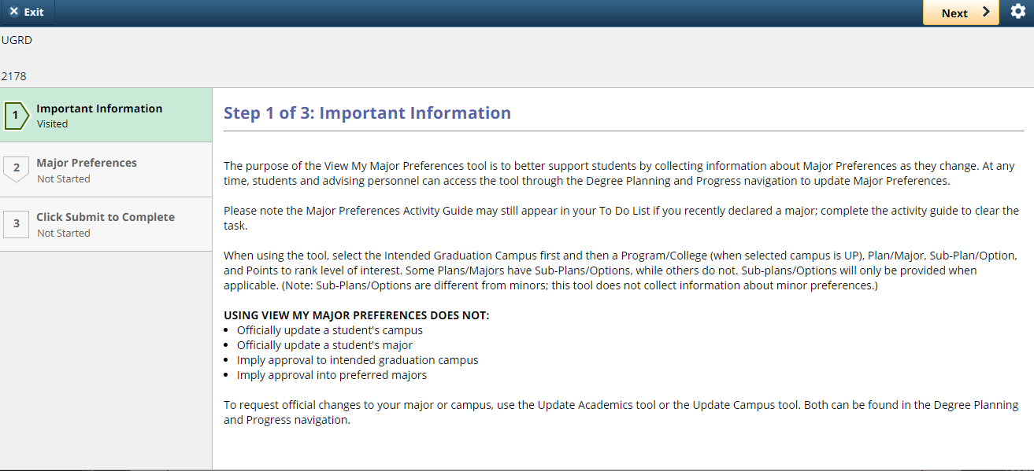
Figure 1: Introduction page of the Major Preferences Activity Guide

Major Preferences Activity Guide: Tasks

Important Information
The Important Information page contains instructions for completing the guide. When you are finished reviewing the page, select the Next button to move to the next screen.

View My Major Preferences
The View My Major Preferences page requires you to enter information. Read the Instructions in the blue box at the top of the page, and proceed to the steps below:
- In #1 Major Preferences:
  - Select Intended Graduation Campus.
  - If you chose University Park for Intended Graduation Campus, select Program/College.
  - Select Plan/Major.
  - Enter Points to rank #1 Major Preference.
- If you have no other Major Preferences, click Save. Otherwise, make selections for #2 and #3 Major Preferences accordingly. Click Save.

Tips:
- Click the View History link to view your Major Preferences History. Ensure popups are enabled; a pdf will open in a new window.
- Populate and display your last selection(s) by clicking Autofill with Previous Preferences, make any applicable updates, and click Save.
- Click the Clear button to start over.
Upon making your selections and clicking the Save button, the Next button will appear in the top right corner of the page. Click the Next button to move to the last page.

Completion
The last item in the Major Preferences Activity Guide is the Completion page. Once you have read the communication, click the Submit button in the top right corner of the page to complete the activity guide. At this time, the task will be removed from your To Do List.

*Disclaimers:
- The View My Major Preferences tool is available only to degree-seeking undergraduate students.

Statement of Non-Discrimination
The University is committed to equal access to programs, facilities, admission, and employment for all persons. It is the policy of the University to maintain an environment free of harassment and free of discrimination against any person because of age, race, color, ancestry, national origin, religion, creed, service in the uniformed services (as defined in state and federal law), veteran status, sex, sexual orientation, marital or family status, pregnancy, pregnancy-related conditions, physical or mental disability, gender, perceived gender, gender identity, genetic information or political ideas. Discriminatory conduct and harassment, as well as sexual misconduct and relationship violence, violates the dignity of individuals, impedes the realization of the University’s educational mission, and will not be tolerated. Direct all inquiries regarding the nondiscrimination policy to the Affirmative Action Office, The Pennsylvania State University, 328 Boucke Building, University Park, PA 16802-5901, Email: aao@psu.edu, Tel 814-863-0471.

