Planning Your Schedule: LionPATH Planner
The LionPATH Academic Planner allows you to plan, by term, the courses you intend to take in the future.
Note: You should consult with your assigned Academic Advisor prior to enrolling.

Navigating to the My Planner Page
To plan your schedule using the planner you must first navigate to the My Planner page located in LionPATH.
- From the Student Home Base, select the Degree Planning and Progress button.
- Select the My Planner button located in the navigation collection on the left side of the page.
You can add courses to you planner from the Course Catalog or from your Academic Requirements (Degree Audit).
Add a Course to Your Planner Using Browse Course Catalog
To locate courses to add to your planner using the course catalog, click the BROWSE COURSE CATALOG button.

Using the Catalog to Locate Courses
- To locate courses to add to your planner, click the Browse Course Catalog button.
- Select a letter in the A to Z index, at the top of the page, to display the course subject codes beginning with the selected letter.
- Select the arrow to the left of the appropriate subject code to view the courses in the course catalog.
- A list will display with all courses available in the catalog. To see the course details for a section, select the Course Nbr or the Course Title link.

Adding a Course to Your Planner
When you add a course to your planner, you are adding the course from the catalog, not a specific class section. A course can be added from the Course Detail page or directly from the Course List browse catalog page.

Course Details Page
From the Course Details page, you can select the View Class Sections button to see the sections that are available for the selected term or you can add the course to your planner without viewing the sections.
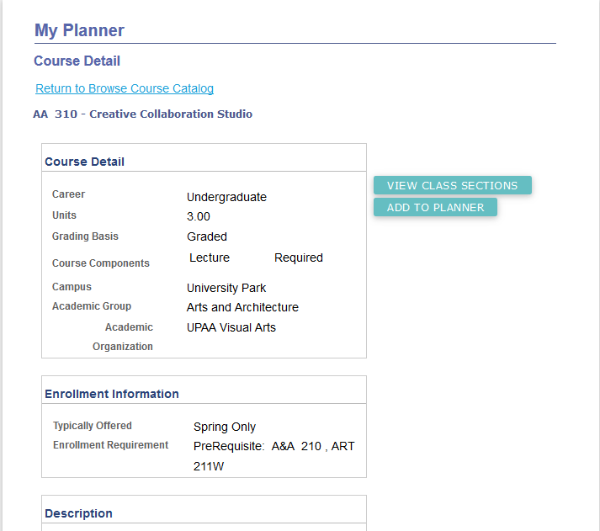
Figure 1: Course Detail page
- Select the Add to Planner button, on the Course Detail page, to add the course to your planner.
A confirmation message will display stating the course was added to your planner.

Course List Page
If you know the course you want to add, and you don’t need to see the details, the course can be added to you planner directly from the course list page of the browse catalog.
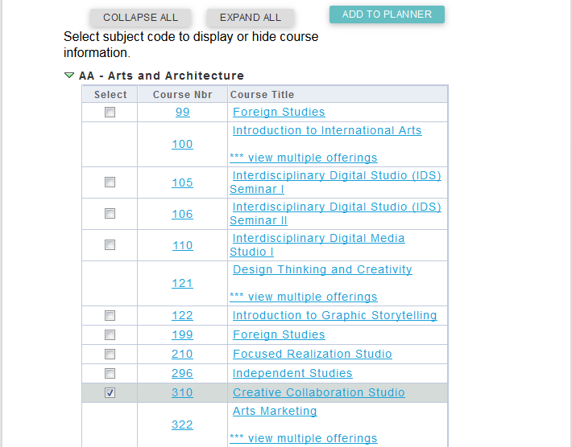
Figure 2: Course List page
- Click the checkbox to the left of the course title of the course you want to add to your planner.
- When you are finished selecting the courses, click the Add to Planner button located at the bottom of the page.
A confirmation message will display stating the course was added to your planner.
Note: If appropriate, multiple courses can be selected from the course catalog and added to the planner simultaneously.
Add a Course to Your Planner Using your Academic Requirement (Degree Audit)
- To plan your courses using your Academic Requirement (Degree Audit), select the Plan by My Requirements button.
- Using your Academic Requirement report, scroll down to the requirement you would like to add to your planner.
- Click on the course description link for the course you want to add to your planner.
- The Select Course Offering page displays a listing of all campus locations where the selected course is offered. Select the checkbox to the left of the campus where you will be taking the course.
- Select the Add to Planner link to add the course to your planner.

Assigning a Course to a Specific Term/Semester
Once courses are added to your planner, they are, by default, not assigned to a specific term. Courses can be left as unassigned or moved to the term you intend to take them.
- When you are finished selecting courses, click the My Planner button in the navigation collection, to return to your planner.
- To assign a course to a particular term, select the checkbox to the left of the course.
- Select the term you intend to take the courses from the Move selected courses to Term drop-down list.
- Click the Move button.
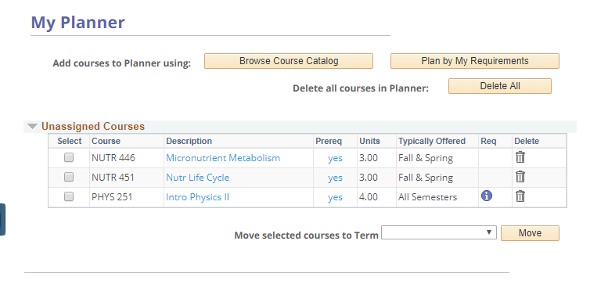
Figure 3: My Planner page with unassigned courses
A confirmation message displays letting you know the courses were moved to the selected term.
Once a course is moved to a specific term, you can see the course listed in a table along with the other courses assigned to that term.

Statement of Non-Discrimination
The University is committed to equal access to programs, facilities, admission, and employment for all persons. It is the policy of the University to maintain an environment free of harassment and free of discrimination against any person because of age, race, color, ancestry, national origin, religion, creed, service in the uniformed services (as defined in state and federal law), veteran status, sex, sexual orientation, marital or family status, pregnancy, pregnancy-related conditions, physical or mental disability, gender, perceived gender, gender identity, genetic information or political ideas. Discriminatory conduct and harassment, as well as sexual misconduct and relationship violence, violates the dignity of individuals, impedes the realization of the University’s educational mission, and will not be tolerated. Direct all inquiries regarding the nondiscrimination policy to the Affirmative Action Office, The Pennsylvania State University, 328 Boucke Building, University Park, PA 16802-5901, Email: aao@psu.edu, Tel 814-863-0471.

