Interpreting a Degree Audit
Degree Audits are used by students, faculty, and staff to monitor and evaluate how students are progressing toward degree completion.
The Academic Requirements and the What-If Report both display the Academic Advisement Report, more commonly known as degree audits.
The Academic Requirements Degree Audit will display requirements for all major(s) and minor(s) in which a student is currently active. The What-If Degree Audit will display the requirements for the selected major(s) or minor(s).

Navigating to the Academic Requirement Page
- From the Student Home Base, select the Degree Planning and Progress button.
- Select the My Academic Requirements button located in the navigation collection on the left side of the page.

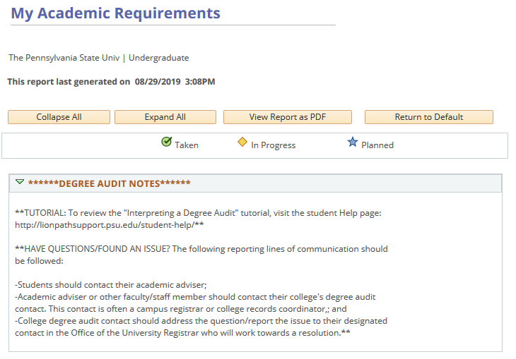
Figure 1: My Academics Requirements report

Navigating the Degree Audit
In most cases, once a requirement has been satisfied, that requirement’s area in the audit collapses. If the requirement has not been satisfied, the section is expanded.
The buttons at the top of the degree audit will allow you to expand or collapse all sections, as well as print the audit as a pdf document. In addition, if you have changed the audit by expanding or collapsing sections, you can return the audit to its default view.
The legend defines icons that will appear throughout the degree audit. These icons indicate if a course has been taken, is in progress, or is planned for the future.
The report is divided into sections. The title is displayed at the top of each section. Some sections are broken down into sub-sections.
The green triangles allow you to collapse or expand items to view requirements for that section or sub-section. Requirements that have been fulfilled will be collapsed by default when a degree audit is run, but you can expand any item by clicking on the green triangle.
Tables in the degree audit can be sorted using the column headers. Click on the column header to sort the table in alphabetical or numerical order by that column. Click the header again to reverse the sort order for that column. In Addition, tables may not display all rows by default. The lower right corner of the table will indicate the total number of rows. There are navigation options available that allow you to move page by page or directly to the first and last rows. If you would like to display all rows within a table, you can click the View All link.

Sections of the Degree Audit
The Degree Audit begins with a message to inform users that this is an unofficial document that interprets the student’s progress towards their degree. Only college deans can officially approve a student for graduation. There is also a listing of plan(s)/subplan(s) that are part of the report.

Entrance Requirements
The Entrance Requirements section provides information regarding requirements for entering the major.

Schreyer Honors College Requirements
If a student is officially in the Schreyer Honors College, a section for their Honors Requirements will appear. If a student is not in the Schreyer Honors College but completes honors coursework, a different section of the audit will appear to list courses taken with the Honors attribute so users can more easily identify such courses.

In Progress Courses
The In Progress Courses section contains a list of courses that the student has scheduled but not yet completed. Notice that the Status column includes the In Progress icon. This section will not appear when a student has no courses scheduled.

Withdrawn, Unsatisfactory, Repeated, & Excluded Academic Renewal Courses
The Withdrawn, Unsatisfactory, Repeated, & Excluded Academic Renewal Courses section will be populated when a student has any of the following; courses that they have failed or dropped through late drop or withdrawal, repeated courses beyond the unit limits allowed by the Course Catalog, or courses taken prior to Academic Renewal with grades below C, which cannot be used to satisfy any degree requirements.

Ineligible Courses
The Ineligible Courses section will display courses that cannot fulfill degree requirements. If a student has not taken any ineligible courses, this section will not appear.

World Language Admission Requirement
This section monitors whether the student has fulfilled their World Language Admission Requirement.

First-Year Seminar
This section shows whether the First-Year Seminar (FYS) requirement has been fulfilled. The First-Year Seminar requirement will appear if a student is admitted as a first-year student to a campus that requires FYS.

Writing Across the Curriculum
The Writing Across the Curriculum section shows the requirement of three units of writing-intensive coursework from the college of enrollment.
There may be two sub-categories in this section. The first sub-category indicates whether a student has taken any writing-intensive courses within the college of their chosen major. Once this requirement is met, the entire requirement will be satisfied. The second sub-category indicates if any writing-intensive courses were taken outside of the college of the chosen major. This line helps monitor concurrent degree fulfillment as well as possible substitutions.

United States and International Cultures (US/IL)
This section monitors whether a baccalaureate student has completed 3 units of United States Cultures (US) and 3 additional units of International Cultures (IL) coursework. (Associate degree students are required to complete 3 units in either US or IL Cultures.)

Minimum 2.00 Cumulative Grade Point Average Required for Graduation
This section will monitor the 2.0 cumulative grade point average graduation requirement. If this requirement is satisfied at the time of the audit request, this section will display collapsed by default.

Residency Requirements
This section monitors Residency Requirements such as the number of units taken at Penn State and the number of units taken in the last five years.

General Education
The General Education section shows each category as well as courses required for the major that will fulfill these requirements. The note **Units also apply to major/option requirements** will display when courses can fulfill both the General Education and major or option requirements.

Integrative Studies
Students entering Penn State Summer 2018 and after must fulfill an Integrative Studies requirement through completion of 6 units of Inter-Domain courses or 6 units of paired Linked courses. Courses in this section also have the potential to satisfy other degree requirements. However, you may not complete an entire General Education area listed lower in your audit solely with Inter-Domain courses.
Note: Remember that at least 3 units in each area must be fulfilled by a class that is not Inter-Domain.

Major Requirements
Depending on the requirements of the major, the Major Requirements section will often be divided into 3 possible parts: Prescribed Courses, Additional Courses, and Supporting Courses.
The Prescribed Courses section can also be divided into several parts based on the requirements of the major. These sections may include: Prescribed Courses-C or higher, Prescribed Courses, and Writing.
- All courses in the Prescribed Courses-C or higher required section must be completed with a grade of C or higher.
- All courses in the Prescribed Courses section are required but do not need to be completed with a grade of C or higher.
- Courses within the Writing section require the writing attribute.
The Additional Courses section will display when there are additional required courses. If no additional courses are required, this section will not display.

Option Requirements
When an option is required, the Option section will be populated in a similar manner that the Major Requirement section is displayed.
Note: A Supporting Courses and Related Areas section will display under the Option Requirements when there are required supporting courses. If no supporting courses are needed, this section will not display.

Elective and Total
The Electives and Total section will help monitor the total number of units required to complete the degree, along with a breakdown of units required for all specific requirements and all elective requirements (if applicable). This was designed to help students and advisors monitor progress towards degree completion. (Remember though, that all above sections of the audit must be Satisfied too.)

30 units General Education Coursework in areas of GN, GA, GH, GS, GHW
This section is present for students following the General Education requirements that went into effect Summer 2018 and checks to ensure the required completion of 30 total units in the areas of GN, GA, GH, GS and GHW.

Courses Not Used to Satisfy Degree Requirements
This section will display any courses that were not used to satisfy requirements of the chosen major. If a student has not taken any courses that would fit into this category, this section will be collapsed.

Reporting Sections: Penn State Courses, Transfer Credit, Test Credit, Other Credit
The last 4 sections; Penn State Courses, Transfer Credit, Test Credit, and Other Credit are not monitoring degree requirements for the student’s Plan(s) and Subplan(s). These sections are simply reporting the courses on the student’s record and how they were completed.

Statement of Non-Discrimination
The University is committed to equal access to programs, facilities, admission, and employment for all persons. It is the policy of the University to maintain an environment free of harassment and free of discrimination against any person because of age, race, color, ancestry, national origin, religion, creed, service in the uniformed services (as defined in state and federal law), veteran status, sex, sexual orientation, marital or family status, pregnancy, pregnancy-related conditions, physical or mental disability, gender, perceived gender, gender identity, genetic information or political ideas. Discriminatory conduct and harassment, as well as sexual misconduct and relationship violence, violates the dignity of individuals, impedes the realization of the University’s educational mission, and will not be tolerated. Direct all inquiries regarding the nondiscrimination policy to the Affirmative Action Office, The Pennsylvania State University, 328 Boucke Building, University Park, PA 16802-5901, Email: aao@psu.edu, Tel 814-863-0471.

