GPA Calculator Quick Start Guide*

- Go to the LionPath Support Page at https://lionpathsupport.psu.edu
- Click on the yellow Students, Faculty, Staff Login button to log in to LionPATH. Note: You must use your Penn State Access Account to log in.
- From the student home page, click Degree Planning and Progress.

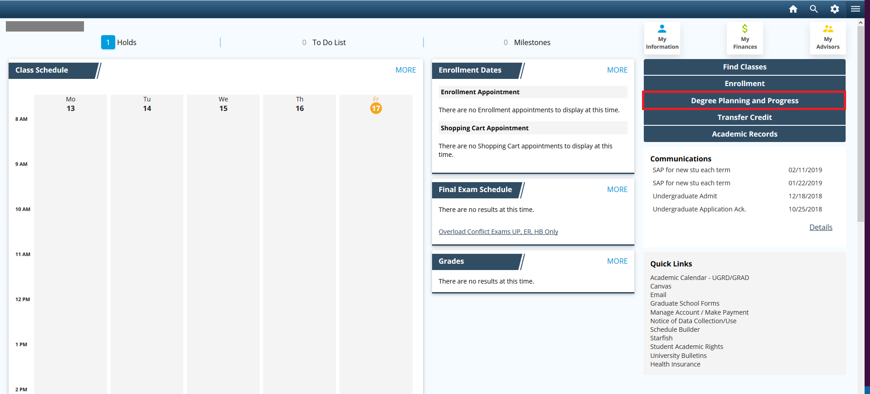

- From the left navigation menu, click GPA Calculator.
- Units for GPA, Cum GPA, and Grade Points pre-populate from your academic record. Note: You can edit these boxes if you wish to perform a different calculation.
- OPTIONAL: If using the Desired Cum GPA box, enter the CGPA you are trying to attain.
- Enter the number of Class Unit(s)/credits for each class.

6A. If using the Desired Cum GPA box above, you can leave some or all of the Class Grade boxes blank. When you click “calculate,” the application will generate the minimum grades needed to meet the Desired Cum GPA or will give you a message that the Desired Cum GPA cannot be reached.

--OR—

6B. If using this GPA Calculator to simply calculate specific grades, leave the Desired Cum GPA box blank. Use the Class Grade dropdown menu to indicate a grade in each class.

- Use the + and - buttons to adjust the number of classes you are taking/calculating.
- This section will display the calculations for Units for Term GPA, Term GPA, and Estimated Cum GPA based on the data entered above.
- Select Calculate to see the results of your GPA scenario.
- Select Clear to remove any data you entered/changed. It restores Units for GPA, Cum GPA, and Grade Points to their initial values from your academic record. Note: A “clear” is recommended between each of your calculations.
- Depending on your calculations, different messages may appear.
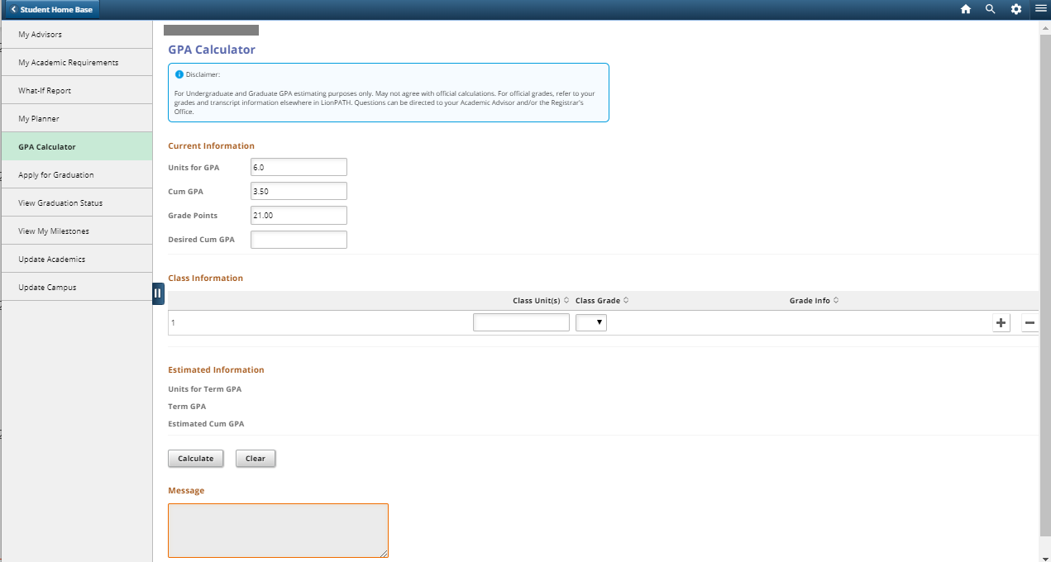
*Disclaimer: For Undergraduate and Graduate Grade Point Average (GPA) estimating purposes only may not agree with official calculations. For official grades, refer to your grades and transcript information elsewhere in LionPATH. Questions can be directed to your Academic Advisor and/or the Registrar’s Office.

Statement of Non-Discrimination
The University is committed to equal access to programs, facilities, admission, and employment for all persons. It is the policy of the University to maintain an environment free of harassment and free of discrimination against any person because of age, race, color, ancestry, national origin, religion, creed, service in the uniformed services (as defined in state and federal law), veteran status, sex, sexual orientation, marital or family status, pregnancy, pregnancy-related conditions, physical or mental disability, gender, perceived gender, gender identity, genetic information or political ideas. Discriminatory conduct and harassment, as well as sexual misconduct and relationship violence, violates the dignity of individuals, impedes the realization of the University’s educational mission, and will not be tolerated. Direct all inquiries regarding the nondiscrimination policy to the Affirmative Action Office, The Pennsylvania State University, 328 Boucke Building, University Park, PA 16802-5901, Email: aao@psu.edu, Tel 814-863-0471.

