Enrollment Verification
An Enrollment Verification is a printed statement of a student’s academic information. You can submit this statement to an insurance agency, employer, or other third party as proof of enrollment at the University.
You can print an unofficial copy using your browser print function, or you can request that the University mail you, or a third party, an official Enrollment Verification.

Navigating to the Enrollment Verification Page
- From the Student Home Base, select the Academic Records button.
- Select the Enrollment Verification button located in the navigation collection on the left side of the page.

Printing an Unofficial Enrollment Verification Statement
- Verify that Allow to Print from My Browser is selected.
- Leave both checkboxes checked, to include the listed academic information on your Enrollment Verification.
- Select the SUBMIT button.
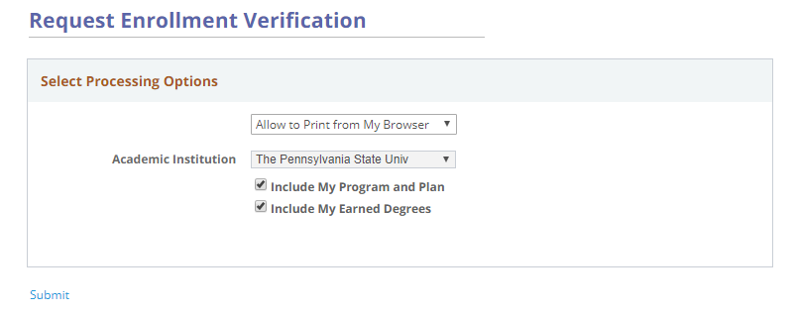
Figure 1: Print Processing Options displayed on the Request Enrollment Verification page
The Enrollment Verification statement is displayed. Selecting the Printer Friendly Version link at the bottom of the page will open the Enrollment Verification statement optimized for printing. Use your web browser’s print function to print the statement.

Requesting an Official Enrollment Verification Statement
- From the Student Home Base, select the Academic Records button.
- Select the Enrollment Verification button located in the navigation collection on the left side of the page.
- Select Request Institution to Mail from the Select Processing Options drop-down menu.
- Leave both checkboxes checked to include the listed academic information on your Enrollment Verification.
When you select Request Institution to Mail from the drop-down menu, the Enter Recipient Address Information section will appear.
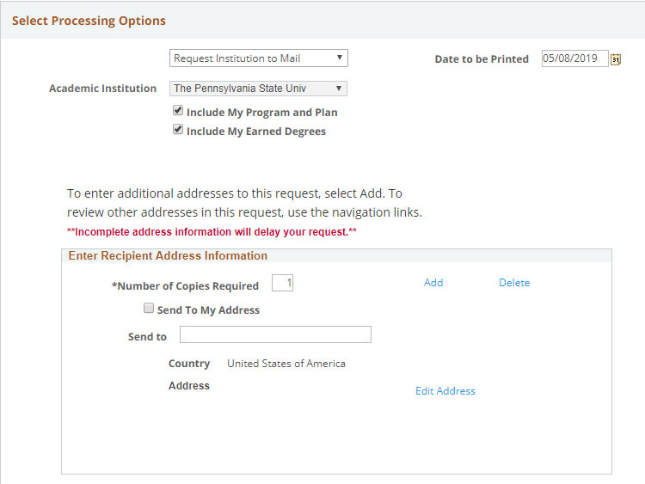
Figure 2: Print processing Options for an official verification
- To have the statement sent to a third party, enter the name of the recipient into the Send to field. Note: To have the Enrollment Verification statement sent to you, click the Send to My Address check box.
- Select on the Edit Address link.
- The Edit Address screen appears. Use the Change Country link to select the country and then enter the recipient’s address into the provided fields.
- Once you are finished entering the address, select the OK button. Note: The system checks to make sure the address entered is a valid address. You can click the OK button to accept the address or the Cancel button to use the address you entered. This message will only appear for addresses in the United States and Canada.
- Once the address has been entered, select the Submit link to send the request.
Confirmation that you successfully submitted the request will display.

Statement of Non-Discrimination
The University is committed to equal access to programs, facilities, admission, and employment for all persons. It is the policy of the University to maintain an environment free of harassment and free of discrimination against any person because of age, race, color, ancestry, national origin, religion, creed, service in the uniformed services (as defined in state and federal law), veteran status, sex, sexual orientation, marital or family status, pregnancy, pregnancy-related conditions, physical or mental disability, gender, perceived gender, gender identity, genetic information or political ideas. Discriminatory conduct and harassment, as well as sexual misconduct and relationship violence, violates the dignity of individuals, impedes the realization of the University’s educational mission, and will not be tolerated. Direct all inquiries regarding the nondiscrimination policy to the Affirmative Action Office, The Pennsylvania State University, 328 Boucke Building, University Park, PA 16802-5901, Email: aao@psu.edu, Tel 814-863-0471.

