Enrolling in an Installment Payment Plan
You have the ability to enroll in an installment payment plan through the Penn State Student Account Dashboard. The optional installment payment plan distributes the bill payment across the first four months of the fall and spring semesters. Due to the shorter length of the summer session, the installment payment plan for summer is three monthly installments. There is a $45 fee when signing up for the installment payment plan.
Note: You cannot enroll in an installment payment plan if you have a balance due for any prior semester.

Navigating to the Penn State Student Account Dashboard
- From the Student Home Base, select the My Finances button.
- On the My Account page, select the Manage My Account / Make a Payment button.

Enrolling in the Installment Payment Plan
The installment Payment Plans section will display a link for each semester that is currently available for enrollment in a plan. If you have a balance due on any prior semester, you will receive a message indicating that all prior balances must be paid before you can enroll in a payment plan. Once you have paid all prior balances, you may have to refresh your browser or log out and log back in to update your account.
- Select the Enroll in the Payment Plan link for the appropriate semester to begin enrolling in the payment plan.
- The eSignature Disclosure will appear. After reading the disclosure, select the Accept button to consent to receive your payment authorization electronically.
The total budget will be displayed at the top of the page. This is the amount (before fees are applied) that you will be paying through the installment payment plan.

What You Pay Now Section
The total budget amount will be evenly distributed across four months for fall and spring semesters and three months for the summer semester.
Note: Refer to the Penn State Office of the Bursar website at https://bursar.psu.edu for installment payment plan due dates.

What You Pay Later Section
Future installments dates and amounts are listed, these are predefined and must be setup at the time of enrollment. Reminder emails for future payments will be sent prior to the payment due date.

Terms and Conditions Section
The Terms and Conditions of the agreement are located at the bottom of the page.
- Once you read and fully understand the agreement. Select the I agree to the terms & conditions checkbox.
- Select the Submit button.

After agreeing to the terms and conditions you will be prompted to make your first installment payment.

Entering Payment Information
You can make an online payment using a credit card or electronic check through the Penn State Student Account Dashboard.
- Select the radio button to the left of the payment method you would like to use for this payment. Note: if you have setup a saved payment method previously, it will appear in the list as an option.
- Select the Continue button.

Credit Card Payments
A service fee applies to all credit card transactions. This service fee will be assessed at the time the payment is applied to your credit card.
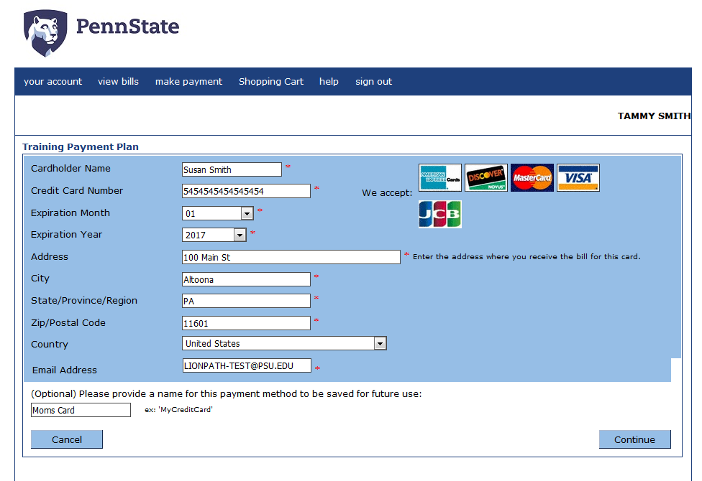
Figure 1: Payment information form
- Complete the form by entering the appropriate information into the fields provided. Note: The fields with an asterisk to the right are required.
- If you would like to make this a saved payment option that you can use again, enter a familiar name into the field provided.
- Select the Continue button.
- When paying with a credit card, the service fee amount will be displayed. Select the checkbox to accept the terms and conditions.
- Select the Continue button.
- A summary of the transaction is displayed including any Service Charge for credit card transactions. Select Submit Payment to process the first installment. Note: if you select the Cancel button the entire payment plan will be canceled, and you will be returned to the dashboard.
Your receipt will be displayed including a message indicating that a copy was emailed to the address listed.
Note: The process for paying with an electronic check is the same as with a credit card; however, there are no additional fees assessed on electronic check transactions.
Your enrollment is not complete until you enter a payment method for the remaining two installments. You can select to use the same method of payment as the initial installment or select to enter another credit card or electronic check.
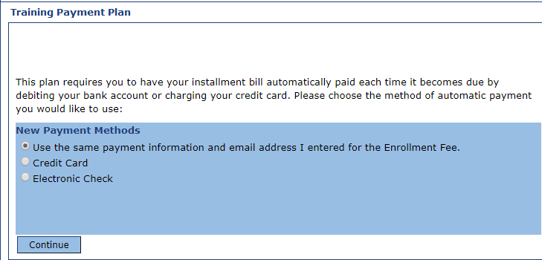
Figure 2: Payment Plan future payment methods.

- Select the radio button to the left of the payment method you would like to use for the remaining installment payments. Note: Any saved payment methods you have setup will display in the list. If you select the No radio button in the list, you will cancel the entire installment payment plan and return to the dashboard.
- Select the Continue button.
- A summary of your future installments is listed, including the service charge if a credit card payment is used. Select the Submit button to complete your enrollment.
- A confirmation of your enrollment is displayed, including the date the first installment will be charged. Select the Return to Your Account page button to return to the dashboard.
Your first installment and enrollment fee will be displayed in the Your Recent Payments section.
A Scheduled Payments section is now displayed on your dashboard that includes the due date of your next installment. Selecting the plan link will allow you to make changes to the account information for the future installments, if needed.
If the web payment is returned for nonsufficient funds, the payment will be reversed, a $25.00 charge will be assessed, and late fees will apply retroactively to the original due date. After two nonsufficient funds web payments, a service indicator will be placed on your record preventing you from making web payments.
If the credit card expires, an email will be sent prior to a scheduled payment directing you to update your payment information.

Statement of Non-Discrimination
The University is committed to equal access to programs, facilities, admission, and employment for all persons. It is the policy of the University to maintain an environment free of harassment and free of discrimination against any person because of age, race, color, ancestry, national origin, religion, creed, service in the uniformed services (as defined in state and federal law), veteran status, sex, sexual orientation, marital or family status, pregnancy, pregnancy-related conditions, physical or mental disability, gender, perceived gender, gender identity, genetic information or political ideas. Discriminatory conduct and harassment, as well as sexual misconduct and relationship violence, violates the dignity of individuals, impedes the realization of the University’s educational mission, and will not be tolerated. Direct all inquiries regarding the nondiscrimination policy to the Affirmative Action Office, The Pennsylvania State University, 328 Boucke Building, University Park, PA 16802-5901, Email: aao@psu.edu, Tel 814-863-0471.

