Dropping a Class
You can drop a class from your schedule up until the last day of the regular drop period. After this date occurs, you can late drop a class until the last day of the late drop period.
Note: An LD will be listed on your transcript when you late drop a class. Students who are considering late dropping a class are encouraged to discuss the implications with an advisor.

Navigating to the Drop Classes Page
- From the Student Home Base, select the Enrollment button.
- Select the Drop Classes button located in the navigation collection on the left side of the page.
- Select the term in which you would like to drop a class and a list of classes for that term will then appear.

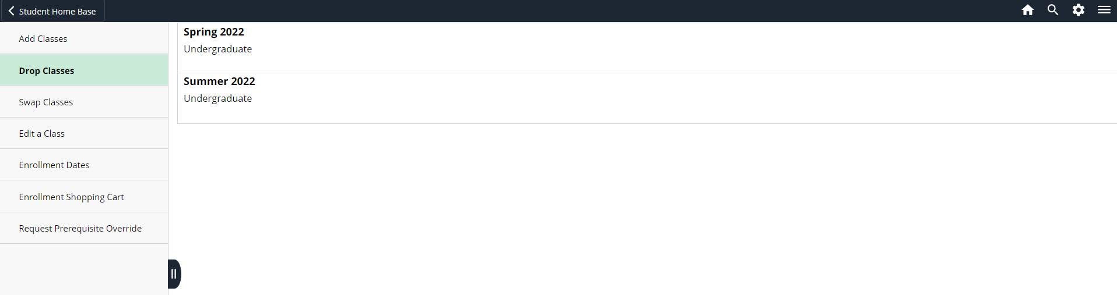
Figure 1: List of available terms that can be selected.

Dropping a Class from Your Schedule
The classes you are enrolled in for the selected semester will be displayed.
- When selecting the class(es) to be dropped, the Tuition Calendar can be used to provide additional information about possible tuition adjustments. To continue with dropping a class after viewing the Tuition Calendar for a class, select the Return to Drop Classes button.
- Select the checkbox to the left of the class you wish to drop and click the Next > button.

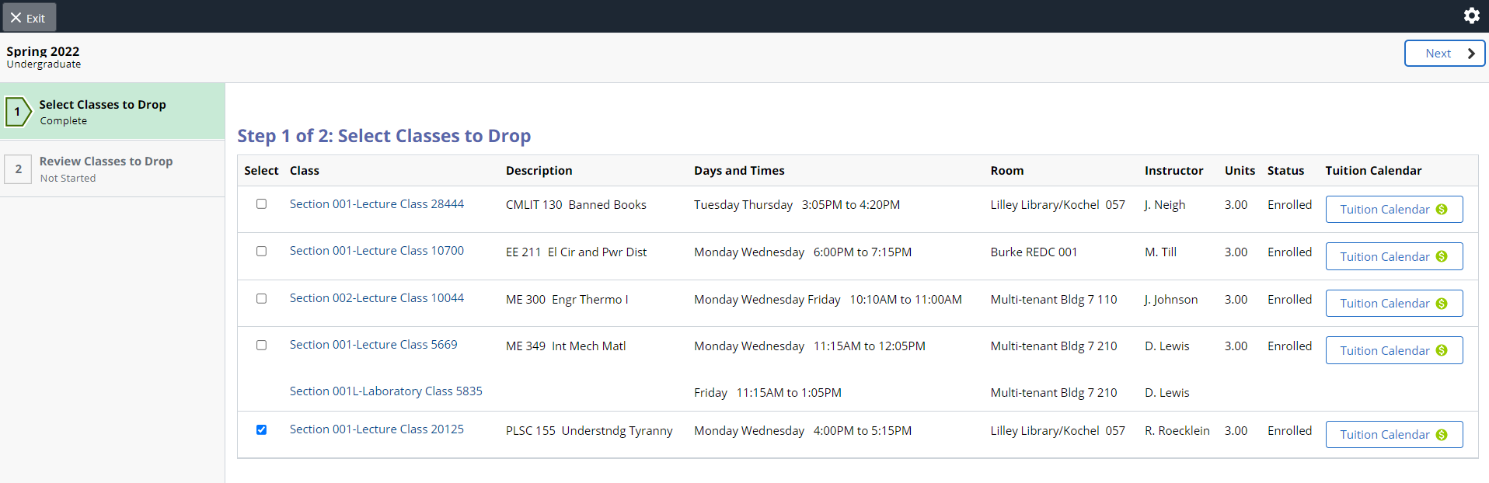
Figure 2: A table with the list of classes the student is currently enrolled in.

- To complete the process and drop the class from your schedule, select the Drop Classes button.
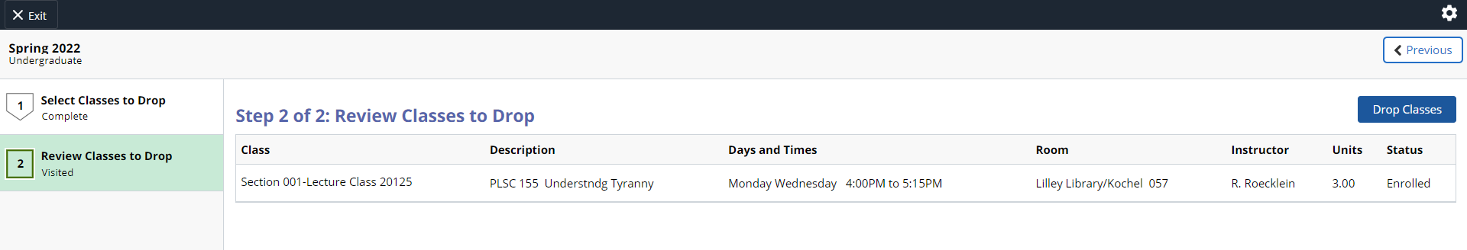
Figure 3: A table with the list of classes the student is requesting to drop.

- Review the results to verify you have successfully dropped the class.
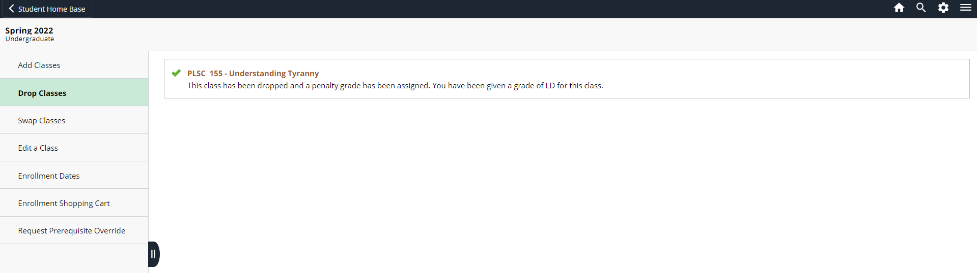
Figure 4: Message display for the results of the drop transaction.
Once you are finished verifying the results, you can return to your Student Home Base to view your schedule.

Statement of Non-Discrimination
The University is committed to equal access to programs, facilities, admission, and employment for all persons. It is the policy of the University to maintain an environment free of harassment and free of discrimination against any person because of age, race, color, ancestry, national origin, religion, creed, service in the uniformed services (as defined in state and federal law), veteran status, sex, sexual orientation, marital or family status, pregnancy, pregnancy-related conditions, physical or mental disability, gender, perceived gender, gender identity, genetic information or political ideas. Discriminatory conduct and harassment, as well as sexual misconduct and relationship violence, violates the dignity of individuals, impedes the realization of the University’s educational mission, and will not be tolerated. Direct all inquiries regarding the nondiscrimination policy to the Affirmative Action Office, The Pennsylvania State University, 328 Boucke Building, University Park, PA 16802-5901, Email: aao@psu.edu, Tel 814-863-0471.

