Enrolling in eRefund
Setting up a direct deposit refund allows any future refunds to be electronically deposited into an account you specify. This allows you to receive your refund quickly, since you do not have to wait for a paper check to be mailed.

Navigating to the Penn State Student Account Dashboard
- From the Student Home Base, select the My Finances button.
- On the My Account page, select the Manage My Account / Make a Payment button.

Enrolling in eRefund
- In the eRefund section, select the Click to enroll in eRefund link.
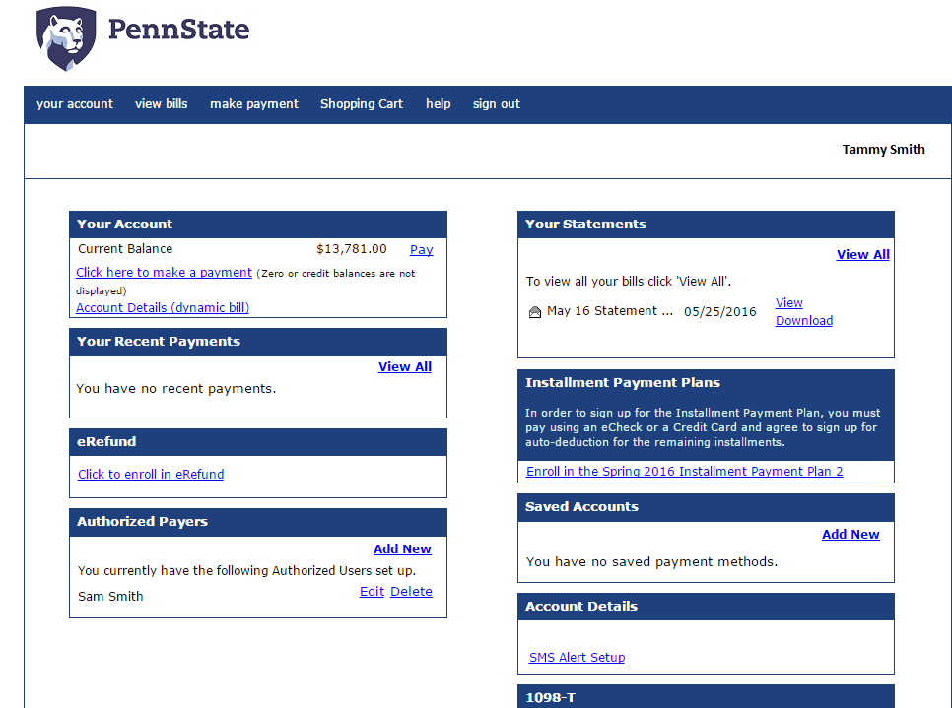
Figure 1: The Penn State Student Account Dashboard
- Select the Yes, I want refunds deposited directly into my bank account radio button.
- Complete the eRefund Signup form by entering your bank information into the appropriate fields.
- After completing the form, select the Continue button.
- Once you have read and fully understand the terms and conditions of the agreement, select the I Agree checkbox.
- Select the Submit button to complete the process. A confirmation page will display. From here you can add another account, edit the current account, or withdraw from electronic refund.
- Select the Return to Your Account page button.
Your eRefund status will display on the Student Account Dashboard as Enrolled.

Statement of Non-Discrimination
The University is committed to equal access to programs, facilities, admission, and employment for all persons. It is the policy of the University to maintain an environment free of harassment and free of discrimination against any person because of age, race, color, ancestry, national origin, religion, creed, service in the uniformed services (as defined in state and federal law), veteran status, sex, sexual orientation, marital or family status, pregnancy, pregnancy-related conditions, physical or mental disability, gender, perceived gender, gender identity, genetic information or political ideas. Discriminatory conduct and harassment, as well as sexual misconduct and relationship violence, violates the dignity of individuals, impedes the realization of the University’s educational mission, and will not be tolerated. Direct all inquiries regarding the nondiscrimination policy to the Affirmative Action Office, The Pennsylvania State University, 328 Boucke Building, University Park, PA 16802-5901, Email: aao@psu.edu, Tel 814-863-0471.

