LionPATH Degree Audit Reports FAQs and Pointers
Table of Contents
LionPATH Degree Audit Reports FAQs and Pointers 2
General Functionality 2
How is progress toward graduation tracked? 2
How are degree audit reports obtained? 2
What happens on the degree audit report when a requirement has been satisfied? 2
In what order are requirements fulfilled? 2
Main Sections of the Report 3
First-Year Seminar 3
Writing Across the Curriculum 3
General Education (GenEd) 3
Major/Option Requirements 3
Electives and Totals 3
What-if Reports (WHIF) 4
What is a What-if Report (WHIF)? 4
Additional Information 5
Substitutions and Exceptions 5
Course Equivalents 5
PDF Audit 5
Resources 5

LionPATH Degree Audit Reports FAQs and Pointers

General Functionality

How is progress toward graduation tracked?
Penn State uses “degree audits” to track a student’s progress toward meeting degree requirements. In LionPATH, degree audits are referred to as follows:
- Academic Requirements: Degree audit reports for majors/minors in which a student is currently enrolled.
- What-If Report: Degree audit reports for majors/minors in which a student is not enrolled (i.e., an alternative major/minor that they wish to explore). In particular, premajor undergraduate students should utilize What-if Reports for their intended major(s) until they officially enter a major. Baccalaureate Entrance Requirements can be found on each report.

How are degree audit reports obtained?
Degree audit reports are available through Student Home Base. Select the Degree Planning and Progress button on the right. Depending on the type of degree audit report you wish to run, choose either My Academic Requirements or What-If Report located in the navigation collection on the left side of the page.

What happens on the degree audit report when a requirement has been satisfied?
When a requirement has been satisfied or is in progress, the requirement is collapsed, and the green arrow points to the right. When a requirement has not been satisfied, the requirement is expanded, and the green arrow points down.
In the example below, the Social and Behavioral Sciences (GS) requirement has been satisfied, but the Health and Wellness (GHW) requirement has not been satisfied.
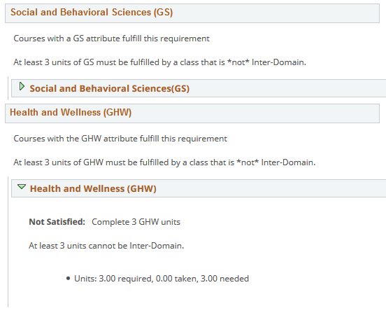

In what order are requirements fulfilled?
The degree audit report fills requirements from the top of the report to the bottom of the report, in chronological order of when courses were completed. If a student wishes to use courses in a manner other than what is displayed, they should consult their academic adviser.

Main Sections of the Report

First-Year Seminar
The First-Year Seminar Requirement will display for students admitted as first-year students (rather than as transfer students) based on whether a student’s initial campus requires a First-Year Seminar or not.

Writing Across the Curriculum
The Writing requirement is 3 units of writing-intensive coursework offered through the college(s) of enrollment and will be fulfilled when the top line of the requirement has been completed. (A second line may be present in this area of the report, which compiles writing-intensive courses completed through other colleges.)

General Education (GenEd)
The report is coded to include, when applicable, specific GenEd courses prescribed by the major and/or option. This helps students and advisers to be aware of major and/or option requirements that can be completed through GenEd course selection.

Major/Option Requirements
When possible, the degree audit report organizes requirements into categories similar to major/option program requirements in the University Bulletin, subdividing major/option requirements into Prescribed, Additional and Supporting areas, with “C or higher required” courses grouped together.
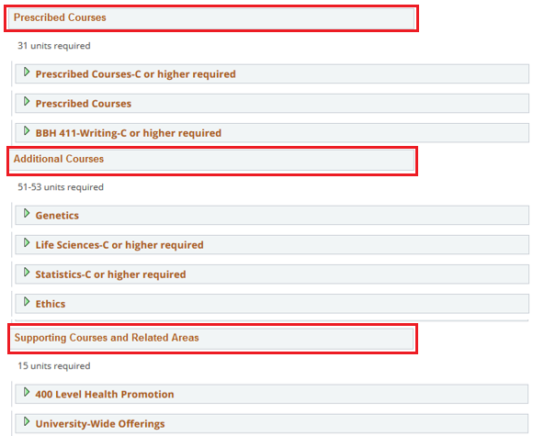
Variable Unit and Writing Across the Curriculum courses are separated onto their own lines due to degree audit report functionality, and to highlight characteristics of these courses.

Electives and Totals
Electives are coded to be limited to the maximum number of elective units that count toward a degree.
Totals are coded to reflect the actual number of units required to graduate with a degree.
If an Electives or Total requirement requires a range of units, it will appear satisfied with the lowest number of units possible, although additional units may be applied to these areas in the future.
In some cases, the number of electives in the degree audit report is different from what is listed in the Bulletin. For example, the Bulletin often does not reflect the full range of electives that may be possible with Bachelor of Arts degrees. Because the degree audit report cannot predict future enrollments or how Bachelor of Arts requirements will ultimately be fulfilled, these requirements will appear to vary on the degree audit report.
Notes:
Considering the above information about Electives and Totals, it is important to utilize the Electives and Totals sections in conjunction with the primary sections to make sure that all sections are indeed satisfied.

What-if Reports (WHIF)

What is a What-if Report (WHIF)?
- What-if Reports (WHIFs) allow undergraduate students and faculty/staff to request degree audit reports for a major or minor other than those in which a student is currently enrolled.
- Students in Pre-Major status should use WHIF Reports in order to see how courses fulfill requirements for a desired major.
  - Requesting an Academic Requirements degree audit report for a Pre-Major student, rather than a WHIF Report, results in a very brief audit that displays entrance-to-college requirements and a referral to request a WHIF report.
Why are Requirement Terms listed on the WHIF Report request page?
- Because requirements to graduate can change over periods of time, appropriate Career, Program and Plan Requirement Terms need to be selected in order to display the appropriate requirements in the WHIF Report.
Which Requirement Terms should be selected?
- Penn State’s policies related to Requirement Terms changed effective Summer 2019, for all students. Requirement Terms typically reflect the year of a student’s most recent admission to the university. For example, students entering Penn State in Fall 2019 would likely have Career, Program and Plan Requirement Terms of Fall 2019.
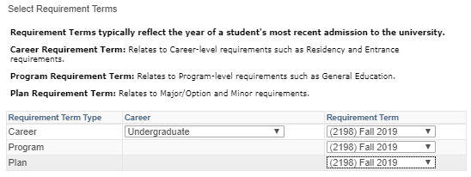

Why did I receive a message that “A degree audit report has not been generated for this program” when requesting a What-if Report?
- This message will be received if you selected a Requirement Term for which a degree audit report has not been built into the system. If this happens, choose a different Requirement Term(s) in consultation with your adviser.

Additional Information

Substitutions and Exceptions
A numbered hyperlink in a degree audit report, like the 03 below, indicates that a substitution or exception has been made by an authorized user (e.g., academic advisor, college dean, records manager). Users can click on the hyperlinked number for details.

Course Equivalents
Courses that are designated as equivalent in the Course Catalog will display in the course list, along with the comparable equivalent(s). For example, a course list may display an Honors course along with the non-honors version.
Once the entire requirement is satisfied, the equivalent course that wasn't taken will no longer display, and the requirement will collapse.

PDF Audit
A PDF version of the degree audit report is available if an audit needs to be printed or saved to the user’s computer. The PDF version has been condensed into columns in order to display the content on fewer pages.

Resources
Video tutorials and documents are available within the Degree Audit section on the LionPATH Support Student Help Page. Students should consult an academic adviser to discuss goals and academic planning.

Statement of Non-Discrimination
The University is committed to equal access to programs, facilities, admission, and employment for all persons. It is the policy of the University to maintain an environment free of harassment and free of discrimination against any person because of age, race, color, ancestry, national origin, religion, creed, service in the uniformed services (as defined in state and federal law), veteran status, sex, sexual orientation, marital or family status, pregnancy, pregnancy-related conditions, physical or mental disability, gender, perceived gender, gender identity, genetic information or political ideas. Discriminatory conduct and harassment, as well as sexual misconduct and relationship violence, violates the dignity of individuals, impedes the realization of the University’s educational mission, and will not be tolerated. Direct all inquiries regarding the nondiscrimination policy to the Affirmative Action Office, The Pennsylvania State University, 328 Boucke Building, University Park, PA 16802-5901, Email: aao@psu.edu, Tel 814-863-0471.

