Checking Your Graduation Status and
Updating Your Diploma Address
Once you have applied for graduation, you will have the ability to check your graduation status as well as review and update your diploma address.
Note: All diplomas are mailed to the diploma address indicated, once graduation is complete.

Navigating to the My Academics Page
- From the Student Home Base, select the Degree Planning and Progress button.
- Select the View Graduation Status button located in the navigation collection on the left side of the page.

Checking Your Graduation Status
Your current programs will be listed at the top of the Graduation Status page with the status of your application displayed to the right of the program. The status will be updated as your application is processed.
Note: If you are in concurrent majors, each one will be listed separately.
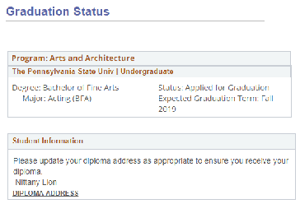
Figure 1: Graduation Status page

Diploma Name
The name that will appear on your diploma is shown in the Student Information section. For more information on changing your diploma name, refer to the University Registrar website.

Diploma Address
The Diploma Address is the address where your diploma will be mailed after graduation. This defaults to the permanent address you have on file. If you would like your diploma mailed to an address other than your permanent address, you must add a Diploma Address type to your record. Select the DIPLOMA ADDRESS link to update this address.

Statement of Non-Discrimination
The University is committed to equal access to programs, facilities, admission, and employment for all persons. It is the policy of the University to maintain an environment free of harassment and free of discrimination against any person because of age, race, color, ancestry, national origin, religion, creed, service in the uniformed services (as defined in state and federal law), veteran status, sex, sexual orientation, marital or family status, pregnancy, pregnancy-related conditions, physical or mental disability, gender, perceived gender, gender identity, genetic information or political ideas. Discriminatory conduct and harassment, as well as sexual misconduct and relationship violence, violates the dignity of individuals, impedes the realization of the University’s educational mission, and will not be tolerated. Direct all inquiries regarding the nondiscrimination policy to the Affirmative Action Office, The Pennsylvania State University, 328 Boucke Building, University Park, PA 16802-5901, Email: aao@psu.edu, Tel 814-863-0471.

