Browsing the Catalog
The Browse Course Catalog page allows you to see courses offered at Penn State. Using the catalog you can see the course description and course details as well as navigate to the course schedule and class details.

Navigating to the Course Catalog
- From the Student Home Base, select the Find Classes button.
- Select the Course Catalog button located in the navigation collection on the left side of the page.

Browsing the Catalog
The Course Catalog displays an alphabetized list of courses offered at Penn State, their descriptions, and related information. To browse for a course, select the letter that corresponds to the first letter of the subject area.
Selecting the arrow to the left of the subject code will display all courses in the selected subject.
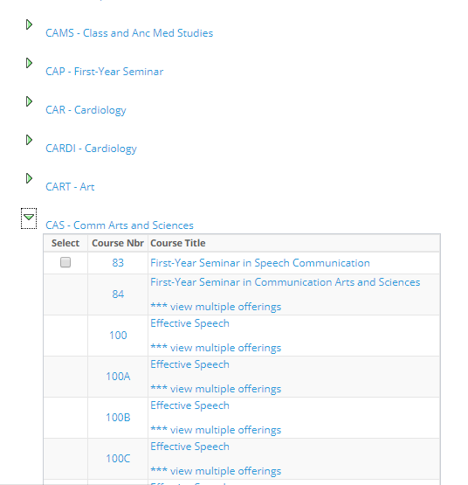
Figure 1: Course List with the subject code expanded

When you select a course, the Select Course Offering page appears. This page lists all of the campus locations where the selected course may be offered.
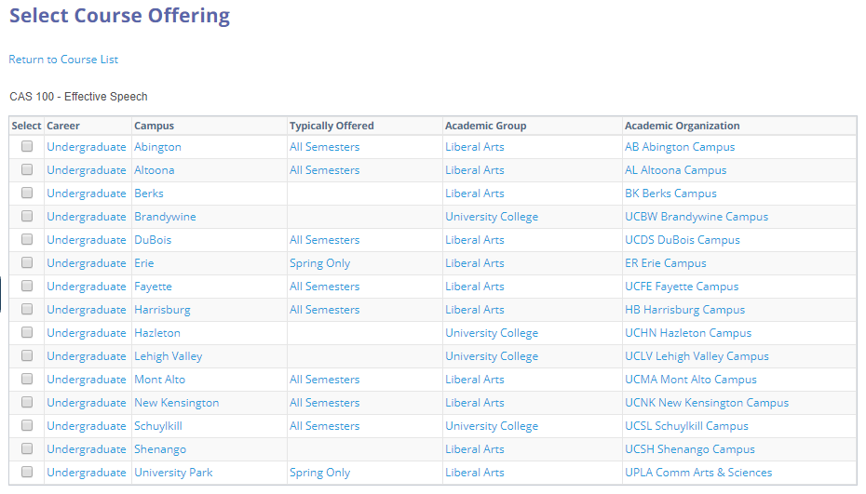
Figure 2: Course Offering page displaying the course offerings by campus
Note: You can add courses to your planner from the catalog by clicking the Add to Planner link. For more information on adding courses to your planner, see the LionPATH Planner tutorial.

Viewing Course Details
If the course has been scheduled, additional course information can be viewed including the Course Details, Enrollment Information, and Description. In addition, you can view the class sections of the course.
- Select the Campus link where you would like to review the details of the course.
- Select the View Class Sections button, on the Course Detail page, to display the sections of the course for the selected term (semester).
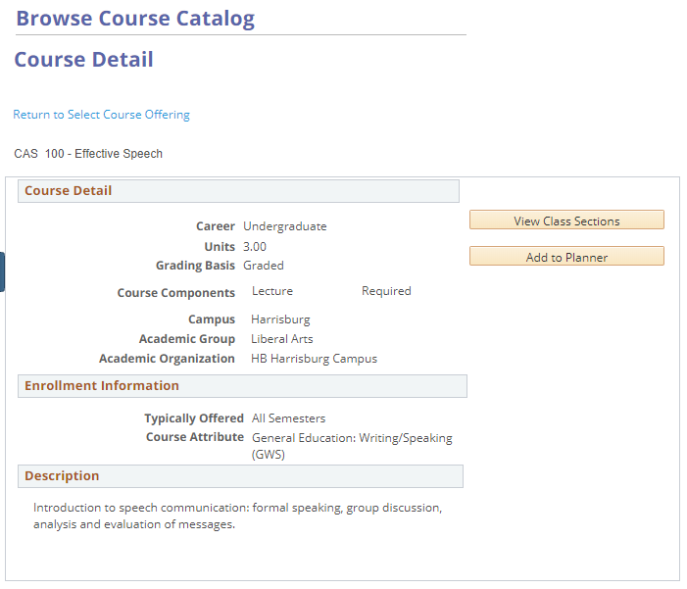
Figure 3: Course Detail page

- Select the term for which you want to view the sections and select the Show Sections button.

Viewing Class Details
The Class Details page contains the meeting and enrollment information, class availability, course description, and any currently available textbook information.
- Select the Section link to open the Class Details page for that specific section.
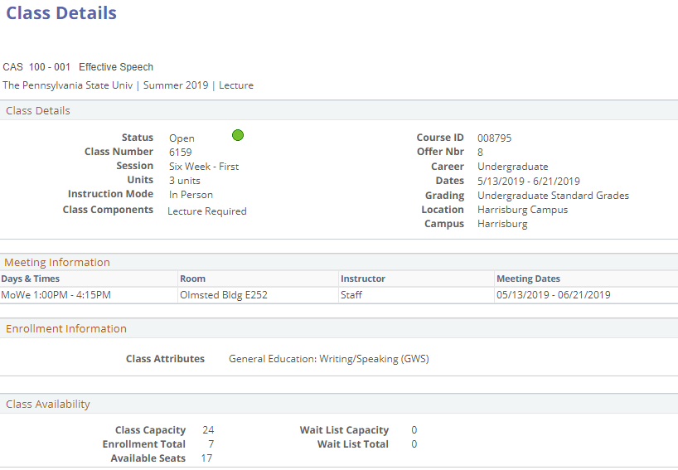
Figure 4: Course Schedule section for the specified term
Note: If you have an open Shopping Cart (Validation) Appointment and/or Enrollment Appointment, the Select button will appear to the right of each class section. Clicking the Select button will take you to the Enrollment Preferences page where you can view the detail of the class and add it to your shopping cart.

Statement of Non-Discrimination
The University is committed to equal access to programs, facilities, admission, and employment for all persons. It is the policy of the University to maintain an environment free of harassment and free of discrimination against any person because of age, race, color, ancestry, national origin, religion, creed, service in the uniformed services (as defined in state and federal law), veteran status, sex, sexual orientation, marital or family status, pregnancy, pregnancy-related conditions, physical or mental disability, gender, perceived gender, gender identity, genetic information or political ideas. Discriminatory conduct and harassment, as well as sexual misconduct and relationship violence, violates the dignity of individuals, impedes the realization of the University’s educational mission, and will not be tolerated. Direct all inquiries regarding the nondiscrimination policy to the Affirmative Action Office, The Pennsylvania State University, 328 Boucke Building, University Park, PA 16802-5901, Email: aao@psu.edu, Tel 814-863-0471.

