Completing the Pre-Registration Activity Guide Desktop Guide

Pre-Registration Activity Guide Information
Prior to each semester’s enrollment, a Pre-Registration Activity Guide will be assigned to your To Do List in LionPATH. The Pre-Registration Activity guide contains the Financial Responsibility Agreement as well as Emergency Contact and Missing Person Information sections. Completion of the Pre-Registration Activity Guide is required each semester and will release the Financial Responsibility hold on your record. When the Financial Responsibility hold is removed, you will be able to enroll during your enrollment window.

Navigating to the Pre-Registration Activity Guide
You will be notified via email when the Pre-Registration Activity Guide is assigned to your To Do List. Log into LionPATH using your Access ID and password.
From the Student Home Base, click on To Do List
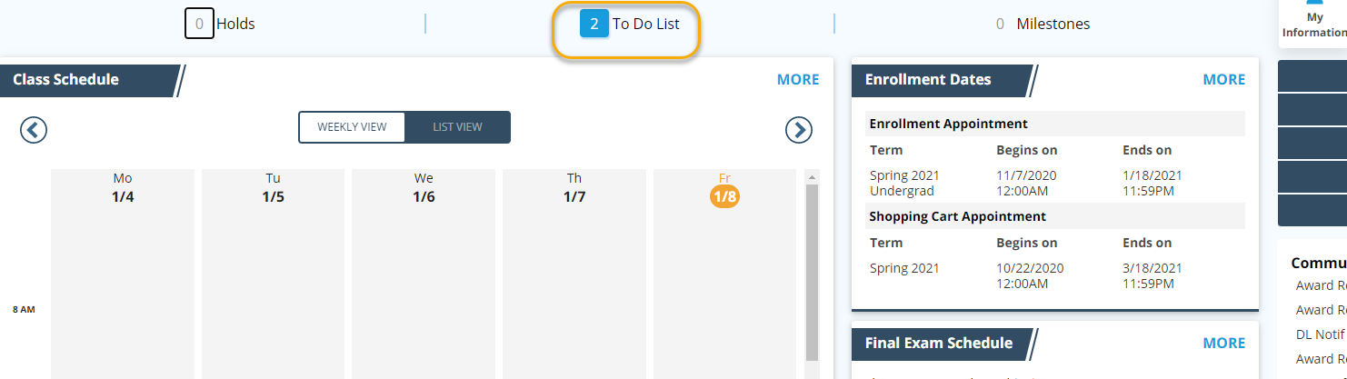

On the next screen, you will see the Pre-Registration Activity Guide assigned for the upcoming or current term. Note that the image in this help guide may not always reflect the term for which you are completing the Pre-Registration Activity Guide.
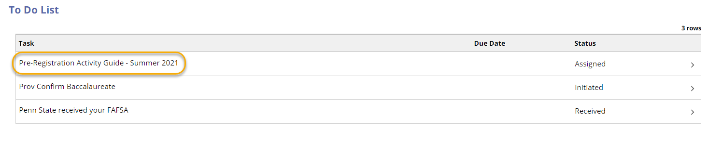

Completing the Pre-Registration Activity Guide
Clicking on the Pre-Registration Activity Guide task in your To Do list will take you to the first page of the guide. The left side of the guide will display progress as you complete each page. Use the Confirm (or variation of confirm), Next, and Submit buttons as directed to progress through the guide. Your Financial Responsibility hold will be removed upon submission of the guide.
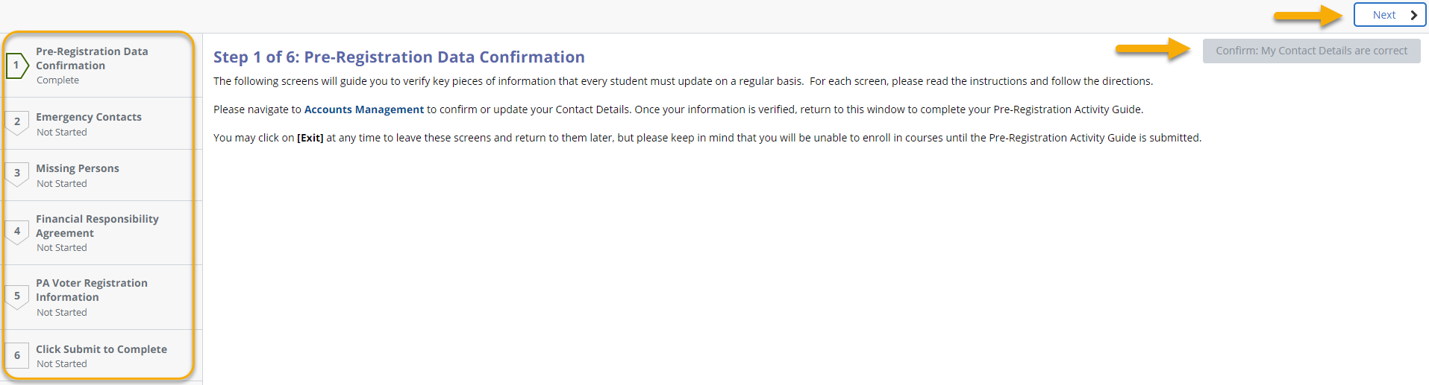

Statement of Non-Discrimination
The University is committed to equal access to programs, facilities, admission, and employment for all persons. It is the policy of the University to maintain an environment free of harassment and free of discrimination against any person because of age, race, color, ancestry, national origin, religion, creed, service in the uniformed services (as defined in state and federal law), veteran status, sex, sexual orientation, marital or family status, pregnancy, pregnancy-related conditions, physical or mental disability, gender, perceived gender, gender identity, genetic information or political ideas. Discriminatory conduct and harassment, as well as sexual misconduct and relationship violence, violates the dignity of individuals, impedes the realization of the University’s educational mission, and will not be tolerated. Direct all inquiries regarding the nondiscrimination policy to the Affirmative Action Office, The Pennsylvania State University, 328 Boucke Building, University Park, PA 16802-5901, Email: aao@psu.edu, Tel 814-863-0471.

