Completing the Pre-Registration Activity Guide
Prior to each semester’s enrollment, a Pre-Registration Activity Guide will appear on your record. It contains a Financial Responsibility Agreement as well as an Emergency Contact section, both of which are required to be completed each semester. Completing this activity guide will release the Financial Responsibility hold and allow you to enroll during your enrollment window.
You will be notified via email when the Pre-Registration Activity Guide is available for you to complete. At this time, the Financial Responsibility hold will also be placed on your record. You can access the Activity Guide via LionPATH.

Navigating to the Pre-Registration Activity Guide
The Pre-Registration Activity Guide can be accessed using the direct link in the body of the email or through LionPATH.
- To access the activity guide, click on the number to the left of the To Do List.
- To complete an item, select the link in the Task column.
Note: A Financial Responsibility hold will also be placed on your account. This hold will be released when you have completed the activity guide.

Pre-Registration Activity Guide: Interface
The left side of the activity guide screen contains the tasks in the activity guide as well as your progress in completing them.
The center of the screen contains information or tasks that must be completed. In this case, directions on how to complete the guide are included.
The upper right contains navigation buttons to move through the activity guide. Click the Mark as Read button when you have completed the screen.
Note: You can use the Exit button to leave at any point and return to the activity guide later, if necessary.
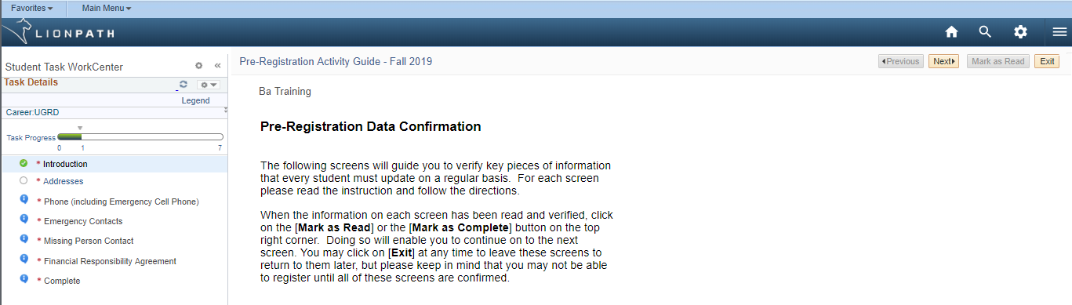
Figure 1: Introduction page of the Pre-Registration Activity Guide

Each time you select the Mark as Read/Completed button and then select the Next button the Task Progress bar will move and the task that is completed will have a green check icon in front, to indicate it is complete.
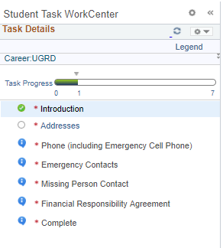
Figure 2: Student Task WorkCenter
Note: Be sure to select Mark as Read/Completed on each screen before selecting the Next button so that your progress is marked as complete. All tasks must be marked as complete for the activity guide to be considered complete.

Pre-Registration Activity Guide: Tasks
The Pre-Registration Activity Guide contains several task that you will need to complete before you can enroll for classes. You must review/update personal information and agree to assume financial responsibility for your tuition.

Introduction
The introduction contains the instructions for completing the guide. You must click the Mark as Read button to continue with the task list.

Addresses
Review your Addresses to ensure they are accurate and make any necessary changes. You can edit current addresses by clicking the pencil icon or you can add an additional address using the Add a new address button. The ability to delete addresses will only appear on certain address types.
When you are finished, select the Mark as Complete button and then the Next button to move to the next screen.
Note: Ensure the Addresses tasks has a green check icon in the progress section indicating it is complete.

Phone Numbers
Review your Phone Numbers information and make any needed changes. You can edit current phones by typing in the fields or you can add an additional phone using the Add a Phone Number button. Be sure that you indicate your preferred method for phone contact using the checkbox. Select the SAVE button if you made any changes.
Note: Your Emergency Cell will only be used in the event of an emergency.
When you are finished, select the Mark as Complete button and then the Next button to move to the next screen.

Emergency Contacts
Review your Emergency Contacts information and make any needed changes. You can edit current contacts by clicking the pencil icon or you can add an additional contact using the Add an Emergency Contact button. Be sure that you indicate your primary contact using the checkbox. Select the Save button if you made any changes.

Missing Persons Contacts
The Missing Persons Contacts page allows you to indicate whom to contact in the event you are missing. A checkbox is available that allows you to make this information the same as your emergency contact information. If you would like this to be different than your emergency contact information, remove the checkmark and edit the appropriate information. In addition, you can decline to provide missing person contact information by checking the checkbox. Select the Save button if you made any changes.
Note: Students under the age of 18 will not have the option to decline providing missing person contact information. When you are finished, select the Mark as Complete button and then the Next button to move to the next screen.

Financial Responsibility Agreement
The last item in the Pre-Registration Activity Guide is the Financial Responsibility Agreement. Use the scroll bar within the agreement to read through the entire document.
- Once you have read and fully understand the terms and conditions of the agreement, select the Accept checkbox.
- Select the Save button to complete the process. Note: The Printable Page button is available if you would like a printed copy of the Financial Responsibility Agreement.
- Select the Next button to move to the next screen.
- Select the Finish button to complete the activity guide and return to the Student Center.
Once you have completed the Pre-Registration Activity Guide, the Pre-Registration Activity Guide and the Financial Responsibility hold will be removed from your record.
Note: If they still appear on your record, return to the activity guide and check that all tasks are complete.

Statement of Non-Discrimination
The University is committed to equal access to programs, facilities, admission, and employment for all persons. It is the policy of the University to maintain an environment free of harassment and free of discrimination against any person because of age, race, color, ancestry, national origin, religion, creed, service in the uniformed services (as defined in state and federal law), veteran status, sex, sexual orientation, marital or family status, pregnancy, pregnancy-related conditions, physical or mental disability, gender, perceived gender, gender identity, genetic information or political ideas. Discriminatory conduct and harassment, as well as sexual misconduct and relationship violence, violates the dignity of individuals, impedes the realization of the University’s educational mission, and will not be tolerated. Direct all inquiries regarding the nondiscrimination policy to the Affirmative Action Office, The Pennsylvania State University, 328 Boucke Building, University Park, PA 16802-5901, Email: aao@psu.edu, Tel 814-863-0471.

