Accepting, Declining, or Decreasing your
Financial Aid Awards
If you were awarded aid, you can accept, decline, or decrease the aid amount using the LionPATH system.
Note: Only certain types of aid must be accepted or declined.

Navigating to the Award Package Page
- From the Student Home Base, select the My Finances button.
- Select the Financial Aid button located in the navigation collection on the left side of the page.
- Select the ACCEPT/DECLINE AWARDS button.
- Select the link for the Aid Year you would like to view.
- The Financial Aid Award Summary page is displayed. For information on viewing your financial aid award, see the Viewing Your Financial Aid tutorial. To accept or decline your award, scroll down the page and select the ACCEPT/DECLINE AWARDS button.

Viewing Award Package
The Financial Aid Award Package page displays all awards you are eligible to receive during the selected year.
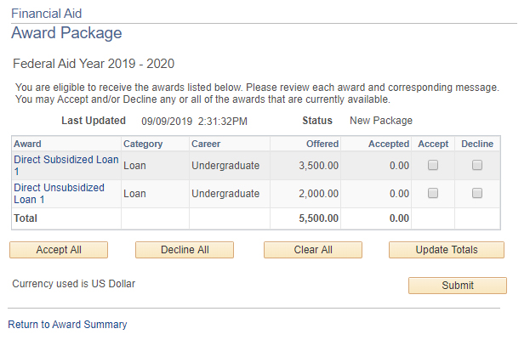
Figure 1: Award Package page
Note: Aid that needs to be accepted includes Federal Work-Study and student loans (Direct Subsidized and Unsubsidized, Federal Perkins, University, Graduate PLUS, and Private Alternative). Grants, scholarships, and Parent PLUS loans are automatically accepted on your behalf.
Clicking the Award link will display the Award Detail page, which contains a breakdown of the aid disbursement as well as a description of the award. Lender fees and net loan disbursement amounts are displayed for loans.
The accept all or decline all buttons can be used to accept or decline all awards.
Note: The decline all button will not decline any grants, scholarships, or Parent PLUS loans you have been awarded.

Accepting and Declining Awards
- If you wish to accept the award or a portion of the award, check the Accept checkbox. Once the Accept checkbox is selected you are able to decrease the award amount listed in the Accepted field.
- If you want to decline the aid, check the Decline checkbox. Note: If you decline an award you are declining it for the whole year.
- To have the award total recalculated based on your changes, click the update totals button.
- Once you have made your selections, select the Submit button. Note: After you select the Submit button, you will not be able to increase the aid amount you accepted on this page. However, you can still decrease the amount. Ensure that you have calculated the loan amount needed before submitting any loan changes.
- Click the Yes button to accept/decline your aid awards. Note: Selecting the No button will cancel your selections and take you back to the Financial Aid Award Package page.
- A confirmation message will display. Select the OK button to return to the Financial Aid Award Package page where you can review your selections.

If you choose to decline financial aid you will need to contact the Financials Aid office to request a reinstatement of aid, if applicable.
Note: If you decline any awards, the Awards Summary page will display a button for viewing the details of the declined award.

Statement of Non-Discrimination
The University is committed to equal access to programs, facilities, admission, and employment for all persons. It is the policy of the University to maintain an environment free of harassment and free of discrimination against any person because of age, race, color, ancestry, national origin, religion, creed, service in the uniformed services (as defined in state and federal law), veteran status, sex, sexual orientation, marital or family status, pregnancy, pregnancy-related conditions, physical or mental disability, gender, perceived gender, gender identity, genetic information or political ideas. Discriminatory conduct and harassment, as well as sexual misconduct and relationship violence, violates the dignity of individuals, impedes the realization of the University’s educational mission, and will not be tolerated. Direct all inquiries regarding the nondiscrimination policy to the Affirmative Action Office, The Pennsylvania State University, 328 Boucke Building, University Park, PA 16802-5901, Email: aao@psu.edu, Tel 814-863-0471.

