Viewing Your Academic Background
You can view select academic background information via LionPATH’s Academic Background page.
Note: The first time you access LionPATH you will provide your consent to do business electronically. This consent will be required annually.

Navigating to the Academic Background Page
- From the Student Home Base, select the Academic Records button.

Viewing Your Academic Background
The Academic Background page is divided into multiple sections.
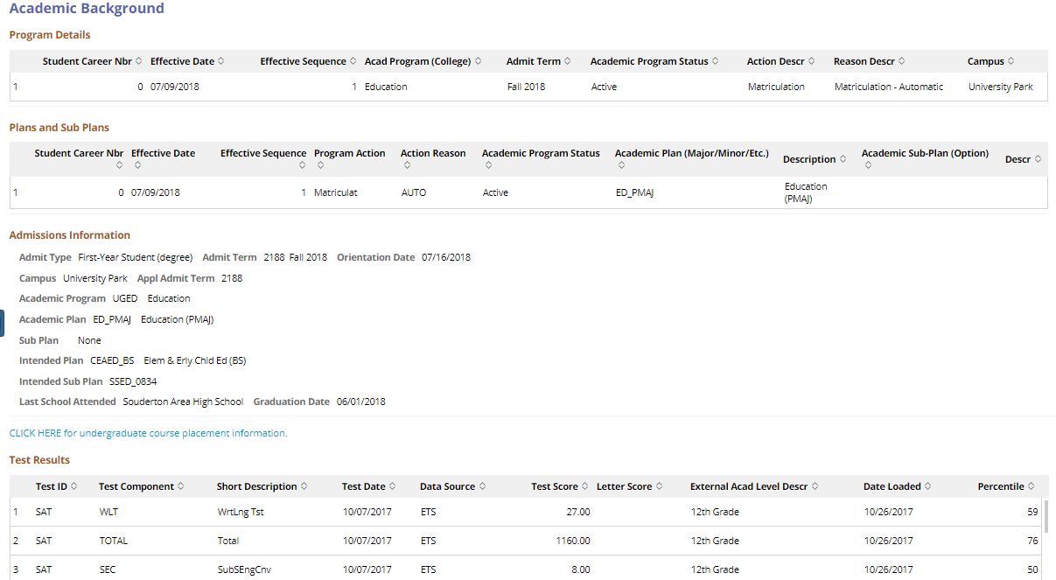
Figure 1: Academic Background page

Program Details and Plans and Sub Plans
The Program Details and Plans and Sub Plans sections display your current academic information including College, Major/Minor, and Option (if applicable).

Admissions Information
The Admissions Information section displays information regarding your admission into the University. For example, Admit Type, Admit Term, Academic Program (College), and Academic Plan (Major).
Note: The Campus listed in this section is the Campus you were initially admitted into.

The CLICK HERE for undergraduate course placement information link, located above the Test Results section, will open course placement information for undergraduate students.

Test Results
The Test Results section displays various types of data in the form of text results. To sort based on a column, click on any column header.
Note: The highest ALEKS score is used for Math, Statistics, and Chemistry placement. The highest SAT-READ writing score is used for English placement.

Statement of Non-Discrimination
The University is committed to equal access to programs, facilities, admission, and employment for all persons. It is the policy of the University to maintain an environment free of harassment and free of discrimination against any person because of age, race, color, ancestry, national origin, religion, creed, service in the uniformed services (as defined in state and federal law), veteran status, sex, sexual orientation, marital or family status, pregnancy, pregnancy-related conditions, physical or mental disability, gender, perceived gender, gender identity, genetic information or political ideas. Discriminatory conduct and harassment, as well as sexual misconduct and relationship violence, violates the dignity of individuals, impedes the realization of the University’s educational mission, and will not be tolerated. Direct all inquiries regarding the nondiscrimination policy to the Affirmative Action Office, The Pennsylvania State University, 328 Boucke Building, University Park, PA 16802-5901, Email: aao@psu.edu, Tel 814-863-0471.

