ALEKS MATH ASSESSMENT FAQs

How/where do I find the ALEKS Math Assessment link in LionPATH?
- Go to the LionPath Support Page at https://lionpathsupport.psu.edu
- Click on the yellow Students, Faculty, Staff Login button to log in to LionPATH. Note: You must use your Penn State Access Account.
- From the student home page, click Academic Records.
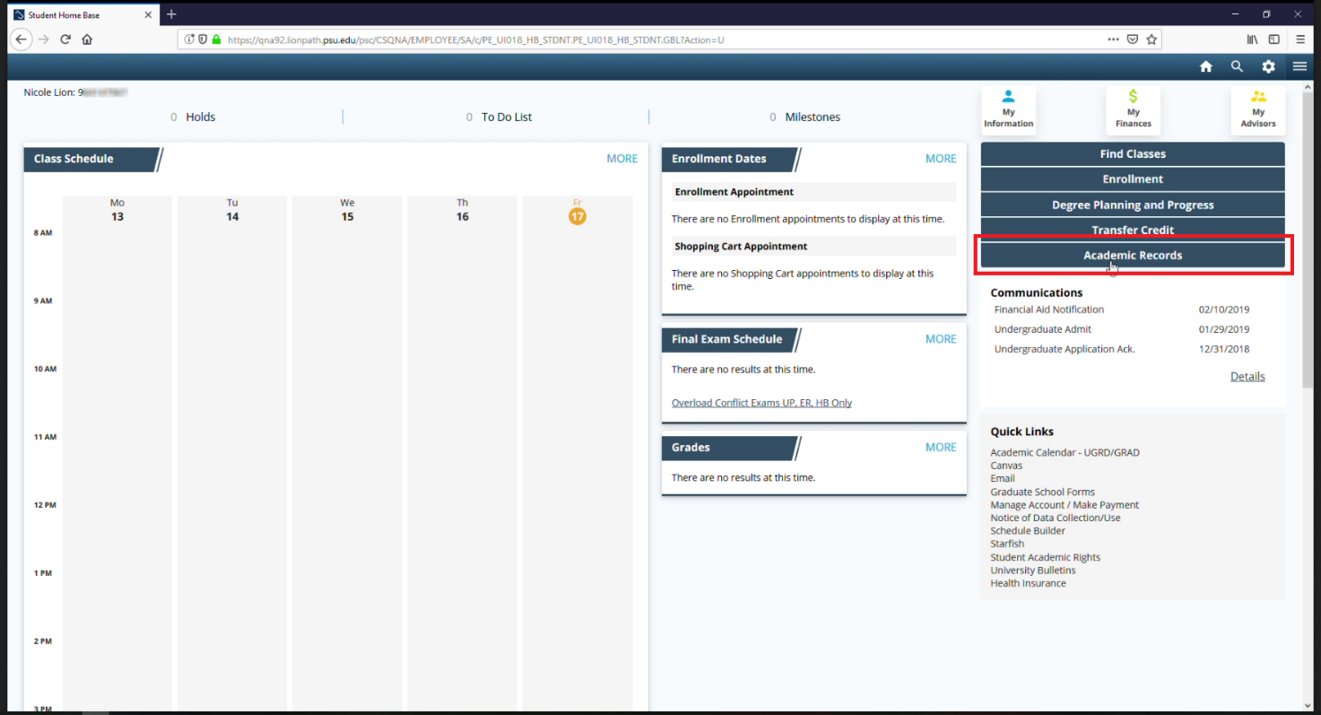
- From the left navigation menu, click ALEKS Math Assessment.
- Click the ALEKS Math Assessment button to enter ALEKS.
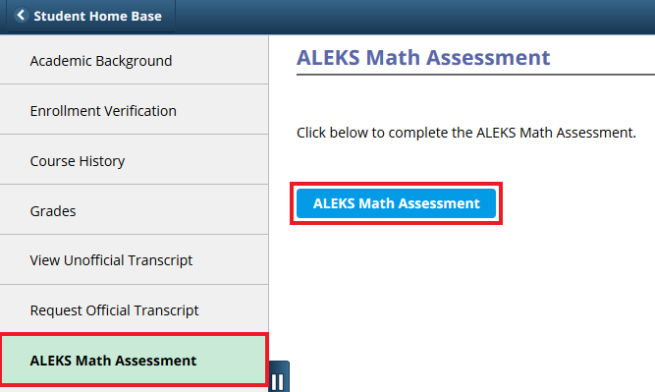
If you need to return to ALEKS, follow the previous steps, then within ALEKS, click on the “Incoming Students…” class to resume your progress.

How/Where do I find my ALEKS Math Assessment score in LionPATH?
- From the student home page, click Academic Records.
- Your Academic Background page will display.
- Scroll down to the Test Results section and find your ALEKS score.
Note: You can get to your ALEKS score easily in the Test Results table by clicking the sort icon in the Test ID column, which will sort the Test ID alphabetically.
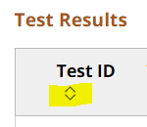
Note: If you completed ALEKS more than once, the highest score is used for course placement purposes.
See the screenshot below for an example of what can be found in and around the Test Results section on the Academic Background page for undergraduate students:
- The green rectangle indicates an external link to interpret course placement information.
- The red rectangle indicates a row with an ALEKS score, including the Test Date and Test Score.

Note: You can also click on the column titles (i.e., Test ID, Test Score, etc.) to sort the columns.
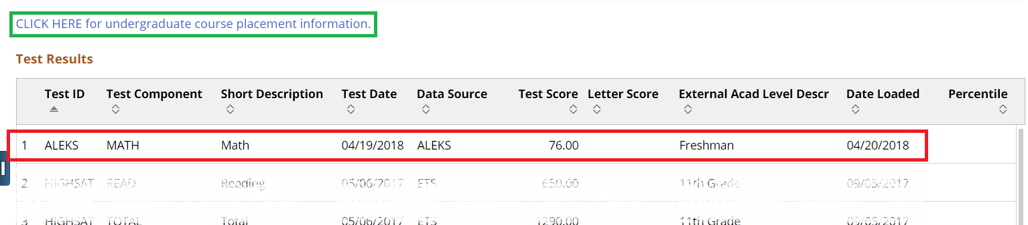

When does the ALEKS Math Assessment link become available in LionPATH?
- New, first-year, undergraduate admits: The link to ALEKS typically becomes available in LionPATH approximately 24-72 hours after you accept your offer of admission and pay your acceptance fees.
- Continuing PSU students and new transfer students:
  - You must first be identified by an Academic Adviser as needing to take the ALEKS Math Assessment.
  - If so, your campus/college/unit/adviser will have an internal process for flagging you as needing to take ALEKS and will make the link available to you in LionPATH.
  - Please allow 24-72 hours from the time the campus/college/unit/adviser indicates that you need ALEKS for the link to display in LionPATH. (If it takes longer than 72 hours, please contact an Academic Adviser for assistance.)

When will my ALEKS Math Assessment score become available in LionPATH?
- Scores typically become available in LionPATH approximately 24-72 hours after you complete the ALEKS Math Assessment.

Where can I find more information?
- Visit the ALEKS Math Assessment website at http://advising.psu.edu/aleks/

Statement of Non-Discrimination
The University is committed to equal access to programs, facilities, admission, and employment for all persons. It is the policy of the University to maintain an environment free of harassment and free of discrimination against any person because of age, race, color, ancestry, national origin, religion, creed, service in the uniformed services (as defined in state and federal law), veteran status, sex, sexual orientation, marital or family status, pregnancy, pregnancy-related conditions, physical or mental disability, gender, perceived gender, gender identity, genetic information or political ideas. Discriminatory conduct and harassment, as well as sexual misconduct and relationship violence, violates the dignity of individuals, impedes the realization of the University’s educational mission, and will not be tolerated. Direct all inquiries regarding the nondiscrimination policy to the Affirmative Action Office, The Pennsylvania State University, 328 Boucke Building, University Park, PA 16802-5901, Email: aao@psu.edu, Tel 814-863-0471.

