Using Delegated Access
Delegated Access provides parents, guardians, or other individuals access to view specific student data in LionPATH. Students are responsible for setting up their delegates in the system and determining which areas they may view.
Note: Once the student has completed the setup of Delegated Access, the delegate will receive an email with instructions on how to log in to LionPATH.

Email Message from Your Student
Delegates will be notified via email that they have been granted Delegated Access in LionPATH.
- The email will be sent to the email address the student indicated during the setup process. If no email is received, the student should verify that they’ve entered the correct email address. If you know the student entered the correct email address, check your Junk or Spam email folders.
- Included in the email are your Login ID and temporary Password. You may use either the unique Delegated Access Login ID provided or the email address displayed to log in to the system. Note: You will be prompted to change your password the first time you log in to LionPATH.
- If you are granted delegated access by a second student (or 3rd, 4th, etc.) using the same email address, the activation email will arrive with a blank password. When you log in to LionPATH, you will be presented with a drop-down box where you can select which student you wish to view. This will allow you to use a single login ID and password for all students who have granted you delegated access.
Note: You will be prompted to change your password the first time you login to LionPATH.

Accessing LionPATH
- Click the log in to LionPATH link, in the email, to go to the LionPATH login screen.
Note: The Delegated Access Login screen can be accessed in the future by visiting the LionPATH Guest page at https://public.lionpath.psu.edu and clicking the Delegated Access tab.
- You can access LionPATH by entering the unique Delegate Access Login ID and temporary Password that appeared in the email. Note: If you prefer, you can use your email address in place of the login ID.
- Click the Login button.

Changing Your Password
The first time you log in to the system as a delegate, you will be prompted to change your password.

- Set your new password by entering your temporary/current password and new password in the appropriate fields.
- Click the SUBMIT CHANGE button. Once you log in, you will be taken to the Delegate Home page.
Note: You can change your Delegate account password at any time by clicking on the Account Settings link in the Delegate Home information box.
Accessing your Students Information
The Delegate Home page contains boxes for viewing each area of Delegated Access.
- Class Schedule
- Financial Aid Awards
- Grades
- Holds
- To Do List
- Enrollment Verification
Note: If the student does not give you access to view a specific item, i.e., grades, then that box will display the message, "You have not been granted access to this area."

Class Schedule
The Class Schedule box allows you to view the student’s current semester schedule. You can access the student’s class schedule by clicking on the semester displayed.
Note: If the student is not registered for classes in the current semester, a note will appear letting you know that there are no results to display at this time.

View Class Schedule Details
- Click the CLASS SCHEDULE DETAILS link to view the additional class details.
- If prompted, select the term in which you would like to view your exam schedule and click the CONTINUE button.

You can choose to display the class schedule in a list view or a weekly calendar view by clicking the appropriate Display Option radio button.
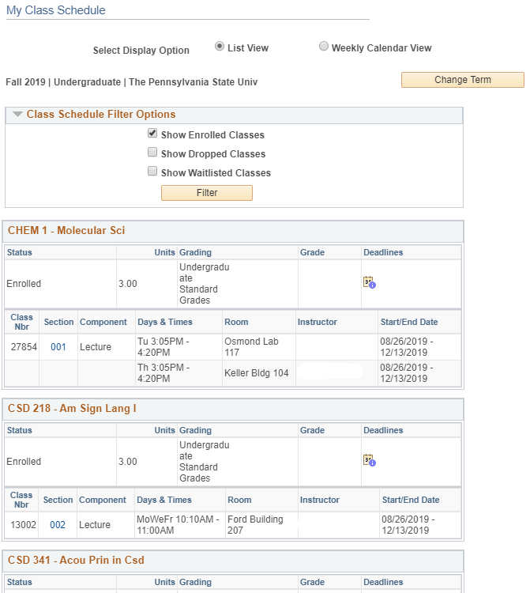
Figure 1: A student’s schedule displayed in list view
In List View, filters are available to allow you to display enrolled classes, classes dropped during the regular drop/add period, and wait-listed classes. Select the appropriate checkboxes and click the filter button to update the schedule.
Icons and links located on the page will provide you with additional information and details. Clicking the calendar icon under the Deadlines column will display the selected semester deadline dates for dropping and withdrawing from a class. The class section number link will display the details of the class section.
- Click on the class section number link to see the details of the class.
The Class Details page contains meeting and enrollment information, class availability, course description, textbook information when it’s made available, and additional details.
The Textbook information is located at the bottom of the page. Clicking the View Books link will open the Barnes & Noble web site in a new tab and display the textbooks for this class. From there, you can see details about the books and place your order. A new tab will open for each class, but the books will be in one shopping cart.
Note: For World Campus courses a textbook link will appear at the top of the page for the class.

Financial Aid Awards
You can view a snapshot of the student’s financial aid by clicking on an aid year listed in the Financial Aid Awards box. Once the term is expanded, clicking on the VIEW AID YEAR DETAIL button will provide additional information about the aid for the specified term. You can also view the award detail by click the VIEW AWARD DETAIL button located at the bottom of the Financial Aid Awards box.
- Click the VIEW AWARD DETAIL button to see the additional information.
- Click the link for the year you wish to view your student’s Award Summary.

The Financial Aid Award Summary contains Estimated Billable Expenses and Aid as well as Estimated Non-Billable Expenses.

Estimated Billable Expenses and Aid
Estimated Billable Expenses will include tuition and fees as well as room and meals for students indicating they will be living on-campus.
Note: To view additional information on expenses and aid, click the information (i) icon located to the right of the item.

Estimated Non-Billable Expenses
Estimated Non-Billable Expenses includes books, supplies, transportation, and other miscellaneous expenses. Also, room and meals will appear in this section if students indicate on the FAFSA that they would be living off-campus.

Financial Aid Shopping Sheet
The Financial Aid Shopping Sheet is a standardized form for first-year students. It contains information to help you easily compare financial aid packages offered by different institutions.
- Click the Financial Aid Shopping Sheet button to view the form.
This form can assist you in understanding the education cost of attending college and the aid which may be available to help with these expenses.
Note: Since the Financial Aid Shopping Sheet opens in a new window or tab, close the window or tab to return to the Award Summary page.

Viewing the Award Summary letter
The PRINT button will generate a Financial Aid Award Summary letter. This letter contains the student’s estimated billable expenses and aid. Additional information is provided to help you understand the financial aid package.
- Click the PRINT button to generate a Financial Aid Award Summary letter.
- The Award Summary letter will open in a new window or tab. Close the letter to return to the Award Summary page.

Financing Strategies, Satisfactory Academic Progress, and Required Actions
In addition to estimated expenses and aid, the Financial Aid Award Summary page contains information on financing strategies, satisfactory academic progress, and additional steps necessary to prevent delays in the processing of aid. Click on the links in each section to view additional information.
Note: Once you are finished viewing the Financial Aid Award Summary page, you can return to the Delegate Access Home page by clicking the SELECT ANOTHER AID YEAR link and then select the Delegate Home Page link.

Grades
The Grades box will display the last four terms the student attended Penn State. Selecting a term will display the grades the student received for that term.

View Grades Details
- Click the VIEW MORE GRADES link, located at the bottom of the Grades box, to display the student's current classes, and to select the semester you wish to view.
- The selected term information is located above the Class Grades table. Clicking the CHANGE TERM button will take you to a screen where you can select a new term to display.
The View My Grades page is displayed with a list of all the terms you have attended at Penn State.
- Select the term you wish to view and click the CONTINUE button.
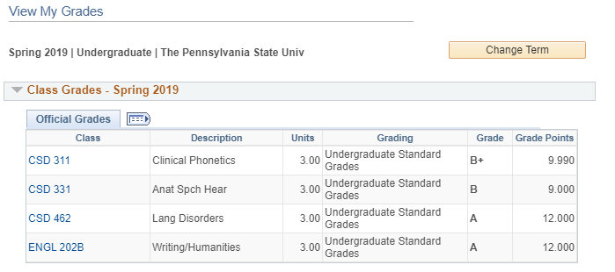
Figure 2: View My Grades page with Class Grades for Spring 2015
The top part of the page displays the enrolled classes for the selected term, the units taken, and the grades earned.
Note: Clicking on a class link will display the details for that class.
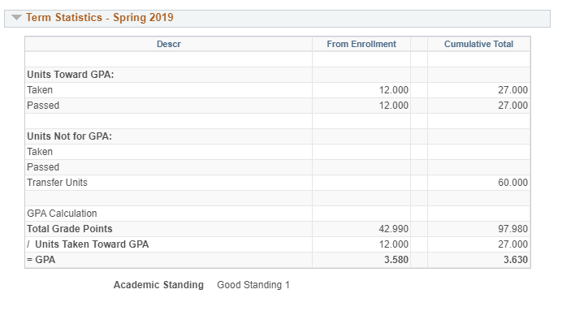
Figure 3: View My Grades page with Term Statistics for Spring 2015
The term statistics for the selected term are displayed at the bottom of the page. The From Enrollment column displays the units and GPA for the selected term. The Cumulative Total column displays all units, including transfer credits, as well as the cumulative GPA up to and including the selected term.
Note: To see the current GPA, view the term statistics for the last semester in which the student received grades.
The Units Towards GPA area includes all units taken at Penn State for a letter grade, even if an F was earned. In this example, the student has 65 cumulative units.
The Units Not for GPA section includes:
- Units satisfactorily completed under the satisfactory/unsatisfactory grading system
- Units earned by examination
- Research units
- Units Transferred to Penn State from another institution

Holds
You can view holds currently on the student’s record. The Holds box will show the number of holds on the student’s account. Clicking the View Holds link will display the holds.
The details of the hold contain the start and end terms/dates of the hold. Clicking on the name of the Hold Item will provide you with the appropriate contact information.

To Do List
The To Do List can be accessed by clicking the View To Do List link. This list contains items that need to be completed by the student. Items placed on this list could impact the student’s ability to complete other tasks.
Note: The To Do List will be used to notify students of the receipt of FAFSA information.
The Task List will display showing the details of each To Do item including the due dates and status.

Enrollment Verification
The Enrollment Verification box provides you access to a printed statement of a student’s academic information.
- Click the Request Enrollment Verification link.

Printing an Enrollment Verification Statement
- To print a copy of the Enrollment Verification, verify that Allow to Print from My Browser is displayed in the Select Processing Options drop-down box.
- Leave both checkboxes checked to include the academic information on your Enrollment Verification.
- Click the SUBMIT button to view the statement.
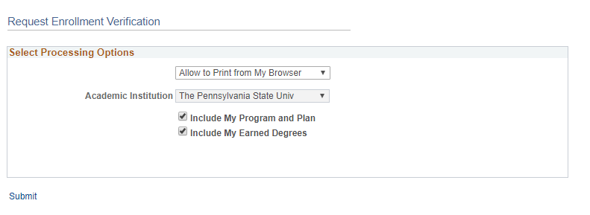
Figure 4: Print Processing Options displayed on the Request Enrollment Verification page
Once the Enrollment Verification statement is displayed. You can click the Printer Friendly Version button at the bottom of the page to create a version of the Enrollment Verification that is optimized for printing.

Requesting an Official Enrollment Verification Statement
- To have the University mail the Enrollment Verification statement, select Request Institution to Mail from the Select Processing Options drop-down menu.
- Leave both checkboxes checked to include the academic information on your Enrollment Verification.
When you select Request Institution to Mail from the drop-down menu above, the Enter Recipient Address Information section will appear.
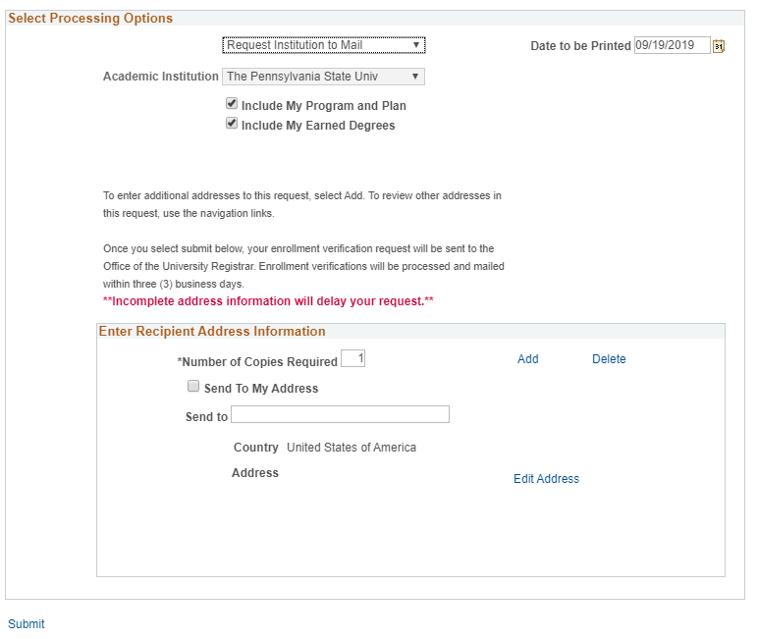
Figure 5: Processing Options for an official verification
Complete the request by filing out the address information.
- To have the Enrollment Verification statement sent to the student, click the Send to My Address check box. Note: To have the Enrollment Verification sent to someone other than the student, enter the name of the recipient and click the Edit Address link.
- Click on the Edit Address link.
- The Edit Address screen displays. Enter the recipient’s address into the fields.
- Once you are finished entering the address, click the OK button.

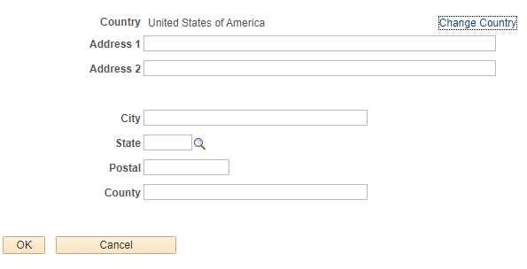
Figure 6: Edit Address page
The system checks to make sure the address entered is a valid address. You can click the OK button to accept the address or the Cancel button to use the address you entered. Note: This message will only appear for addresses in the United States and Canada.
- Once the address has been entered, click the SUBMIT button to send the request.
Confirmation that you successfully submitted the request will display.

END

Statement of Non-Discrimination
The University is committed to equal access to programs, facilities, admission, and employment for all persons. It is the policy of the University to maintain an environment free of harassment and free of discrimination against any person because of age, race, color, ancestry, national origin, religion, creed, service in the uniformed services (as defined in state and federal law), veteran status, sex, sexual orientation, marital or family status, pregnancy, pregnancy-related conditions, physical or mental disability, gender, perceived gender, gender identity, genetic information or political ideas. Discriminatory conduct and harassment, as well as sexual misconduct and relationship violence, violates the dignity of individuals, impedes the realization of the University’s educational mission, and will not be tolerated. Direct all inquiries regarding the nondiscrimination policy to the Affirmative Action Office, The Pennsylvania State University, 328 Boucke Building, University Park, PA 16802-5901, Email: aao@psu.edu, Tel 814-863-0471.

