Update Campus --Frequently Asked Questions

What is Update Campus?
Update Campus allows undergraduate students to request a permanent or temporary change of campus for the upcoming term. Students who are not undergraduates will receive a message indicating the online application is not available for their use.

How do I make an Update Campus request?
Students should submit their own requests by going to their Student Home Base, selecting “Degree Planning and Progress” on the right-hand side of the page, clicking Update Campus and following the prompts.
There will be at least one person at each campus or college who can initiate a request for a student in the event circumstances prevent them from doing so. Information on who can do that for each college/campus can be found at: http://www.registrar.psu.edu/change_campus/contacts.cfm

What are the parameters for automated and manual Update Campus responses?
Parameters are illustrated in the chart below.
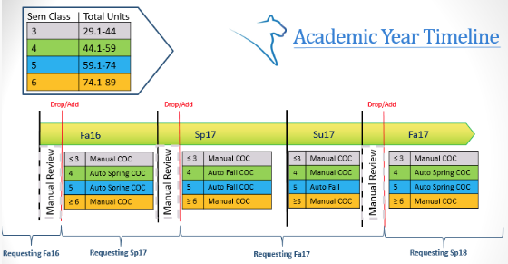

What does a “manual” Update Campus response mean?
Requests falling outside of the automated approval window will be manually reviewed by both the sending and receiving campuses. If either campus denies the change of campus request, the student will be denied.

How soon will I receive a response?
Automated approvals happen immediately. If designated parameters for an automated approval are not met, immediate notification that the request will be manually reviewed by both campuses will be received. The amount of time required for this type of review will vary by college or campus.

If my request is denied, when can I request another?
At the present time, the number of requests per term is not limited. If multiple requests are submitted in an attempt to change campus without valid reasons, a conversation regarding what constitutes an appropriate request will be initiated.

Can I request a temporary change of campus through Update Campus?
Yes. Select “Yes” beside “Temporary COC (one term)” and provide an explanation regarding its need. A temporary COC request will always be sent for a review.

Can I request a change of campus if I’m still in pre-major status?
Yes. However, you are encouraged to change your major via Update Academics before using Update Campus, if at all possible. All students in pre-major status will be reviewed.

If I have an Update Campus request under review, can I submit a request through Update Academics?
Update Academics and Update Campus requests that are under review must be resolved prior to submitting a request within the alternate application.

Can I make a request through Update Campus if I’m conditionally approved for a change of major through Update Academics?
Yes. If you receive a conditional change of major approval in Update Academics, you should file a COC request.

Will I be able to register at my new campus once my request is approved?
Yes. For both temporary and permanent approvals, students are responsible for enrolling at their correct campus when their enrollment appointment opens. Students who are approved for a temporary change of campus will automatically be “returned” to their home campus for the following term.

How do I cancel my Update Campus request if it’s under review?
Please contact the approver at both your home and approving college/campus and ask them to deny your request. Contacts for Change of Campus approvers can be found at: http://www.registrar.psu.edu/change_campus/contacts.cfm

Statement of Non-Discrimination
The University is committed to equal access to programs, facilities, admission, and employment for all persons. It is the policy of the University to maintain an environment free of harassment and free of discrimination against any person because of age, race, color, ancestry, national origin, religion, creed, service in the uniformed services (as defined in state and federal law), veteran status, sex, sexual orientation, marital or family status, pregnancy, pregnancy-related conditions, physical or mental disability, gender, perceived gender, gender identity, genetic information or political ideas. Discriminatory conduct and harassment, as well as sexual misconduct and relationship violence, violates the dignity of individuals, impedes the realization of the University’s educational mission, and will not be tolerated. Direct all inquiries regarding the nondiscrimination policy to the Affirmative Action Office, The Pennsylvania State University, 328 Boucke Building, University Park, PA 16802-5901, Email: aao@psu.edu, Tel 814-863-0471.

