Adding Courses and Advanced Options in
Schedule Builder
Schedule Builder is a tool used to conduct a class search, examine course offerings, and plan course schedules. This tutorial will cover various ways of adding courses and fine tuning your schedule.

Adding Courses
The five tabs at the top of the page give you the options to add courses by subject, by course attributes, through your planner, by instructor, or by class number.
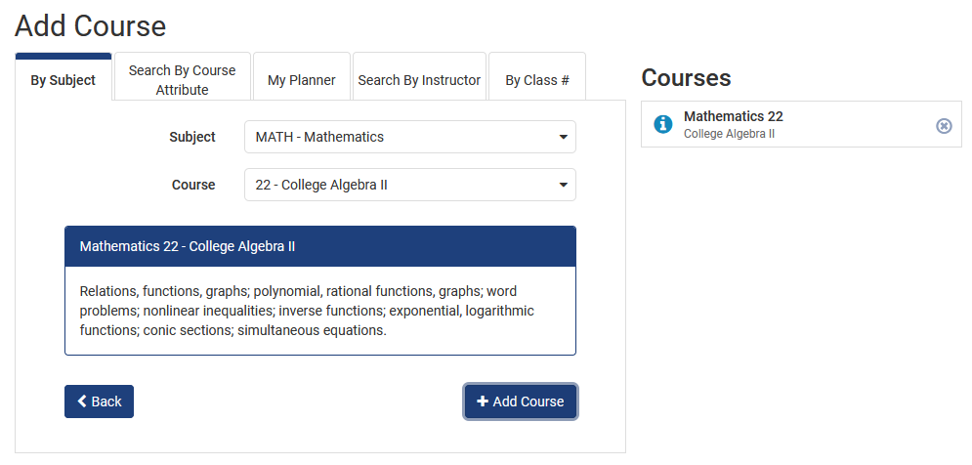
Figure 1: Schedule Builder Add Course page
To begin adding courses, click the Add Course button.

By Subject
- Click the By Subject tab.
- Select the course you would like to add to your schedule, using the Subject and Course drop-down lists.
- Click the Add Course button.
The courses will appear in the Courses list on the right.

Search By Course Attribute
The Attribute drop-down list allows you to select one, or many attributes. The results will be limited to those courses that fit the characteristics of all attributes selected.
- Click the Search By Course Attribute tab.
- Select the appropriate attribute for the attribute list. Note: You can add multiple attributes.
- If necessary, select an appropriate Section Attribute. Section Attributes include First-Year Seminar, Honors, and Writing Across the Curriculum.
- Select the appropriate subject from the Subject drop-down list. Note: When you view the subjects drop-down list, only those subjects where courses exist that have all selected attributes will display.
- Select the appropriate course from the Course drop-down list.
- Click the Add Course button.
The courses will appear in the Courses list on the right.
Note: Not all attributes double count with each other. Talk with your advisor to make sure you understand how courses fulfill requirements in your areas of interest.

My Planner
In addition to subject and course attribute, you can also search by My Planner.
If you have courses in your My Planner they will appear when you click the My Planner tab.
- Click the My Planner tab.
- Select the checkbox next to the course you want included in the schedule options that will be created.
- Click the Add Course button.
The courses will appear in the Courses list on the right.

Search By Instructor
In addition to subject and course attribute, you can also Search By Instructor.
- Click the Search By Instructor tab.
- Select the instructor name that you want to search for using the Instructor drop-down list.
- Select the appropriate course from the Course drop-down list.
- Click the Add Course button.
The courses will appear in the Courses list on the right.

By Class #
In addition to subject and course attribute, you can also search By Class #.
- Click the By Class # tab.
- Enter the Class #.
- Click the Add Course button.
The courses will appear in the Courses list on the right.

Modifying Search Results
You can alter the courses that you have added to schedule builder.

- From the main Schedule Builder page, select the Options link for the course you wish to modify.
- Select the Advanced filters button. Section attributes, instructors, and class numbers affiliated with the selected course are displayed and can be used to further filter your search results.
- Delete any unwanted attributes by clicking on the x located to the left of the attribute. Note: You can further limit your results by only selecting the boxes beside the classes you want included in the search.
Note: The Main Schedule Builder page also includes an Advanced Options button. This is where you can add a specific amount of time in between your classes.

Statement of Non-Discrimination
The University is committed to equal access to programs, facilities, admission, and employment for all persons. It is the policy of the University to maintain an environment free of harassment and free of discrimination against any person because of age, race, color, ancestry, national origin, religion, creed, service in the uniformed services (as defined in state and federal law), veteran status, sex, sexual orientation, marital or family status, pregnancy, pregnancy-related conditions, physical or mental disability, gender, perceived gender, gender identity, genetic information or political ideas. Discriminatory conduct and harassment, as well as sexual misconduct and relationship violence, violates the dignity of individuals, impedes the realization of the University’s educational mission, and will not be tolerated. Direct all inquiries regarding the nondiscrimination policy to the Affirmative Action Office, The Pennsylvania State University, 328 Boucke Building, University Park, PA 16802-5901, Email: aao@psu.edu, Tel 814-863-0471.

